Graphical Budget Planner 1.6.0
User Manual

version : 2025-03-15 16:52:23

Table of Contents
1. Table of Contents 2
2. License, Disclaimers and Source Code Repository 6
3. Accessing this User Manual from the Application Itself 7
4. Supported Platforms & Languages, Requirements 8
5. Installation 9
5.1 On Linux Platforms 9
5.1.1 Ubuntu Special Case 9
5.2 On Windows® OS 9
6. Known Issues 10
7. Introduction 11
7.1 Overview 11
7.2 Cash Stream Definitions 12
7.2.1 Periodic Cash Stream Definition 12
7.2.2 Irregular Cash Stream Definition 13
7.3 Growth for Periodic Cash Stream Definition 13
7.4 Scenario 14
7.5 Cash Balance Curve 15
7.6 Analysis 16
7.7 Tags (a.k.a. Categories) 18
7.7.1 Managing Tags 19
7.7.1.1 Tag Definitions 20
7.7.1.2 Links : Tags View 20
7.7.1.3 Links : Cash Stream Definition View 22
7.7.2 Using Tags as Filters 22
8. User Interface Description 24
8.1 Main Window 24
8.1.1 Splitter 24
8.1.2 Menus 25
8.1.2.1 Scenario 25
8.1.2.2 Tools 27
8.1.2.3 Help 27
8.1.3 Cash Balance Curve : 28
8.1.4 Toolbar buttons 29
8.1.4.1 1M to 50Y toolbar buttons 29
8.1.4.2 "Max" toolbar button 29
8.1.4.3 "Fit" toolbar button 29
8.1.4.4 "Custom" toolbar button 29
8.1.4.5 Panning buttons 29
8.1.5 Action Zone for the Chart 30
8.1.5.1 Start Amount 30
8.1.5.2 Show Points 30
8.1.5.3 CSV Export 30
8.1.6 Selected Point Info Panel 31
8.1.6.1 Date : 31
8.1.6.2 Amount : 31
8.1.6.3 Change : 31
8.1.6.4 Financial Events Listbox Content: 31
8.1.7 General Information 31
8.1.7.1 Eventful Days : 32
8.1.7.2 No Of Events : 32
8.1.8 Date Range 32
8.2 Create New Scenario Windows 32
8.2.1 First step : Choose a currency 33
8.2.2 Second Step : Edit the scenario 33
8.3 Edit Scenario Window 33
8.3.1 Metadata Editing 33
8.3.1.1 Name 34
8.3.1.2 Description 34
8.3.1.3 Annual Inflation 34
8.3.1.4 Duration of Calculation 36
8.3.2 Cash Stream Definitions Editing 36
8.3.2.1 Filters 36
8.3.2.2 List of Cash Stream Definitions 37
8.3.2.3 Action Buttons 37
8.3.2.4 Manage Tags 37
8.3.3 Applying the modifications 39
8.4 Creating/Editing a Periodic Cash Stream Definition 40
8.4.1 Name 40
8.4.2 Description 41
8.4.3 Amount 41
8.4.4 Period and Period Multiplier 41
8.4.4.1 Period Type 41
8.4.4.2 Period Multiplier 41
8.4.5 Start Date 42
8.4.6 End Date 42
8.4.7 Monthly Growth 42
8.4.8 Colorize Name 42
8.4.9 Linked Tags 43
8.4.10 Growth Application Period 43
8.4.11 Enabled 45
8.4.12 Visualize Occurrences 45
8.5 Creating/Editing an Irregular Cash Stream Definition 45
8.5.1 Name 46
8.5.2 Description 46
8.5.3 Colorize Name 46
8.5.4 Linked Tags 46
8.5.5 Enabled 46
8.5.6 List of Financial Events 46
8.5.7 Actions Buttons 46
8.5.8 Visualize Occurrences 47
8.5.9 Load From File 47
8.6 Options Window 48
8.6.1 Category "General" 49
8.6.1.1 How date of "today" is obtained 49
8.6.1.2 Application Font 49
8.6.1.3 Allow colorization of Cash Stream Definition Names 50
8.6.1.4 Export text – Amounts are localized 50
8.6.1.5 Export Text – Dates are localized 50
8.6.1.6 Use Present Value 50
8.6.2 Category "Charts" 51
8.6.2.1 Point Size in Pixels 51
8.6.2.2 Overscaling for Main Chart 52
8.6.2.3 Show a Colored Line at Y=0 53
8.6.2.4 X-Axis Date Format 54
8.6.2.5 Using Dark or Light Mode 54
8.6.2.6 Dark/Light Mode Color Settings 57
8.7 Analysis Window 58
8.7.1 Relative Weight Tab 58
8.7.1.1 Parameters Zone 59
8.7.1.2 Result Chart 59
8.7.1.3 Exporting to Image File 59
8.7.2 Monthly Report - Chart 59
8.7.2.1 Parameters Zone 60
8.7.2.2 Result Chart 61
8.7.2.3 Panning Controls Zone 61
8.7.3 Annual Report – Chart 61
8.7.4 Monthly Report – Table 61
8.7.4.1 Export To CSV 62
8.7.5 Annual Report - Table 62
9. Usage 63
9.1 Preparing to create a budget 63
9.1.1 Collecting Information 63
9.1.2 Modeling Inflation that Varies Through the Months and Years 63
9.1.3 Practical Examples of Periodic Cash Stream Definition 64
9.1.3.1 Salary Received Every 2 Weeks, No Growth 64
9.1.3.2 Salary Received Twice a Month (15th , End of Month), No Growth 65
9.1.3.3 An Annual Rent with Fixed Monthly Payment 65
9.1.3.4 Weekly Grocery Bill that Follows Scenario’s Inflation 66
9.1.3.5 Monthly Loan Payment at Each End-Of-Month 67
9.1.3.6 Monthly Car Maintenance That Increases By a Variable Amount 67
9.1.4 Practical Examples of Irregular Incomes/Expenses 69
9.1.4.1 One-time Tax Return 69
9.1.4.2 Irregular Incomes from Selling Goods 69
9.1.4.3 Periodic Expenses but Irregular Amounts 70
9.1.4.4 Importing a Complex Set of Incomes 71
9.2 Creating the Budget in GBP 72
9.3 Using a Budget Scenario Over Time 73
9.3.1 Typical Workflow 73
9.3.1.1 Set "Start Amount as of Today" Value 73
9.3.1.2 Inspect the Cash Balance Curve and Analysis Module 73
9.3.1.3 Play with the Scenario Data and Look at the Results 74
9.3.1.4 Improve Readability Using Colorization of Name 75
9.3.2 Alternate Workflow 76
9.3.2.1 What Is the Alternate Workflow ? 76
9.3.2.2 When Can this Alternate Workflow Be Useful ? 76
9.3.3 Future Values vs Present Values 77
9.4 Command Line Parameters 80
9.4.1 Force the Use of System Font 80
9.4.2 Override System Locale 80
10. Logs 81
10.1 Format and Location 81
10.2 Example 82
11. Glossary 83

License, Disclaimers and Source Code Repository
Graphical Budget Planner (a.k.a graphical-budget-planner or GBP or gbp) is a free and open source Qt desktop application intended to ease significantly the process of creating, maintaining and analyzing a personal budget.

This application and all its source code are licensed under the GNU Affero General Public License version 3 or later (AGPL-3.0-or-later). It's Free Software. See https://www.gnu.org/licenses/#AGPL/

Software repository for GBP can be found at :

https://codeberg.org/claude_dumas/gbp

Being built with the Qt toolkit, GBP is subject to the Qt terms and conditions : see qt.io/licensing

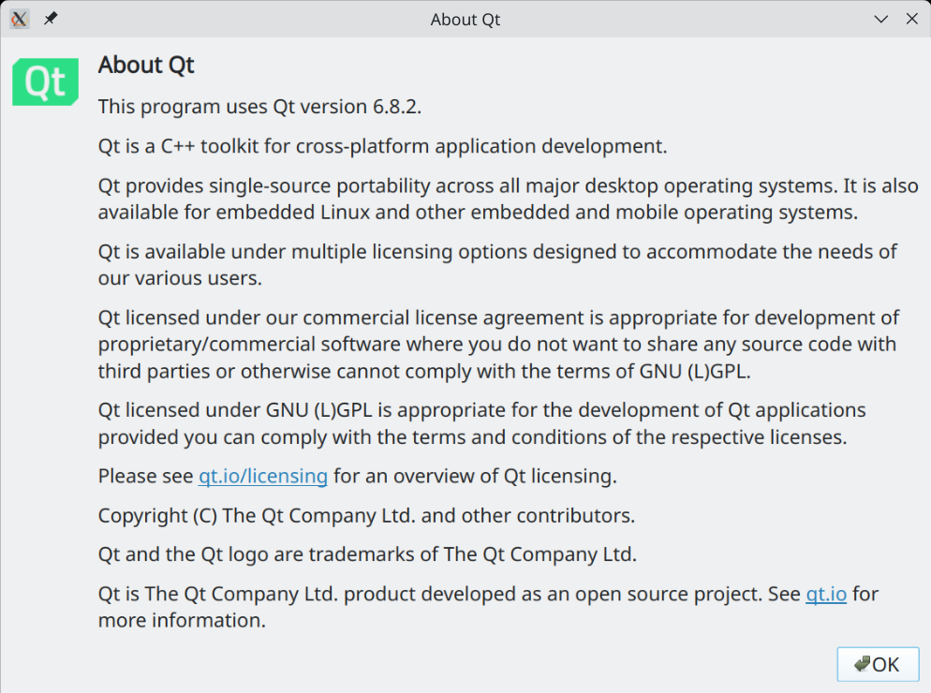
Credits :
- Tobias Leupold : code to calculate difference between 2 dates -> see https://nasauber.de/blog/2019/calculating-the-difference-between-two-qdates/

To contact the author(s) of this software, you can either
- create an issue in the repository’s issue tracker. This way, the owner and other collaborators can discuss and resolve the issue. To create an issue, navigate to the repository’s issue tracker, click "New Issue", and fill in the required information. See https://codeberg.org/claude_dumas/gbp/issues
- Contact by email : redmoon1945@protonmail.com

This documentation is released under the GPL 3.0 license

Accessing this User Manual from the Application Itself
It is possible to access a PDF version (english only) of this User Manual from within the application itself. Select menu "Help → User Manual". The application will copy its own internal and private copy of the User Manual in a temporary directory (the exact location is system dependent) and will then launch the default PDF viewer of the Operating System.
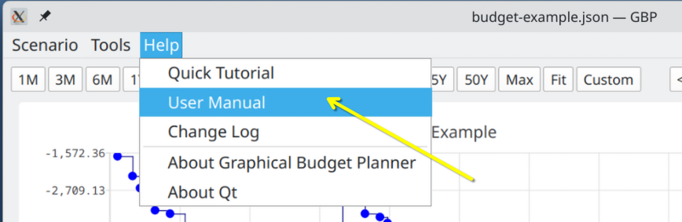
A quick tutorial (english only) is also available in this menu.

Supported Platforms & Languages, Requirements
GBP is intended to be run first and foremost on the Linux Operating System. But since it is built using the Qt cross platform toolkit, a version of GBP for the Windows® Operating System have also been produced. Tests have been conducted on Windows® 10 only.

GBP does not use a lot of RAM (the absolute worst case ever seen is 225 MB for an extremely demanding testing scenario) and necessitate roughly 55 MB of disk space (not taken into account the scenario files that you will create and GBP log files, which are all pretty small anyways).

Screen resolution must be 1366x768 or better. A mouse is required to use the software.

As of April 2025, GBP has been extensively tested on the following Linux platforms :

- Fedora 41, KDE Plasma 6.3.2, Wayland, Kernel 6.13.5
- Ubuntu 24.04.02 LTS, Gnome 46, Wayland, Kernel 6.11.0-19
- Linux Mint 22.1, X11 , Cinnamon 6.4.8, Kernel 6.8.0-55

It has also been tested, but not extensively, on the following platforms :
- Windows® 10
- OpenMandriva Lx 5.0, X11, KDE Plasma 5.27.9, kernel 6.6.2
- MX linux 23.5, XFCE 4.20.0, X11, Kernel 6.1.0-29
- Ubuntu 22.04.5 LTS, Gnome 42.9, X11, Kernel 6.8.0-52
- Ubuntu 22.04.5 LTS, Gnome 42.9, Wayland, Kernel 6.8.0-52

GBP supports English and French languages. By default, English is used, but if the host Operating System is in French (whatever the country), then GBP will switch to French. More languages will hopefully be added in the future, if resources to translate are available.

Installation

On Linux Platforms
GBP is distributed as an "AppImage", which is a single-file executable packaging format allowing a program to run on many Linux distributions. There is nothing else to install. After downloading the AppImage from GBP site, user just has to enable "executable" permission on the file and it is ready to be launched. For example, on Linux Mint, using the "properties" menu of the file :

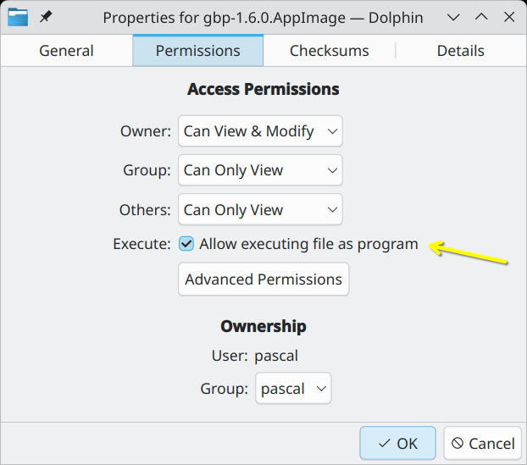

Ubuntu Special Case
On Ubuntu (tested on v 22.04, 24.04), one additional step must be performed. In order to run an AppImage, some packages are missing from the default distribution. Ubuntu needs the FUSE 2 library to run AppImage like GBP. Otherwise, when launched, you will get the following error :

dlopen(): error loading libfuse.so.2

AppImages require FUSE 2 to run. To solve this, do :

sudo apt install libfuse2

On Windows® OS
GBP is distributed as a simple zip file : unzip it in a folder of your choice and run the gbp.exe application.

Known Issues
- When a very large font is used as the application font (e.g. size 24), the menu in the Main Window is not wide enough to show the full menu items texts. This is an issue with Qt itself and no solution has been found at the moment.
- GBP is a Qt 6 application. Unfortunately, at the time of this writing, theme setting in some Gnome-based distributions (like Ubuntu 24.04, Linux Mint 22.1) cannot be understood by Qt 6 application (they wont react to the change made to the theme). You can alleviate the problem by using the "Dark/light mode" settings in GBP Options menu : this will affect the rendering of all the charts in the application.
- In extreme scenarios (meaning that do not correspond to expected use cases of GBP), where a really extremely large data set is generated (e.g. generate many events per day, every day, for 100 years), there could be a noticeable lag between the moment you click on a point of the Cash Balance curve and the relevant info is displayed in the right panel. This depends heavily on the speed of your computer. There is no easy way to speed up things internally, so no improvement is expected in the future for this behavior.
- On Ubuntu systems (tested on 22.04 and 24.04), secondary windows (e.g. popup dialogs) are tied by default to the Main Window and cannot be moved. To be able to move them (which is recommended as it adds flexibility), you can use the Gnome Tweaks application : go to Windows->Attach Modal Dialog and toggle to OFF. Another approach is to type the following command in a terminal : gsettings set org.gnome.mutter attach-modal-dialogs false

Introduction
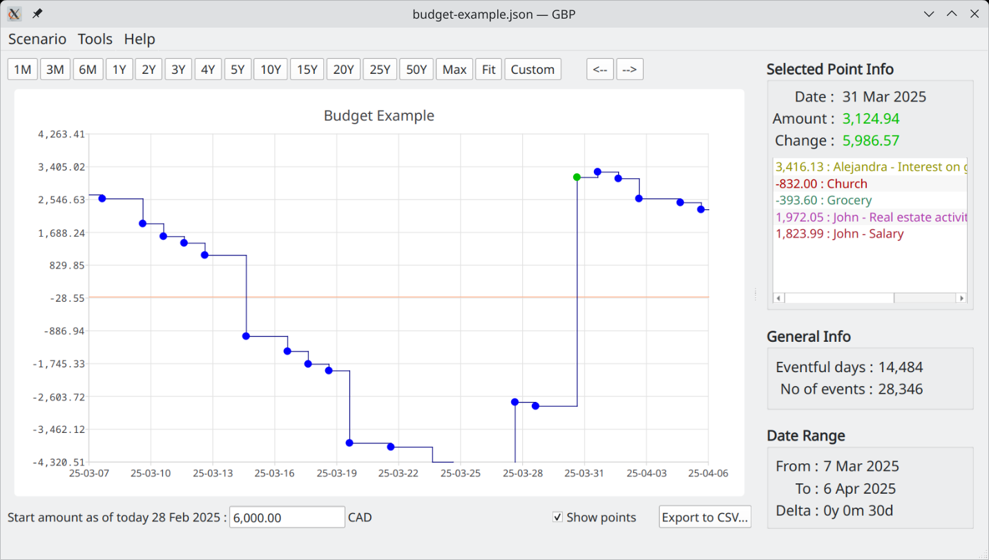

Overview
Graphical Budget Planner (GBP) is an open source Qt desktop application intended to ease significantly the process of creating and maintaining a personal budget. It allows the following :

- See graphically the evolution of your cash balance through time, at any given moment in a period covering 1 to 100 years !
- Easy zooming and/or panning
- Specify painlessly all your forecast income/expense budget items, with flexibility to define periodic or irregular flow of incomes/expenses.
- Optionally define inflation, either as a constant value or a complex series of changing values.
- Optionally define a custom monthly growth pattern for any income/expense specification , expressed either as a constant value or a complex series of changing values.
- Optionally convert all Financial Event amounts to Present Values using a user-defined annual discount rate in Options Dialog.
- Perform automatically different types of analysis on your data, like relative weight of incomes/expenses over custom period, monthly and yearly reports.
- Your data is not locked in : all scenarios are in open JSON format, and resulting data are exportable in CSV format.
- Fully support UNICODE in all text fields.

GBP is all about CASH BALANCE FORECASTING : the key principle adopted in the design of the software is to take into consideration only the FUTURE incomes/expenses expected to occur, starting from "tomorrow".

Consequently, this is not the right tool to use if you want to know how and when your money has been spent in the past ("incomes/expenses tracking"). That also means that if you start the program, lets say once a month, you may not see the same curve in the Main Window each month. This is because events that have occurred during a given month are now past when the next month occurs, and thus not taken into consideration. There is however a way in the Options Settings to overcome this behavior (see "Settings").

Cash Stream Definitions
In GBP, basically, you have to define all the expected/forecasted incomes and expenses of the future, in order to see the evolution of the cash balance in the curve shown in the Main Window.

Of course, you don’t want to manually enter all the occurrences of an income or an expense through time. So to ease significantly the process, one introduces the key concept of "Cash Stream Definition". You can create one or many of these, at will. It is from these definitions that a flow of financial events will be generated, either incomes or expenses. Said differently,

A Cash Stream Definition is a declarative specification created by the user and that states how a flow of money (the financial event "stream") is generated through time.

An example of a Cash Stream Definition could be a salary. You can declare that an amount of 2000 USD is generated every 2 weeks for the next 50 years, without then having to enter all of them manually. Each occurrence of money coming from the definition is called a "financial event" (e.g. the salary occurrence of 2000$ on Feb 3, 2030 is a "financial event". Another occurrence on Mars 3, 2030 is another financial event, etc).

They are 2 types of Cash Stream Definition :

Periodic Cash Stream Definition
It defines a fixed amount of money (income or expense) that occurs at regular intervals in time. The interval is specified by first defining a period type :
- Year
- Month
- End-of-month
- Week
- Day
And then a "period multiplier", which is an integer that is a multiplication factor of the period type selected (e.g. 3 years or 12 weeks).

A Periodic Stream Definition has a "Start Date" and an "End Date". Financial events will be generated only in that interval of time. The End Date can be explicitly specified ("Custom") or it can refer to a value that is defined at the scenario level.

An example of a Periodic Income would be a dividend received every 3 months or a salary received every 2 weeks.

Irregular Cash Stream Definition
This is a set of amounts that are not periodic and that occur at very specific moments in time, as chosen by the user. The amounts can be completely different for each date in the set. There is no special constraints governing when such amounts can occur : it can follow periodic pattern or not. Hence the name "irregular" for that type of Stream Definition.

An example of an Irregular Stream Definition could be a set of incomes received from selling some art paintings. In that case, it is clearly not periodic :
- 1 Feb 2034 : $300
- 23 Mar 2035 : $1800
- 12 Sep 2036 : $3200

Another example of an irregular income could be a periodic revenue stream from complex financial instruments (e.g. dividends from multiple stocks) calculated outside GBP and then imported : the values change every month and thus cannot be simply modeled with a "Periodic Income" with constant values or deterministic growth pattern.

Growth for Periodic Cash Stream Definition
For a Periodic Cash Stream Definition, it is possible to define a "Growth Pattern" that allows the initial fixed amount to actually change in time. There are 4 different ways to specify this grow pattern :

- "No growth" : The initial amount stays constant for the whole range [Start Date – End Date]
- "Scenario’s inflation" : Growth is exactly identical to the inflation pattern defined in the scenario (actually, you can multiply it by an adjustment factor, default = 1)
- "Custom – constant" : Specify a constant growth, that applies only to this Periodic Cash Stream Definition
- "Custom - Variable" : Specify a variable growth pattern, that applies only to this Periodic Cash Stream Definition
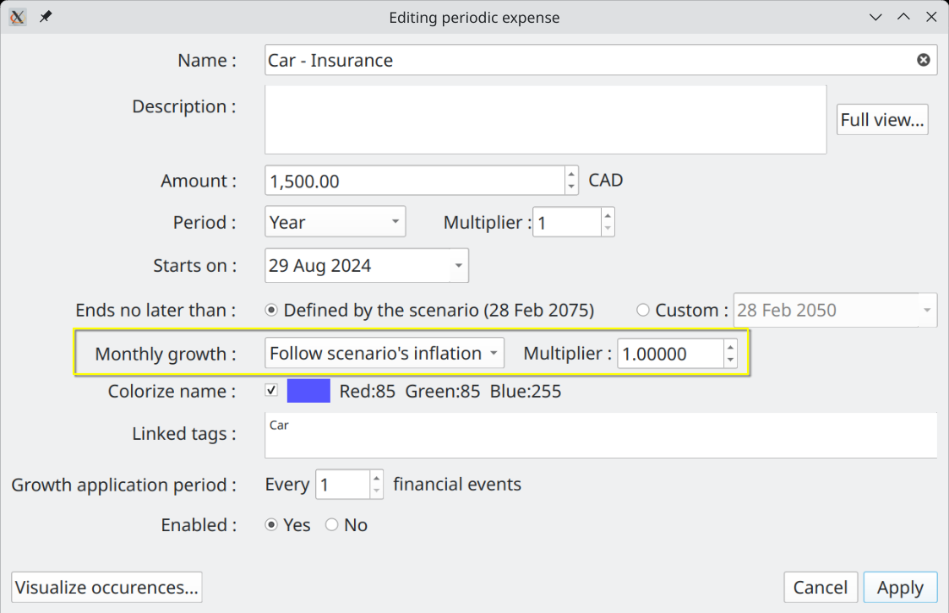

Scenario
In GBP, a scenario is a set of Cash Stream Definitions, plus other miscellaneous metadata.
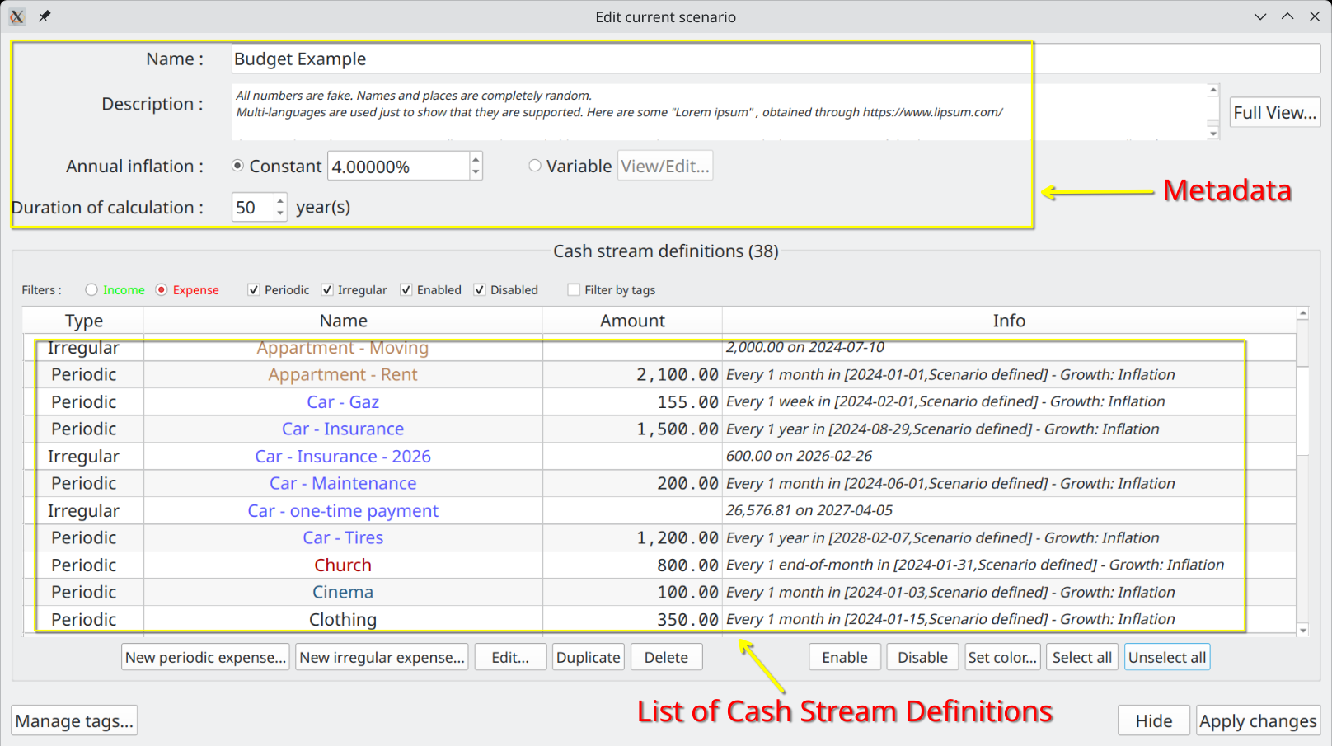

All this information is stored in a single file called a "scenario". On disk, you may have as many scenarios as you want and they may be stored anywhere you like : there are just ordinary files (JSON format). There is only one scenario at a time that can be loaded in GBP. Once loaded via the "Scenario→Open" or "Scenario→Open Recent", scenario’s data can be inspected or edited using the "Scenario->Edit" menu. Any change made must be saved on disk for it to become permanent, through the "Scenario->Save" or "Scenario→Save As" menu.

Cash Balance Curve
Once a scenario is loaded, in the Main Window, the resulting "Cash Balance" curve will be automatically shown. This curve is the result of all the income/expense events occurring through time, generated by all the Cash Stream Definitions found in the scenario. The color of the curve can be configured in the Options Dialog.

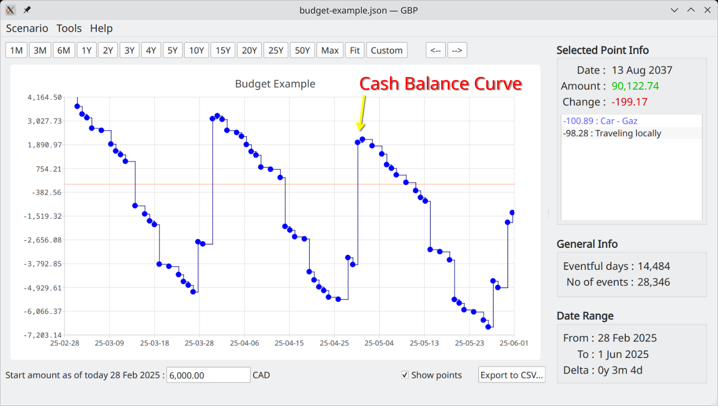
You can zoom the curve or move it with the mouse :
- Zoom / unzoom :
  - HORIZONTAL : middle-mouse wheel + SHIFT
  - VERTICAL : middle-mouse wheel + CONTROL
  - BOTH : middle-mouse wheel
- Move : left-click & hold, then move mouse or use the "←" or "→" buttons in the upper toolbar
- Set predefined Time Interval : use the predefined buttons in the upper toolbar

Each data point shown (the small disk on the chart)
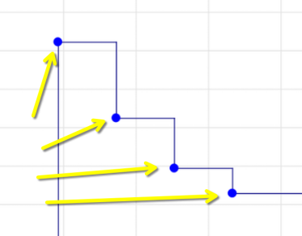
represents an amount which is the sum of :
- all the financial event amounts that occurred in that very day
- the final cash balance of the previous data point.

If you click on a point, the color of the point changes (you set this color in "Options" Dialog.)

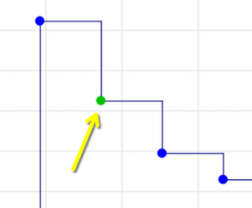
and the "Selected Point Info" panel to the right will show the details :
- Date : date of occurrence for that point
- Amount : total cash balance for that day, taking into account all the daily financial events
- Change : change in cash balance from the previous occurrence

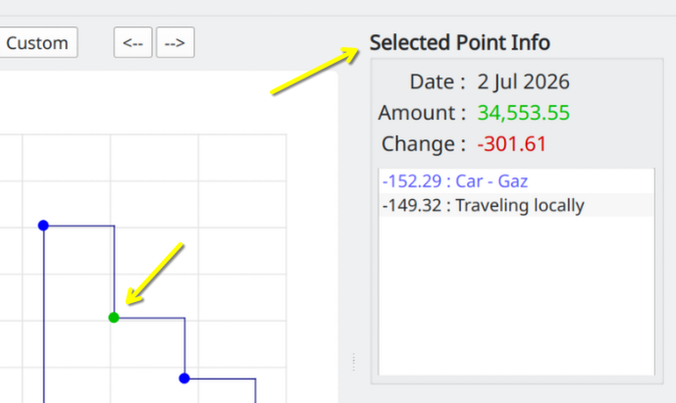
Re-clicking on the point clears this panel.

Analysis
GBP provides an "analysis" module in order to provide depth insight of the data generated from the scenario’s Cash Stream Definitions. More specifically :

=> A pie chart that illustrates the relative weight of each income (or expense). Very useful to understand what are the most important incomes or expenses over a specific time interval.

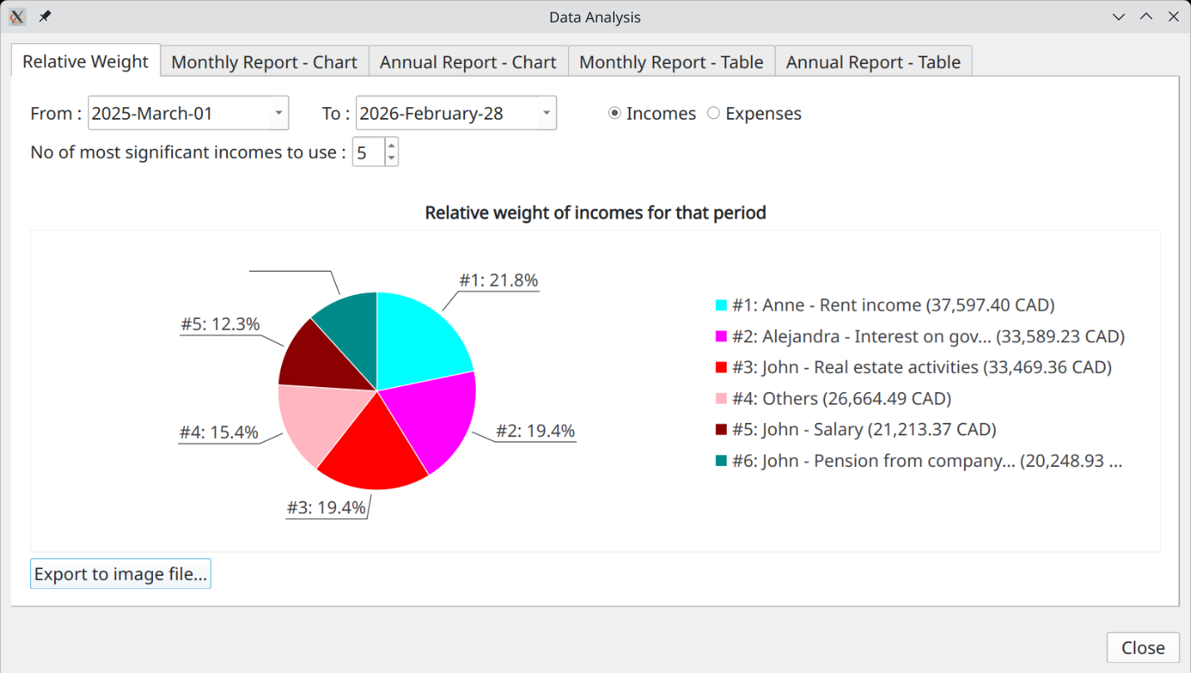
=> A bar chart showing the monthly/yearly total for incomes (or expenses)

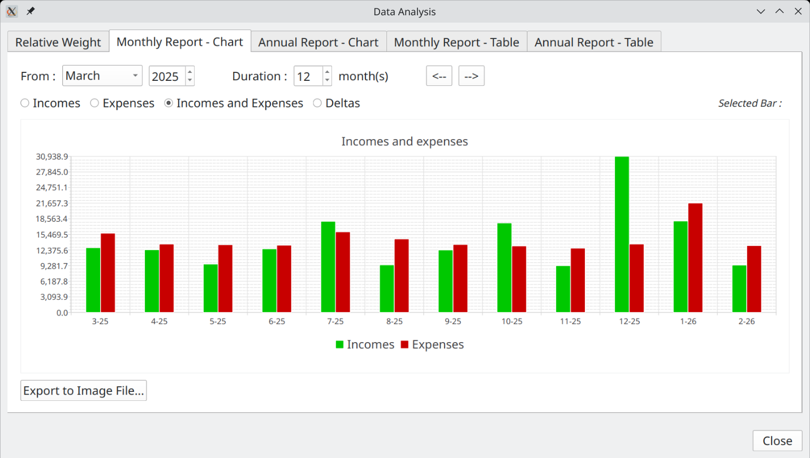

=> A tabular form of the previous

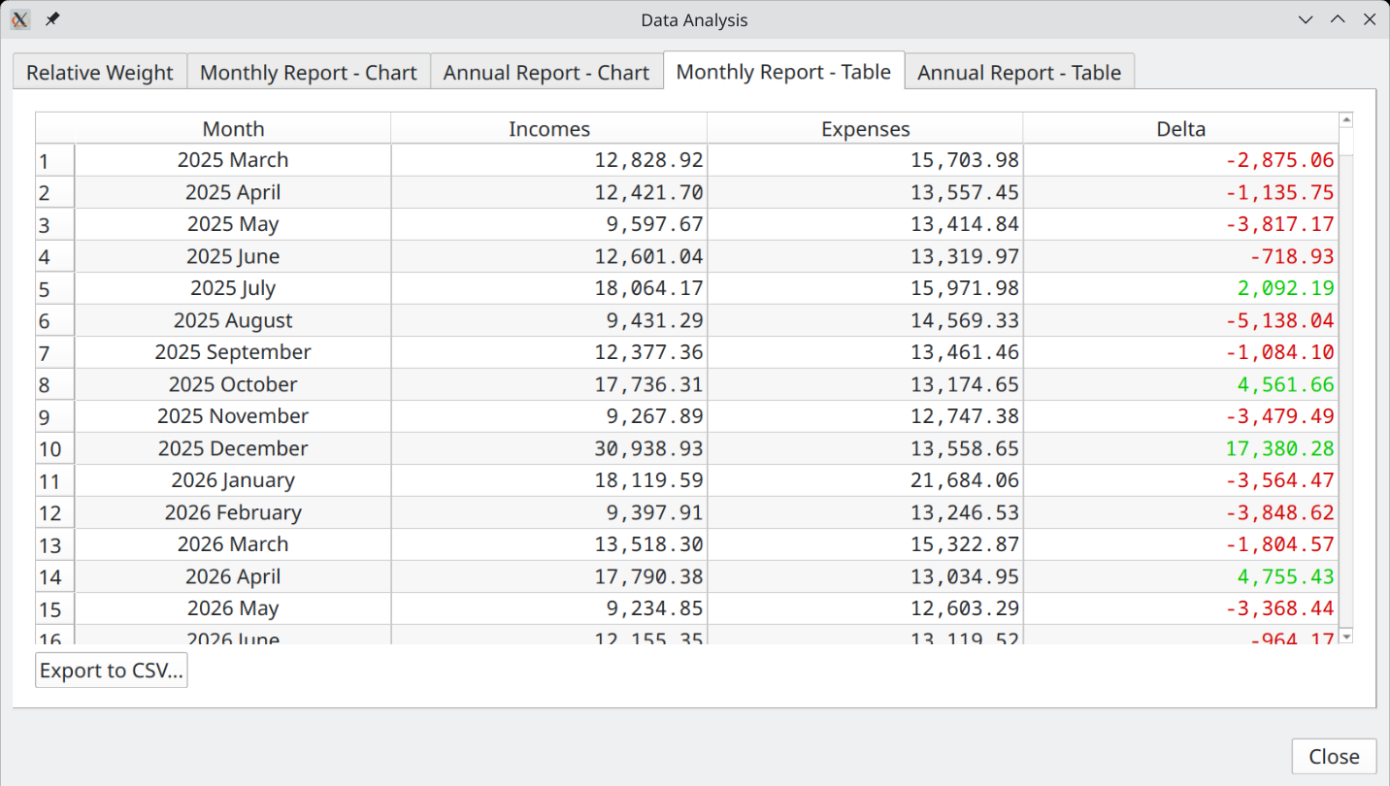

Tags (a.k.a. Categories)
Introduced in version 1.6.0, the concept of Tags allows for easy but powerful categorization of Cash Stream Definitions.

A tag is a set of words that forms a single unit. It is created by the user of GBP, according to his needs. It can be linked to Cash Stream Definitions and is a powerful way to implement categories of incomes/expenses. Each scenario has its own set of tags (although you can easily import tags from other scenarios if you want). A particular tag can be linked to zero, one or many Cash Stream Definitions. Similarly, a Cash Stream Definition can be linked to zero, one or many tags. This is what is called a "N to N" relationship.

Example:
Lets say one has the following tags defined for a given scenario :
- Education
- Investments
- Health care fees
- House
- House insurance
- Employment
- Alejandra
- Pierre
- Confirmed

and the following Cash Stream Definitions (CSD) defined in the same scenario :
- Pierre’s Salary
- University program
- Pension from government

You could associate to CSD "Pierre’s Salary" the tags "Pierre" and "Employment". Or link the tag "Confirmed" to CSD "University Program" and "Pension from government".

You can define as much as 5000 tags per scenario (which is far more than you will ever need...).

Managing Tags
For a scenario, its tags can be managed (that is created, edited, deleted) at a single place, in the Edit Scenario Dialog. Use the "Manage Tags" button to access the Dialog that provides this capability.

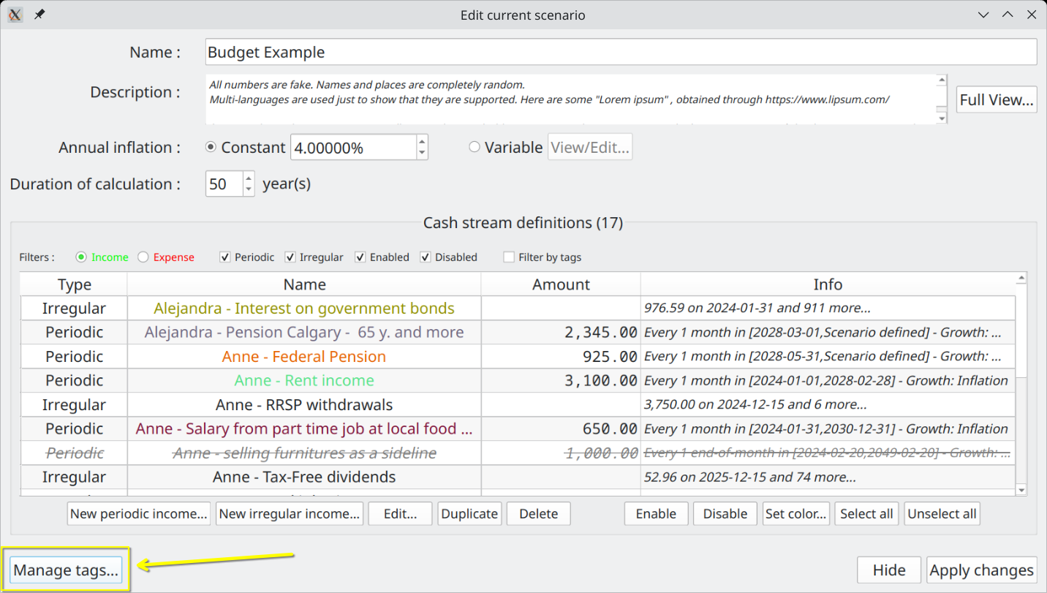

The "Manage Tags" dialog looks like this :

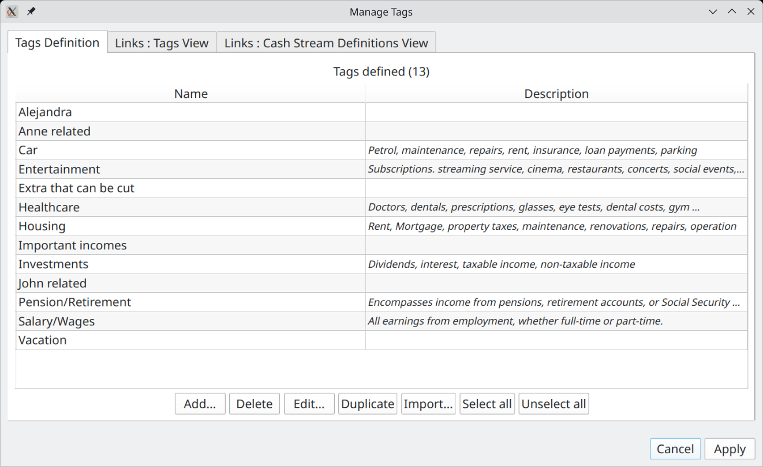

Tag Definitions
This is where you create, edit, delete tags. You can create as many tags as you want, according to your needs, up to 5000. A tag has a name and an optional description. The name must be unique within a specific scenario and is limited to 50 characters.

Links : Tags View
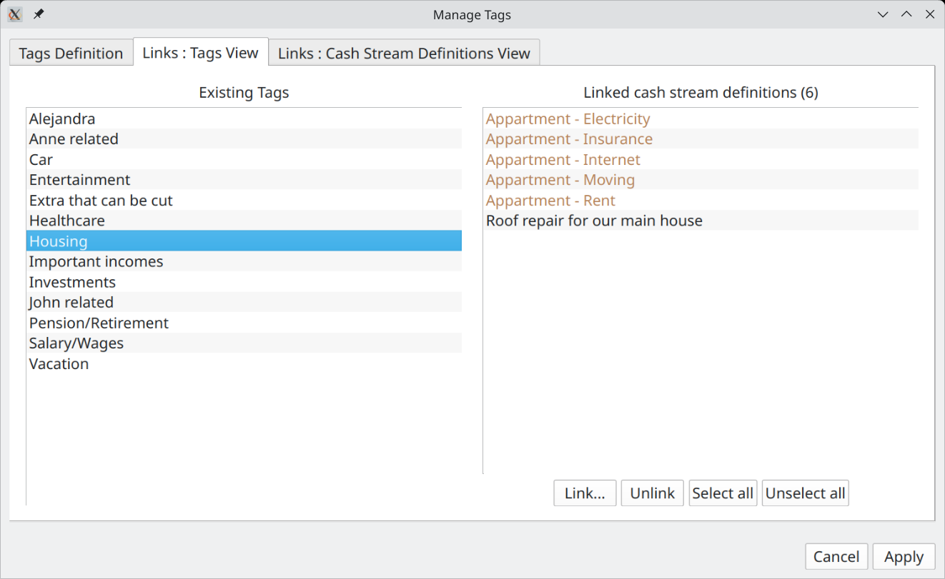
This tab is to manage the links between tags and Cash Stream Definitions, but from the point of view of tags. You select one tag to the left and the linked Cash Stream Definitions appears to the right.

- You can link more Cash Stream Definitions to this tag by pressing the "Link..." button. A new dialog will appear to help you select these Cash Stream Definitions.
- You can delete existing links to Cash Stream Definitions by selecting them and then press "Unlink" button.

Links : Cash Stream Definition View
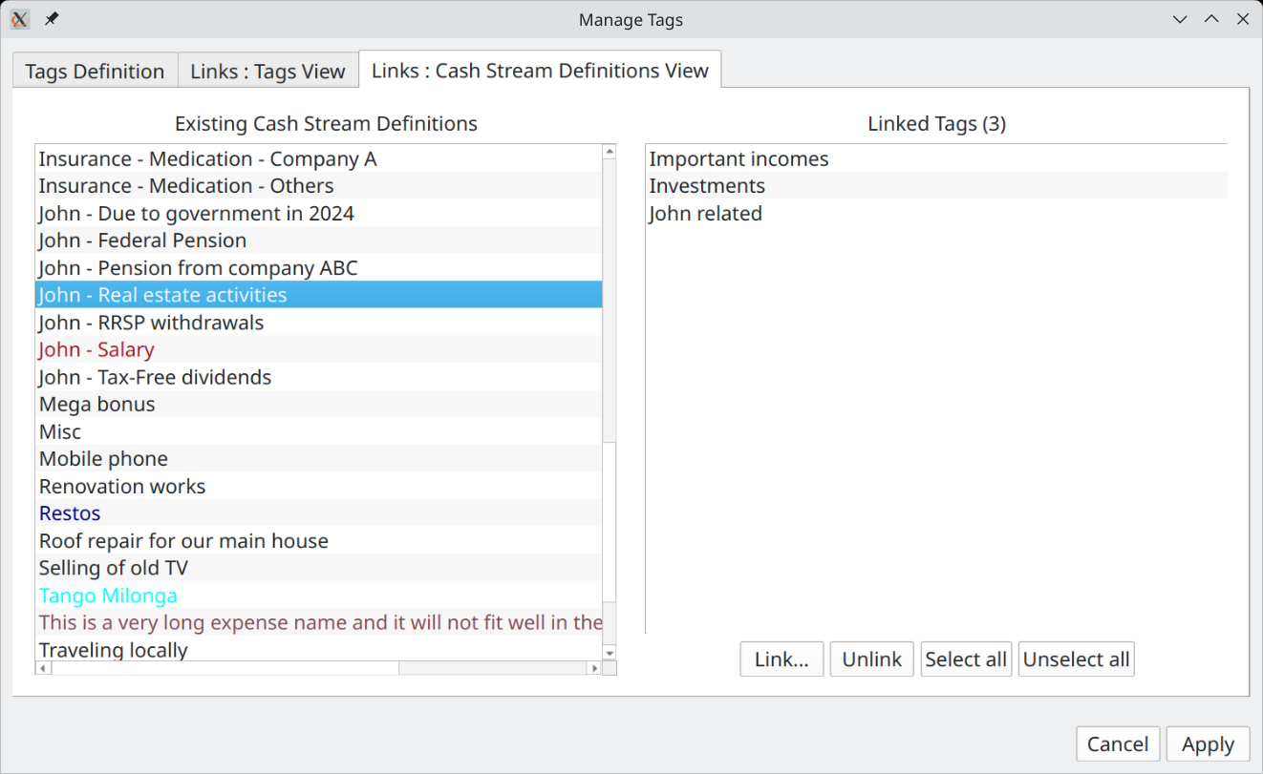
This tab is to manage the links between tags and Cash Stream Definitions, but from the point of view of Cash Stream Definitions. You select one Cash Stream Definition to the left and the linked tags will appears to the right.

- You can link more tags to this Cash Stream Definition by pressing the "Link..." button. A new dialog will appear to help you select these tags.
- You can delete existing links to tags by selecting them and then press "Unlink" button.

Using Tags as Filters
In version 1.6.0, tags can only be used to filter content in the list of Cash Stream Definitions in the Edit Scenario Dialog, which is already useful. In future versions, more functionalities using tags will be added, like the analysis module or reporting.

Restricting the list of Cash Stream Definitions is useful for example if you want to see just the Cash Stream Definitions related to Pierre, or those related to investment incomes, the car, etc. Note that the Cash Balance curve is NOT affected by this filtering.
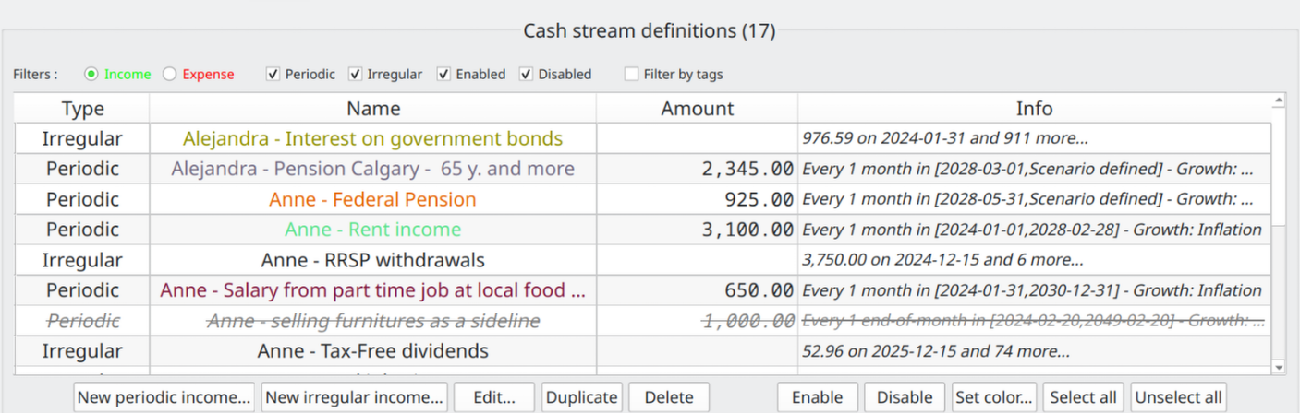
check the "Filter by tags" checkbox

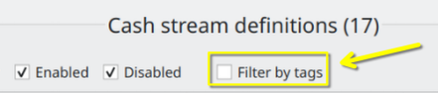
A dialog will appear to help you select the tags to be used as filter.

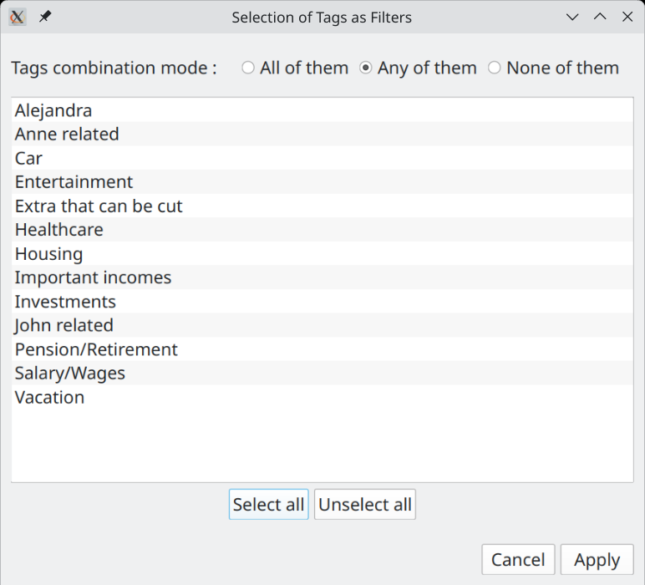

The list of Cash Stream Definitions in the Edit Scenario Dialog will be updated accordingly.

User Interface Description

Main Window
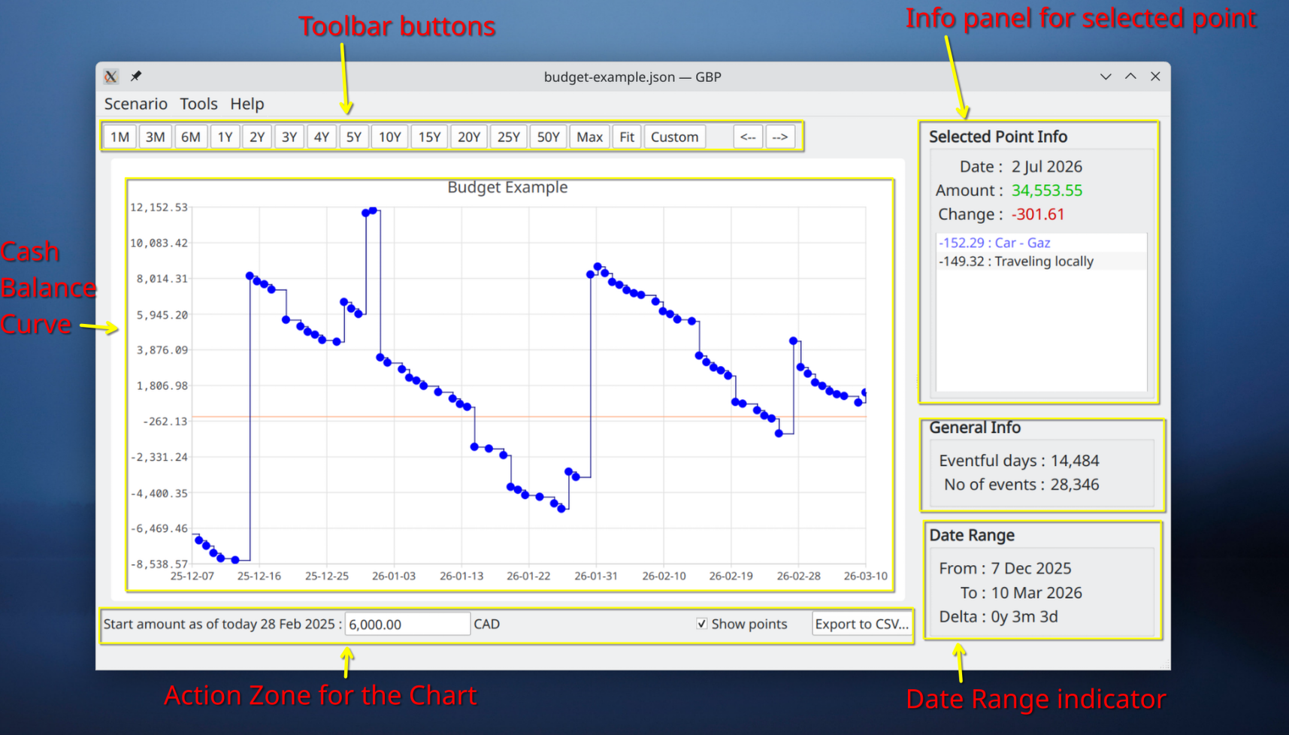
This is the first window displayed by GBP after being launched.

Splitter
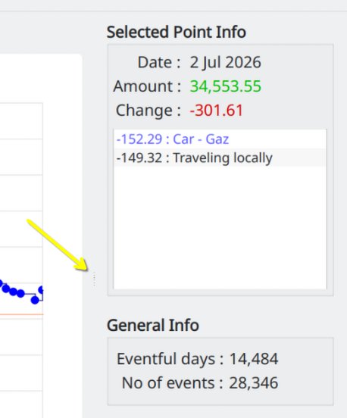

User can increase/decrease the size of the right part of the Main Window relative to the Cash Balance curve by using the "splitter" control found between the 2 "left" and "right" regions (see the yellow region to the left).

Just click on the region identified by the arrow in the figure above and move the mouse while still pressing on mouse button.

The different areas of the Main Window are described below :

Menus

Scenario
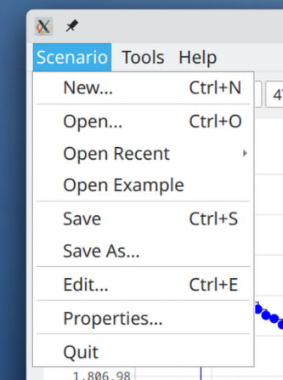
New
Create a new scenario in memory. If a scenario is already loaded and modifications made have not been saved yet, the following prompt will appear to give the user the opportunity to save the modifications before going forward :
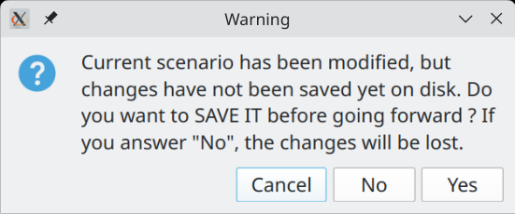
"Cancel" will abort the request (here, it is the creation of the new scenario), "No" will proceed with the request but will discard the changes made, "Yes" will also proceed with the request but will first save the changes in the associated scenario file.

Open
Open an existing scenario file on disk. If a scenario is already loaded and modifications made has not been saved yet, the same processing will happen than for "New".
Open Recent
Open an existing scenario file on disk, from a list of the most recent scenario files opened. If a scenario is already loaded and modifications made has not been saved yet, the same processing will happen than for "New".
Open Example
Open a pre-built sample scenario just to help give an idea of what graphical-budget-planner can do. The sample scenario file is copied to the Temp directory for the OS and can then be modified at will. If a scenario is already loaded and modifications made has not been saved yet, the same processing will happen than for "New".
Save
Save the current scenario data to the associated scenario file. This is a JSON file, default extension is ".json", but user can override it and select whatever he wants.
Save As
Save the current scenario data in a file chosen by the user. If the file already exists, user will get a warning and may replace the current content it if he wants. This is a JSON file, default extension is ".json", but user can override it and select whatever he wants.
Edit
Display the scenario data and allow the user to modify anything he wants, except the currency. Note that :
- User must press the "Apply Changes" button in order to update the currently loaded scenario in memory, and thus see the effect on the Cash Balance curve and the Analysis Dialog.
- the changes made are not saved to the scenario file on disk : this must be done explicitly using the "Scenario→Save" menu.
Properties
Show a Dialog displaying several properties of the scenario. The "Name", "File Name" and "Path" controls will display scroll-bars if the content is big. This way, very big Path and/or file name strings are supported.
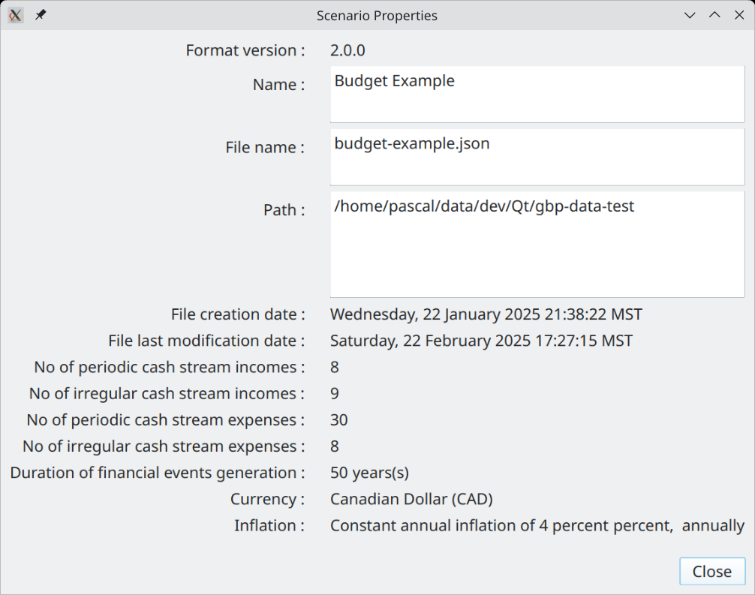
Quit
Terminate the application. If a scenario is already loaded and modifications made has not been saved yet, the same processing will happen than for "New".

Tools
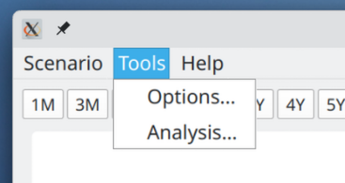
Options
Launch the Options Dialog to view or change the configuration.
Analysis
Launch the Analysis Dialog in order to conduct detailed statistical analysis on the financial event generated.

Help
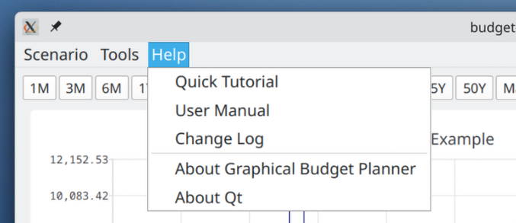
Quick Tutorial
Open a short (7 spages) PDF document that provides a very quick tutorial about using graphical-budget-planner. The document is opened by the default system application for PDF reading (e.g. Okular on KDE). The document is in english only.
User Manual
Open a long and detailed PDF document that provides an in-depth description of what is graphical-budget-planner and how to use it effectively. The document is opened by the default system application for PDF reading (e.g. Okular on KDE). The document is in english only.
Change Log
Shows all the changes made to graphical-budget-planner since version 1.
About Graphical Budget Planner
Open a window that provides the application version, the license terms, source code location, credits and author(s) with email contact.
About Qt
Open a window showing misc info about the Qt toolkit used to build this application.

Cash Balance Curve :
This curve shows a series of point, each one being for a specific distinct day where at least one financial event occurred. There can be no point for a day where no financial event happened. The amount associated to a point is the "final daily amount" for that day, that is the sum of :
- All financial events having occurred during that day (incomes and expenses)
- The final amount for the previous point

The X axis shows the current time interval and the Y axis the amount values in the currency associated with the current scenario.

Toolbar buttons
This area is made of 2 zones :
- the predefined range buttons (to the left)
- the panning buttons (to the right)

1M to 50Y toolbar buttons
These buttons will rescale the chart for a predefined time interval range, starting at the date of "tomorrow". "M" stands for "month(s)", "Y" for "year(s)"

"Max" toolbar button
Rescale the chart so that the X range is from "tomorrow" to "last allowed date for the calculated data". The latter is set by the option "Scenario – No of years calculated" in the Option Dialog. Scenario’s calculated data may or may not end before this date, depending on the nature of the Cash Stream Definitions in the scenario. Y axis is rescaled to include the min and max values.

"Fit" toolbar button
Rescale the chart so that the X range covers exactly the date range of the Scenario’s calculated data. Y axis is rescaled to include the min and max values.

"Custom" toolbar button
Allow the user to enter its own X axis range. The start of the X axis can then be different than "tomorrow".

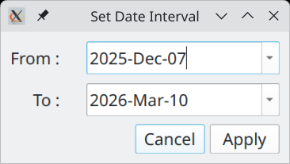

Panning buttons
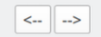
These buttons allow to "scroll" the chart to the left or to the right, by approximately the same date range width than the current date interval currently displayed.

Action Zone for the Chart
This area contains controls that may alter the chart content or appearance, or allow exporting the data to a CSV file.

Start Amount
This features adds a "baseline" amount to the chart, which corresponds to the current starting amount before any financial events occurred. In other words, this is your current cash balance as of today. It is NOT part of the scenario and thus is NOT saved on disk. It has to be re-entered each time GBP is started, but this is the whole point...It represents the available amount of cash for the user as of "today". All the financial events will occurred from "tomorrow" and add/subtract to this initial amount. See "Usage" for more information about how to use it.

There is an option to set the value of "today" not to the system’s date at launch time (which is the default), but to an arbitrary value. See Options Dialog.

Show Points
When OFF, the chart will not show the colored disk around the chart’s data points, used to help localize the data points on the chart. This is useful if there is a huge number of points and one want to see the overall shape of the curve.

CSV Export
Allow to export ALL curve’s data points to a CSV file for futher processing by other tools (like Libre Calc). The user selects a file name : by default, a .csv extension is added if the file name does not contains one, otherwise it uses what the user has entered.

The first line of the file is a header, with fields separated by a TAB character :

Date Total Daily Incomes Total Daily Expenses Total Delta Cumulative Total

with the following semantic for the columns :
- Date : Date for this data point (format = YYYY-MM-DD)
- Total Daily Incomes : The total amount of all the incomes that occurred during that day
- Total Daily Expenses : The total amount of all the expenses that occurred during that day
- Total Delta : Total Daily Incomes - Total Daily Expenses
- Cumulative Total : The final amount at the end of the day (cash balance)

The rest of the file contains the data points info (one line per data point), like for example

2024-07-01 3100.00 -3031.29 68.71 20068.71
2024-07-02 0.00 -333.00 -333.00 19735.71
2024-07-03 0.00 -375.02 -375.02 19360.69
2024-07-04 0.00 -310.60 -310.60 19050.09
2024-07-06 0.00 -281.79 -281.79 18768.30

where fields are separated by a TAB character.

By default, amounts are written in the form

Thousands separator : none
Decimal separator : ‘.’

but it is possible to generate a localized version : see Options Dialog

Selected Point Info Panel
Provides information for the selected point on the chart.

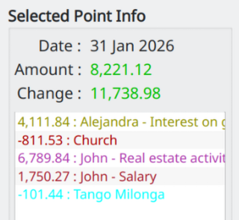
Date :
Date of the data point. Format is YYYY-MMM-DD

Amount :
Final Daily amount, taking into account all the financial events of the day. The amount is green if >=0, red otherwise

Change :
Total of all the incomes of the day minus total of all expenses of the day. The amount is green if >=0, red otherwise

Financial Events Listbox Content:
This is the list of all financial events that occurred during the day. It is sorted by Cash Stream Definition name (sorting takes into account the Locale defined on the user’s computer).
Expenses are number < 0. Financial Event name is colorized if defined so.

General Information

This section provides miscellaneous information about the scenario’s calculated data (a.k.a. "flow data"). It changes only when a new scenario is loaded.
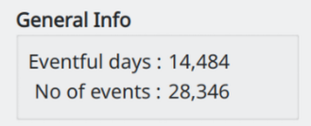

Eventful Days :
For the whole Cash Balance curve (hence not only for what is displayed with the current date interval), it tells how many days have at least one financial events associated with each of them. It corresponds also to the total number of data points on the Cash Balance curve.

No Of Events :
Total number of financial events for the whole Cash Balance curve (hence not only for what is displayed with the current date interval). In the example below, there are 17 days displayed, but only 2 of them have 1 or more financial events associated. The first point has 1 financial event, the second one has 2 (this point is selected on the figure). The total no of events is thus 3.

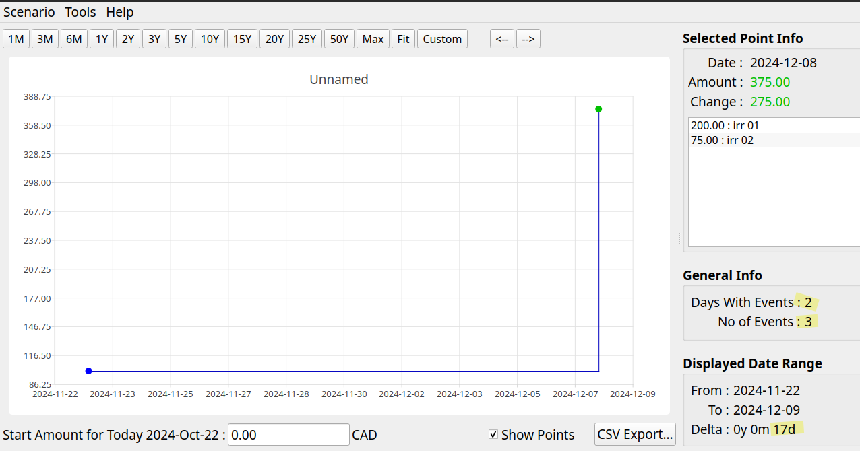

Date Range
Shows the time interval (X axis) currently used by the chart. Real-time refreshed when zooming or panning occurs.

Create New Scenario Windows
Accessed with the "Scenario→New" menu. This is used to create a new scenario. To save it, use the "File→Save" or "File→Save As" menu.

First step : Choose a currency
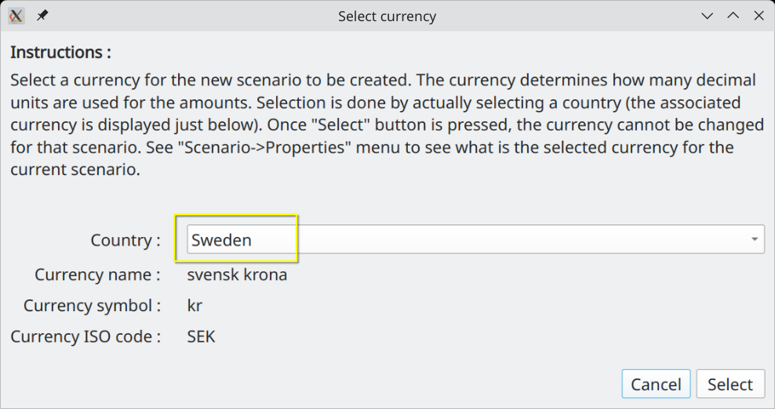
When a scenario is created, the first thing to do is to select a currency to be associated to it. This is required because it defines how many decimal units the amount shown will have (e.g. Yen has 0 decimal, Euro has 2). But it is easier to select a country instead, since there is a 1-to-1 relationship between both. The country must be chosen with the "Country" combobox (in yellow in the figure above).

Once selected, a currency cannot be changed for a given scenario.

Second Step : Edit the scenario
By default, an "empty" scenario is created and you will be brought to the "Edit Scenario" dialog, where you can change whatever parameter you want.

Edit Scenario Window
Accessed with the "Scenario→Edit" or "Scenario→Recent" menu. This window is intended to view and/or change the content of an existing scenario. Changes are NOT saved in the scenario file on disk until you select "File→Save" or "File→Save As" menu.

This window is not modal (the only one in GBP), meaning that its content can be edited while still having access to the Main Window that shows the charts. This is on purpose and intended to ease and accelerate the work on a scenario. A typical use is to have the Main Window maximized on a monitor and the Edit Scenario window shown on another monitor. This way, change in parameters can be seen immediately in the Main Window, allowing for example zooming and panning.

All changes made to a scenario can be committed for the update of the cash balance curve by pressing the "Apply" button. Again, this does NOT save the data on disk.

Metadata Editing
Metadata are located at the top half area of the Edit Scenario window :
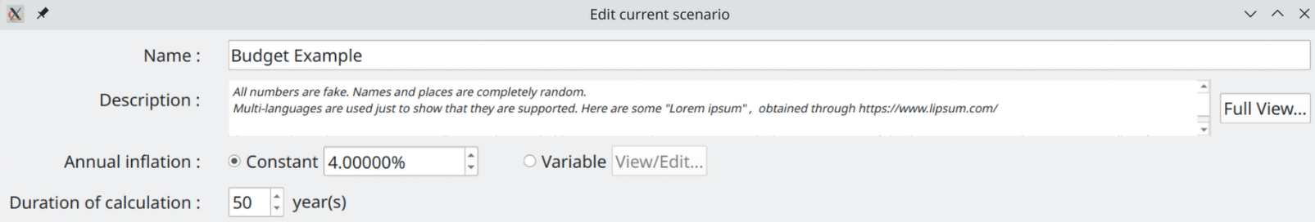

Name
Just enter the new name in the right field. There is a limit of 100 characters for the name. This is NOT the name of the scenario file on disk !

Description
User’s notes about the scenario. An be up to 4000 characters. Click "Full View" to edit the Description in a much bigger window.

Annual Inflation
A growth pattern specific to this scenario and used to define an inflation value that may affect all incomes/expenses (increase or decrease their values, depending on the inflation value). Inflation is made available to all Cash Stream Definitions to be used or not (this is optional).

Constant :
A constant growth value ranging from -100% to 10000%. It stays the same in past, present, future. This is an ANNUAL value, but it is the equivalent monthly growth value that is actually applied on a monthly basis on the 1st of each month.

Variable :
A variable growth pattern : this is for advanced use. It can be used to define a complex and changing growth pattern for inflation.
It consists of a list of (month date, annual inflation value) "pairs", each defining a new inflation value to be applied from this date, until a new pair is defined or otherwise for ever. Before the first pair is defined, inflation value is 0. Each time a new pair is defined, a new inflation value becomes in force from that date. Inflation is always applied on the first day of each month.

For example, lets say we have the following pairs defined :

(1 jan 2000, 10%) , (1 jan 2002, -10%)

Here are the values of an amount of 1000 that starts existing on 1 jan 1998 and is submitted to this growth pattern:

- 1 jan 1999 : 1000 (growth = 0%)
- 1 jan 2000 : 1100 (new growth value=10%,)
- 1 jan 2001 : 1210 (growth value still at 10%)
- 1 jan 2002 : 1089 (new growth value=-10%)
- 1 jan 2003 : 980.10 (growth still at -10%, for ever)

If the amount of 1000 starts existing on 1 jan 2003, then we have

- 1 jan 2003 : 1000 (no growth applied on the first occurence)
- 1 jan 2004 : 900 (growth is -10% as lastly defined in 1 jan 2002)
- 1 jan 2005 : 810 (growth is -10% as lastly defined in 1 jan 2002)

Here is what looks like the definition of variable inflation (values are different from above) :

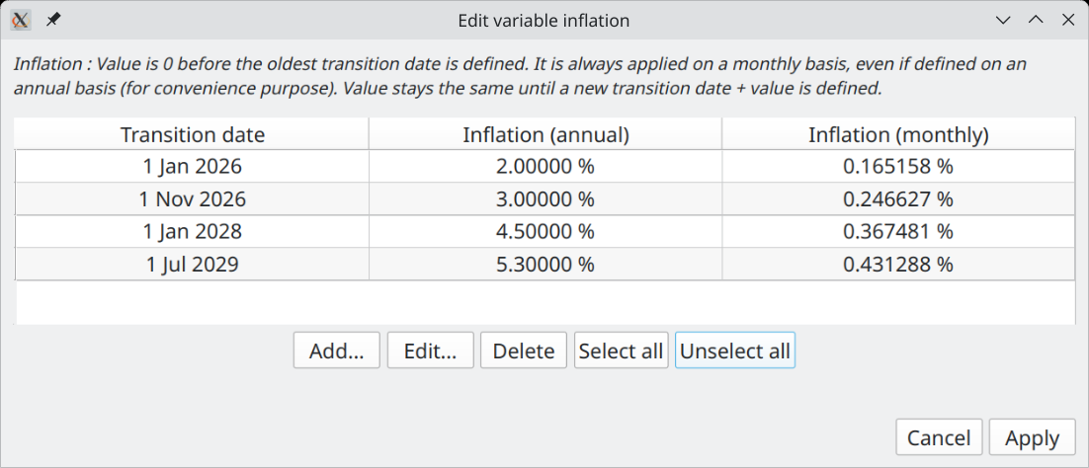
The buttons "Add", "Edit", "Delete" at the bottom are to change the list of "pairs". a.k.a "transition points". Note that "Delete" remove all the selected rows. The "Add" button pops up the following Window :

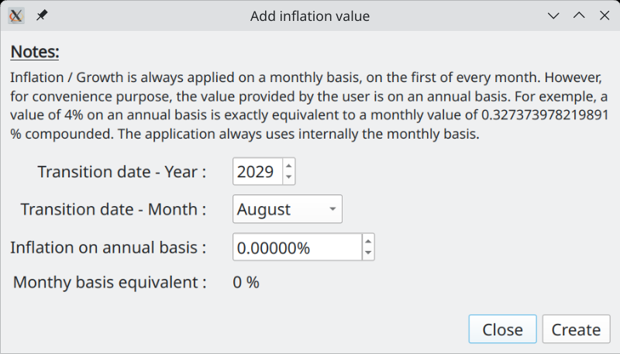
When adding a new "transition point" (date + inflation value), the value entered is always on an Annual Basis, but as mentioned before, it is actually the equivalent Monthly Basis that is used internally and applied every month on the 1st. This is why is shown the "Monthly Basis Equivalent" at the bottom. Note that you cannot create a new "transition point" with a date that already exists.

Editing a "transition point" uses essentially the same Dialog. One notable difference is that if you enter a date that already exists, it will be accepted and the new value of inflation replaces the old one for that date.

Duration of Calculation
This value determines what is the limit date over which no financial events will be generated for the current scenario, whatever what the Cash Stream Definitions specify. The limit date is "tomorrow" + the value of this field minus 1 day.

The idea here is to limit the amount of calculation GBP has to do. The smaller this value is, the faster the calculation is done and the lesser system’s memory is consumed. The default of 25 years is probably more than adequate for most use. You can increase this amount however, up to 100 years.

Cash Stream Definitions Editing
There are 4 zones in this part of the Edit Scenario Dialog (middle section of the window) :
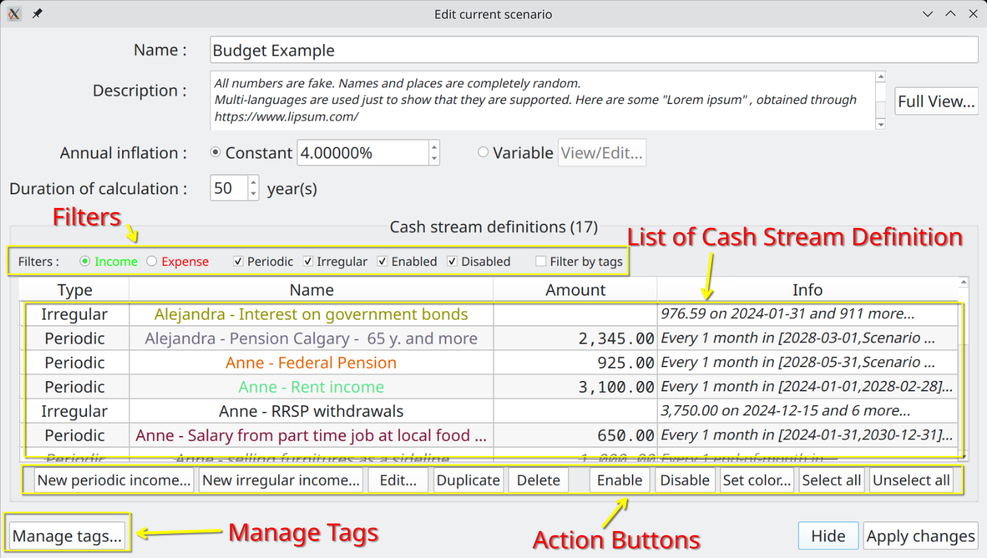

Filters
Filters change what you see in the list of Cash Stream Definitions by applying criteria to restrict what can be displayed. This is useful when you want to focus on Cash Stream Definitions that have specific characteristics.

=> Please note that filters DO NOT affect what is shown in the Cash Balance curve, nor the Analysis module.

List of Cash Stream Definitions
List some properties of the Cash Stream Definitions contained in the scenario (either Incomes or Expenses). To view the details, select one item and press the "Edit" button or just double-click on it. Names are colorized according to the Cash Stream Definition settings. A disabled Cash Stream Definition is rendered as strikethrough font and is NOT taken into account into the calculation of the cash balance curve.

The list is always sorted by name ("locale-aware", meaning the sorting takes into account your language).

Action Buttons
Actions that affect the selected Cash Stream Definitions of this scenario. As a reminder, none of these actions are committed to the current scenario until you press “Apply”. If you press “Cancel”, all of them are discarded. Note also the following :

- It is allowed to have identical names for 2 or more Cash Stream Definitions, although it is not a good practice. This is possible, because under the cover, each one has a unique ID (not shown in the dialog), name is just a property.
- "Delete" button remove all the selected rows (remove the Cash Stream Definitions from the scenario)
- "Duplicate" button make a copy of each selected Cash Stream Definition. The name of the duplicates will be prefixed by "Copy of".
- "Set color…" button applies one color to the selection. Very convenient, as otherwise you have to go into each Cash Stream Definition and select its color. It also offers to the user the choice to revert back to the default system color for the selected Cash Stream Definitions .
- The very convenient "Disable" button will deactivate the selected Cash Stream Definitions : they will NOT be taken into account when producing the Cash Balance curve, nor the graphs & tables in the Analysis module. It is as if they were deleted from the scenario (they aren’t). The disabled CSDs will be grayed and have their font changed to "Strikethrough". This is extremely useful if you want to explore alternate options without creating other scenarios.
- "Enable" button just do the inverse of "Disable".

Manage Tags
Launch the Manage Tags Dialog that allows tags editing and also links editing for this scenario. Since each scenario has its own set of tags and links, this edition affects only the current scenario.

All the changes made are committed to the current scenario only if “Apply” is pressed. Otherwise, they are discarded.

Tags Definitions
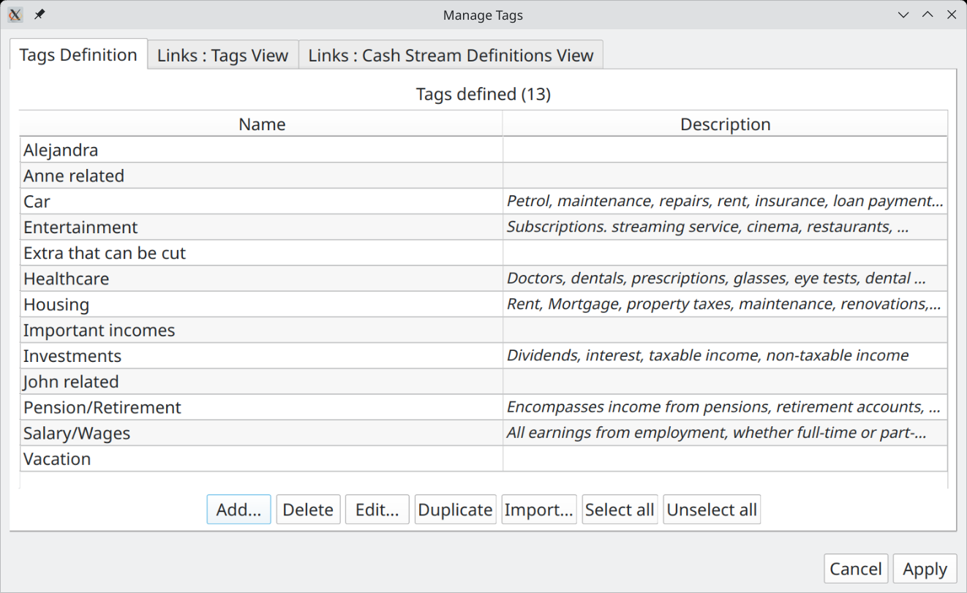
This is where tags are created/edited/deleted. When a tag is deleted, all its links to Cash Stream Definitions are also deleted. It is possible to import tags from another scenario : in that case, they are just copied and links are NOT transferred.

Links : Tags View

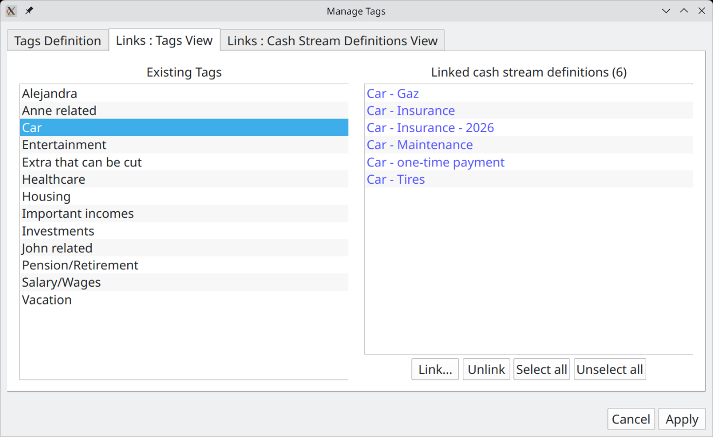
This is where we create links from tags to Cash Stream Definitions. This tab presents the view from the tags perspective. Once a single tag is selected (left panel), all the linked Cash Stream Definitions appear in the right panel.

It is possible to add more links, pressing the "Link…" button. The following dialog will appear :
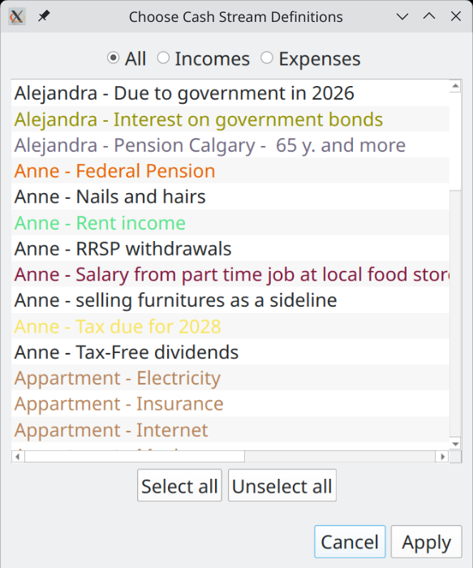
The idea is to select the additional Cash Stream Definitions to be linked to this tag. Select all that are required and press "Apply".

To delete links, select them in the right panel and press "Unlink".

Links : Cash Stream Definions View

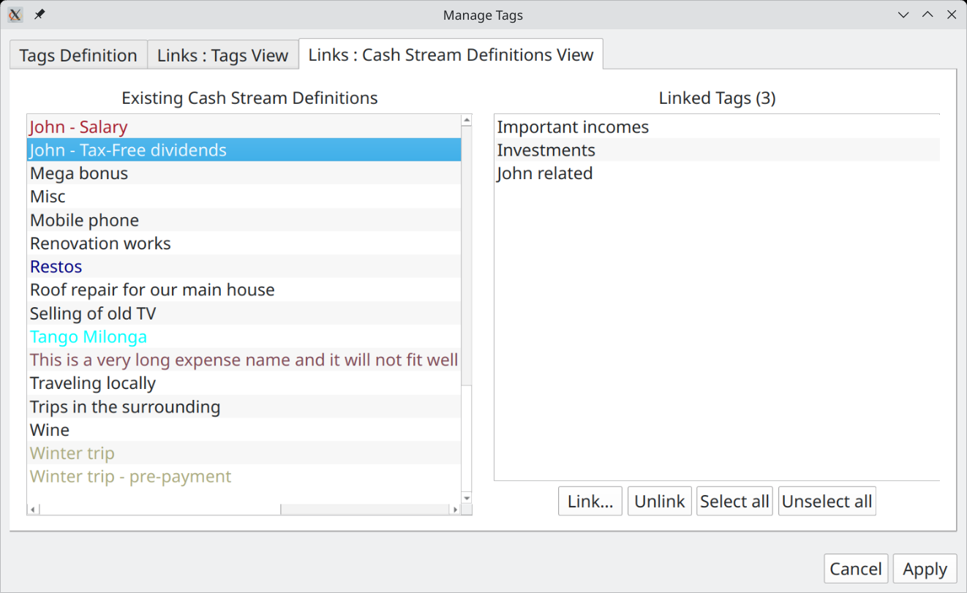

Applying the modifications
All changes made must be committed to see the current scenario modified and the chart updated. This is accomplish by pressing the "Apply Changes" button. Once pressed, the dialog will not be closed though : this is because in practice one may make many changes in exploring different options and opening-closing this window would be a burden. Pressing "Hide" discards any change made and close the window.

Note that there is no way to “undo” the changes made before "Apply changes" is pressed (there is no "Cancel" button). The only option is to reload the scenario (without saving it) from the menu.

*** Please not that "Apply" does NOT save the modifications on disk ! ***

Creating/Editing a Periodic Cash Stream Definition
First, note that while editing a scenario, selecting "Income" or "Expense" button will change the name of some Action buttons.
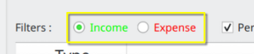
- Pressing "New Periodic Income…" (or "New Periodic Expense…" if Expense button is checked) will display a dialog to create a new Periodic Cash Stream Definition.
- Pressing "Edit..." while a Periodic Cash Stream Definition is selected will bring essentially the same window (names of the bottom buttons change though), but filled with the data of the selected Cash Stream Definition.

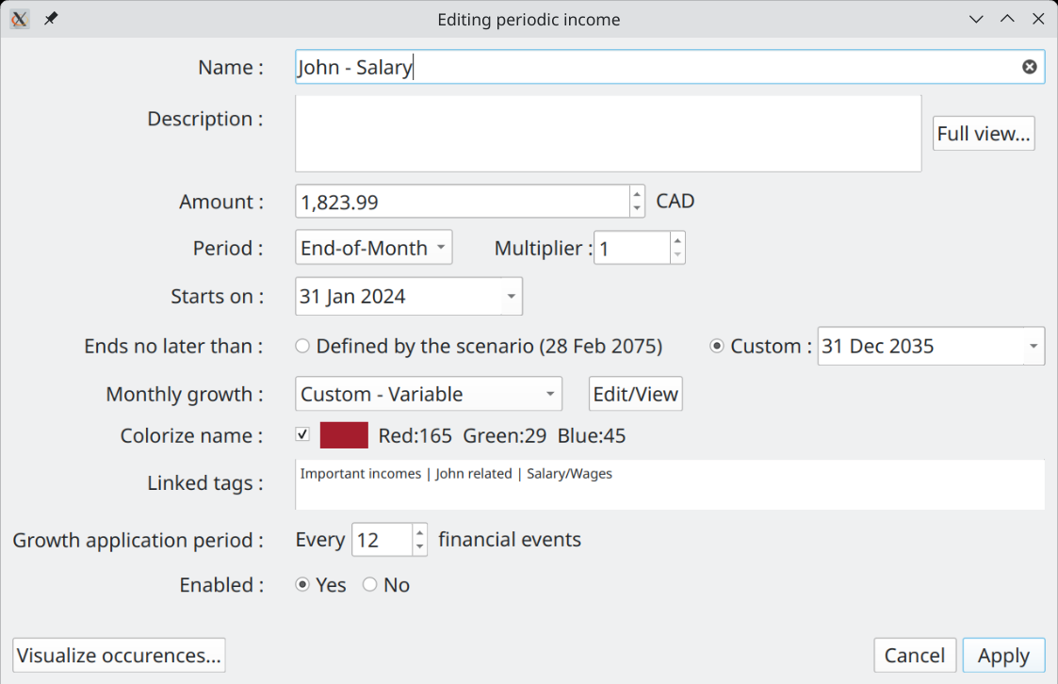

Name
Name of the Periodic Cash Stream Definition (e.g. "Salary"). 100 characters maximum. It can be an exact copy of another Cash Stream Definition’s name, but it is not a good practice.

Description
User notes for this particular Periodic Cash Stream Definition . 4000 characters maximum. Pressing the "Full View" allows for editing the content in a much bigger window.

Amount
The initial amount of money to be repeated periodically, before any inflation or growth is applied. If there is no growth pattern defined, this amount will stay constant. Note that if the advanced option "Convert to present value" is selected in Options Dialog, the amount will change even when no growth is defined.

Period and Period Multiplier
The interval of repetition for the amount is specified by first defining a period type, then a period multiplier.

Period Type
- Year
- Month
- End-of-month
- Week
- Day

A note on "End-of-month" : this force the events to occur at the very end of a month. Since the last day of the month changes with month, the actual date will vary.

Consider a Periodic Cash Stream Definition defined with a period of 1 end-of-month, with validity range of [29 Feb 2000 – 5 mar 2001]. The financial events generated will be (note in particular the date "2001-02-28") :

2000-02-29 : 1,000.00
2000-03-31 : 1,000.00
2000-04-30 : 1,000.00
2000-05-31 : 1,000.00
2000-06-30 : 1,000.00
2000-07-31 : 1,000.00
2000-08-31 : 1,000.00
2000-09-30 : 1,000.00
2000-10-31 : 1,000.00
2000-11-30 : 1,000.00
2000-12-31 : 1,000.00
2001-01-31 : 1,000.00
2001-02-28 : 1,000.00

Period Multiplier
This is an integer that is used as a multiplication factor of the period type selected (e.g. 3 years or 12 weeks).

Start Date
The first financial event of a Periodic Cash Stream Definition can only occur at the date specified by the Start Date field. The only exception to this is when the Period Type "End-of-month" is selected. In that case, it will occur at the NEXT end-of-month from this date.

End Date
Specify when the flow of financial events will end : no financial event will be generated past this date. Note that it is possible that the last financial event occur before this date.

There are 2 options offered to the user :

- Specify explicitly the End Date : this is the "Custom" option. The data limit specified in the scenario metadata still hold however.
- Use the date limit defined at the Scenario Level (see "Duration of calculation" for the scenario metadata).

"Start Date" must not occur after "End Date" date.

Monthly Growth
The amount defined can actually change with time, by following a specified growth pattern. This group of fields define the nature of the growth pattern.

There are 4 options :

- "No growth" : The initial amount stays constant for the whole validity range
- "Follow inflation" : Growth is exactly identical to the inflation pattern defined in the scenario (whether "constant" or "variable), multiplied by the value of the multiplier field. For example, if the scenario defined 4% constant inflation and the multiplier value is 1.5, then the actual growth applied to this Cash Stream Definition will be 6% constant.
- "Custom – constant" : Specify a constant growth
- "Custom - Variable" : Specify a variable growth pattern. See "Scenario Inflation" above to have more information about how to specify a variable growth. Here, inflation is exactly like growth.

Colorize Name
To make it easier to distinguish one Cash Stream Definition from another in the user interface, it is possible (meaning optional) to associate a color to the name. There are 2 possibilities :

1) If the checkbox is unchecked (default for newly created item), it means no custom color is associated to this name and system default color will be used.


2) If the checkbox is checked, with a colored square and RGB value to its right, then this color is associated with the name

To select a color, click the colored square : a color selection dialog will appear.

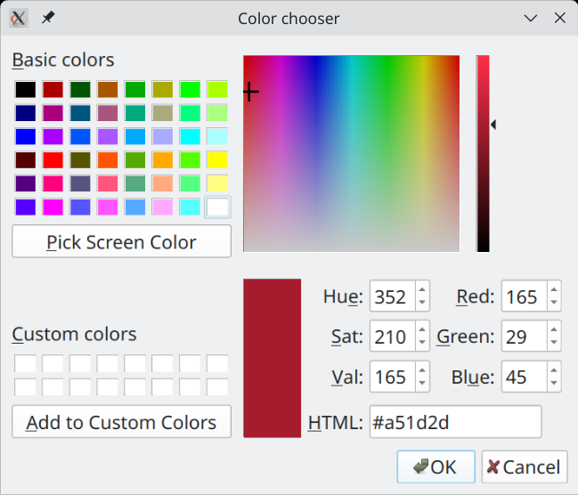
Select a color and press OK to have the color associated with the name. To apply the same color to many Cash Stream Definitions, you can copy the content of the "HTML" field and paste it as many time as required.

Linked Tags
List all the tags that are linked to this Cash Stream Definition. Each of them are separated by the " | " characters. Note that this is a read-only list : to change it, go to the "Manage Tags" Dialog.

Growth Application Period
Lets first remember that GBP applies growth or inflation on a monthly basis, on the 1st.

This field determines how often the "cumulative" monthly growth is applied to the flow of financial event occurrences. By default, it is 1, meaning that every occurrence of the amount will be adjusted with the growth pattern defined.

Sometimes however, it may be required to restrict the application of the specified growth only every "n" occurrences. A good example is a rent. The amount stays constant for the duration of the rent (12 occurrences), but needs to be augmented when the rent is renewed (once every 12 occurrences), by the growth accumulated over 1 year.

Example

Lets say you have an annual rent, with 1000$ paid monthly. The renewal is on July 1st of every year. Lets also say that you want to specify a growth of 5% annually for this amount. Then the Periodic Cash Stream Definition to create would be something like this :
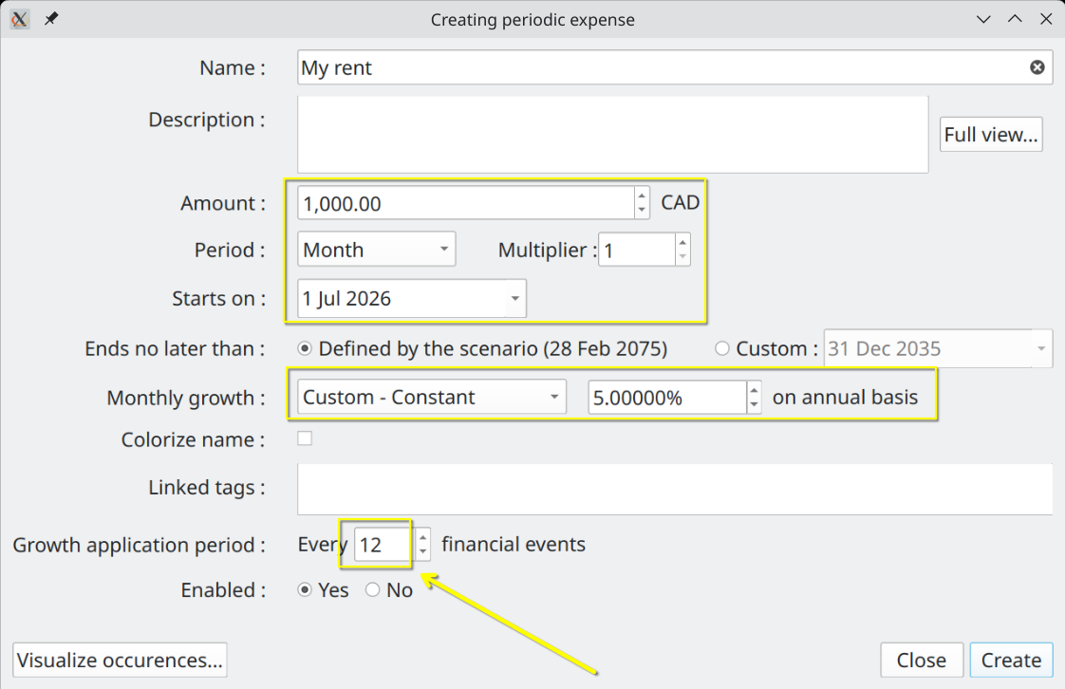
The value of Growth Application Period must be 12, in order to have 12 months of constant rent price. This would give the following financial events :

2026-07-01 : 1,000.00 CAD (cummul=1,000.00 CAD)
2026-08-01 : 1,000.00 CAD (cummul=2,000.00 CAD)
...
2027-06-01 : 1,000.00 CAD (cummul=12,000.00 CAD)
2027-07-01 : 1,050.00 CAD (cummul=13,050.00 CAD)
2027-08-01 : 1,050.00 CAD (cummul=14,100.00 CAD)
...
2028-06-01 : 1,050.00 CAD (cummul=24,600.00 CAD)
2028-07-01 : 1,102.50 CAD (cummul=25,702.50 CAD)

As expected, the monthly amount paid for the rent stays the same until 2027-07-01, when it is increased by 5%. If Growth Application Period would have stayed at the default value of 1, we would have obtained :

2026-07-01 : 1,000.00 CAD (cummul=1,000.00 CAD)
2026-08-01 : 1,004.07 CAD (cummul=2,004.07 CAD)
2026-09-01 : 1,008.16 CAD (cummul=3,012.23 CAD)
2026-10-01 : 1,012.27 CAD (cummul=4,024.50 CAD)
2026-11-01 : 1,016.40 CAD (cummul=5,040.90 CAD)
2026-12-01 : 1,020.54 CAD (cummul=6,061.44 CAD)
2027-01-01 : 1,024.70 CAD (cummul=7,086.14 CAD)
2027-02-01 : 1,028.87 CAD (cummul=8,115.01 CAD)
2027-03-01 : 1,033.06 CAD (cummul=9,148.07 CAD)
2027-04-01 : 1,037.27 CAD (cummul=10,185.34 CAD)
2027-05-01 : 1,041.50 CAD (cummul=11,226.84 CAD)
2027-06-01 : 1,045.74 CAD (cummul=12,272.58 CAD)
2027-07-01 : 1,050.00 CAD (cummul=13,322.58 CAD)
2027-08-01 : 1,054.28 CAD (cummul=14,376.86 CAD)
2027-09-01 : 1,058.57 CAD (cummul=15,435.43 CAD)
2027-10-01 : 1,062.89 CAD (cummul=16,498.32 CAD)
2027-11-01 : 1,067.22 CAD (cummul=17,565.54 CAD)
2027-12-01 : 1,071.56 CAD (cummul=18,637.10 CAD)
2028-01-01 : 1,075.93 CAD (cummul=19,713.03 CAD)
2028-02-01 : 1,080.31 CAD (cummul=20,793.34 CAD)
2028-03-01 : 1,084.71 CAD (cummul=21,878.05 CAD)
2028-04-01 : 1,089.13 CAD (cummul=22,967.18 CAD)
2028-05-01 : 1,093.57 CAD (cummul=24,060.75 CAD)
2028-06-01 : 1,098.03 CAD (cummul=25,158.78 CAD)
2028-07-01 : 1,102.50 CAD (cummul=26,261.28 CAD)

Enabled
If "Yes" is selected (default), the Periodic Cash Stream Definition will be taken into account in all the calculation and chart displays. If set to "No", it wont be taken into account anywhere.

Visualize Occurrences
This button offers a nice feature that uses all the values of the fields above and display all the resulting occurrences for the defined validity range. This also takes into account the option to "Convert to Present values" all amounts, as defined in the Options Dialog. Curve can be zoomed in/out with the mouse wheel. "Fit" button restore the scaling back to the maximum possible.

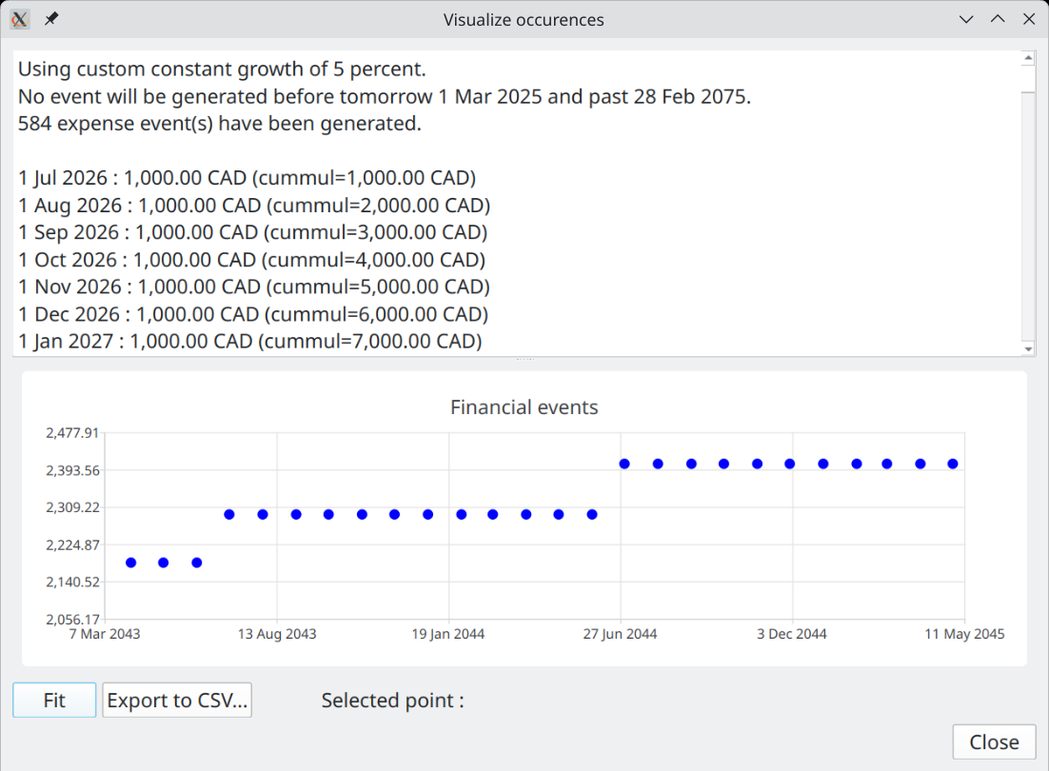

Creating/Editing an Irregular Cash Stream Definition
First, note that while editing a scenario, selecting "Income" or "Expense" button will change the name of some Action buttons.
- Pressing "New Irregular income…" (or "New Irregular expense…" if Expense button is checked) will display a dialog to create a new Irregular Cash Stream Definition.
- Pressing "Edit..." while a Irregular Cash Stream Definition is selected will bring essentially the same window (names of the bottom buttons change though).

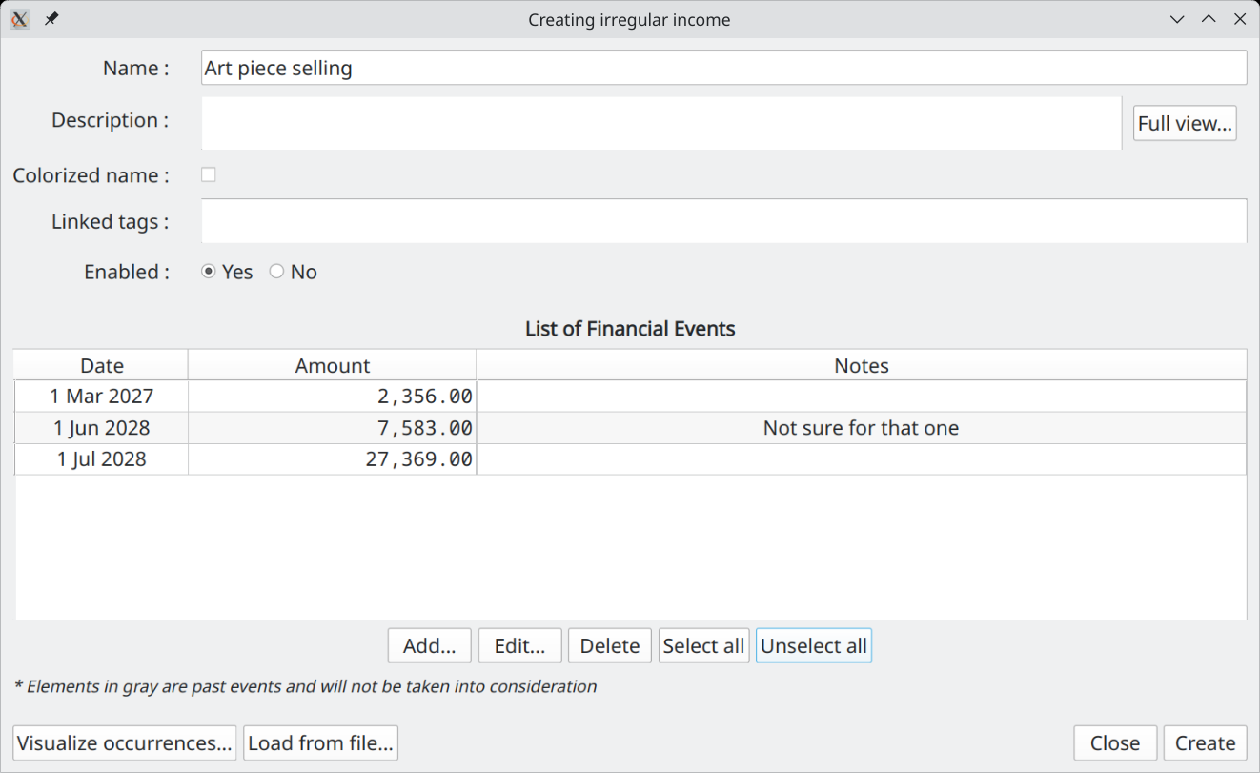

Name
Same as Periodic Cash Stream Definition

Description
Same as Periodic Cash Stream Definition

Colorize Name
Same as Periodic Cash Stream Definition

Linked Tags
Same as Periodic Cash Stream Definition

Enabled
Same as Periodic Cash Stream Definition

List of Financial Events
List of all the financial events to be generated by this Irregular Cash Stream Definition. Note that the amounts defined here are always "future values".

Actions Buttons
"Add" :

Create a new financial event (occurrence) for the Irregular Cash Stream Definition. The date must not be already used by an existing financial event defined in this Irregular Cash Stream Definition
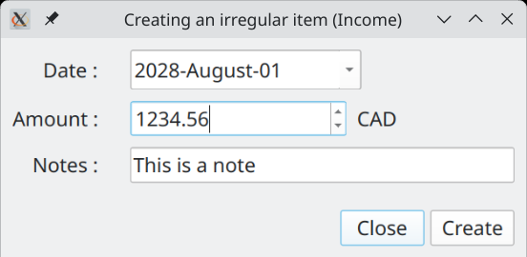
"Edit" :
Same as "Add", but if there is already another financial event that is using this date, the new amount replace the old one.

"Delete" :
The selected financial events are removed from this Irregular Cash Stream Definition

Visualize Occurrences
Show the actual financial events that will be generated (same as for Periodic Cash Stream Definition Edition). Normally, they will be the same as the ones defined in the table. However, if option to "Convert to Present values" in Options Dialog is activated, the amounts will be different, since each one will be converted to their present value.

Load From File
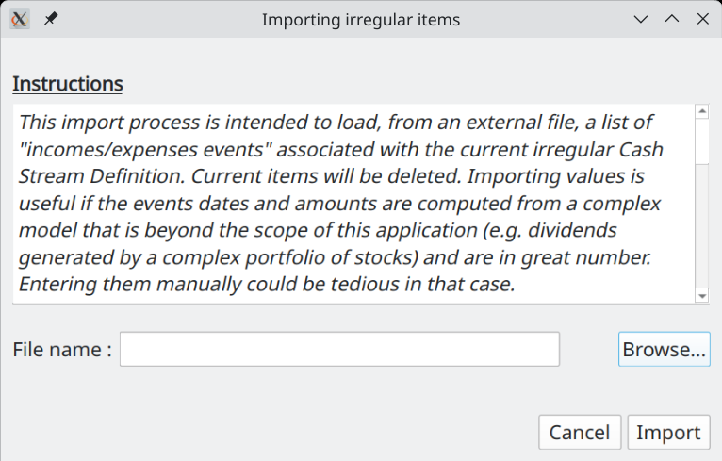
Import a list of financial events defined in a CSV text file. All financial events currently defined are removed and replaced by the new imported ones. Import is very useful if the financial events are computed from a complex model that is beyond the scope of this application (e.g. dividends generated by a complex portfolio of stocks) and are in great number. Entering them manually could be a tedious task.

The file to be imported must be a UNICODE-ENCODED text file. UTF-8 , UTF-16 and UTF-32 encodings are supported. Each line contains exactly 1 irregular financial event. Empty lines are not allowed. Format of each line is :

<date>TAB<amount>TAB<notes>CR

where :
<date> :
date of the event. Must be in ISO 8601 format (YYYY-MM-DD). E.g. 2025-12-31
TAB :
is the TAB character (0x09)
<amount> :
a double number, without thousand separator. Decimal separator must be ".". Not smaller than 0 and not greater than :
999,999,999,999,999 for currencies with 0 decimals (e.g. Yen)
99,999,999,999,999.9 for currencies with 1 decimal
9,999,999,999,999.99 for currencies with 2 decimals
999,999,999,999.999 for currencies with 3 decimals
<notes> :
a brief description of this item. Max 100 characters. Note that this field is OPTIONAL.
CR :
carriage return character (\n )

All imported items will be tagged as "enabled", meaning they will be considered for the Cash Balance curve.

Options Window
Accessed through the "Tools→Options…" menu, this dialog allows you to see and modify the miscellaneous configuration parameters of GBP .

The configuration of GBP is written in an INI-style configuration file named "graphical-budget-planner.ini". On Linux, it is located in the ~/.config directory. Exact name and location can be seen in the Help → About Graphical Budget Planner.

When GBP starts, it tries to find this configuration file. If found, it loads its content, otherwise it assigns default values to the configuration parameters.

When button "Save" is pressed in the Options dialog, all changes are saved into this INI file. When "Cancel" is pressed, any changes made since the last appearance of the dialog is discarded.

When "Save" is pressed, most changes take effect immediately, unless stated otherwise by GBP with a special warning window. For example, changing the GBP font shows the following message after "Save" is pressed :

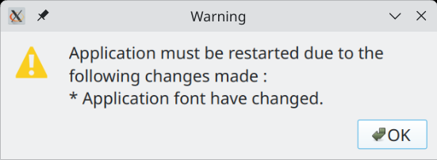

Category "General"
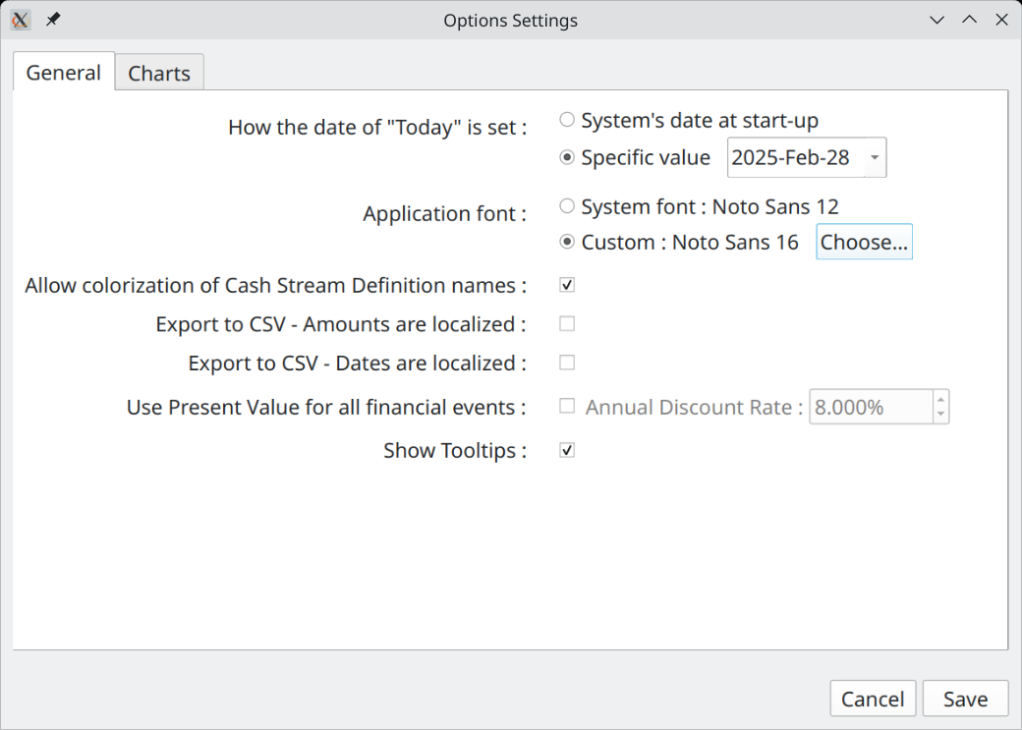

How date of "today" is obtained
GBP is built to generate financial events starting from the date of "tomorrow", which is "today" + 1 day. By default, "today" is set to the system’s date as read by GBP when it starts. This is the expected behavior, because one are interested only to future events. Every time GBP is started, user updates the field "Start Amount as of Today", which provide the current total amount of cash available as of "today". This amount is determined by the user only (typically by logging into his bank account and looking at the current balance) and not by GBP. The section "Usage" describes how GBP is expected to be used and provide more details.

This being said, there are some use cases where it is beneficial to always have "today" set to a specific and constant value. One such case is testing, where repeatability of initial conditions is required. Another case is when user decides to "freeze" the view in time at a specific moment (e.g. the end of month), because it fits better his own way to update scenario data.

For those cases, it is possible to "freeze" the value of "today" to a specific date. Every time GBP will starts, it will use this value and discard the true current date obtained from the system. The value of "Today" is displayed at the bottom of the Main Window.

Application Font
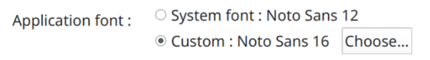
By default, GBP uses the default system font to display characters. If user prefers a different font style and/or font size, without changing the system configuration, it may set GBP application font by selecting first the "Custom" radio button and then press the "Choose" button. He will then be able to select the required font. GBP must be restarted for the change to take effect.

To return to default font, just select the "System Font" radio button.

If ever the user selects a font that make the text unreadable, GBP can be started in a terminal window with the argument "-usesystemfont". This will reset the font to system font.

Allow colorization of Cash Stream Definition Names
Enable or disable the colorization of names for all Cash Stream Definitions. This can be useful if a scenario is used on an OS where custom theming makes difficult the reading of colorized name. "Disable" means that default Operating System text color will be used.

Export text – Amounts are localized
When checked, any amount used in any CSV export process will be written using the conventions of the system’s Locale. For example, on a French system, the amount 12345.67 would be written :

12 345,67

When unchecked, no "thousands separator" is used and the "decimal separator" is ".".

Export Text – Dates are localized
When checked, any full date (meaning including year, month, day) used in any CSV export process will be written using the conventions of the system’s Locale. For example, on a German system, the date 01 feb 2026 would be written :

01.02.26

When unchecked, ISO format "YYYY-MM-DD" will be used.

Use Present Value
This is an advanced topic.

When checked, this option will convert all the financial event amounts of the calculated scenario data set from future values (default) to present values, using the annual discount rate selected to the right.

This applies for the Cash Balance curve in the Main Window, as well as all the data displayed in the Analysis Window. The formula used for the conversion is :

FV = PV / (pow((1 + 0.01*discountRatePercent), period))

where :

- FV : Future Value
- PV : Present Value
- pow : power function
- discountratePercent : monthly discount rate in percent, derived from the annual rate specified
- period : no of months away from "present". 0 means in the same month than present

Note that the calculation is a monthly basis : it means that the present value is the same for any day of the month for which a financial event occurs.

The section "Future Values vs Present Values" describes in more details why one would want to use Present instead of Future Values, but basically, PV gives a better view of the equivalent current values of future incomes/expenses.

Category "Charts"
These settings are specific to curves and charts.
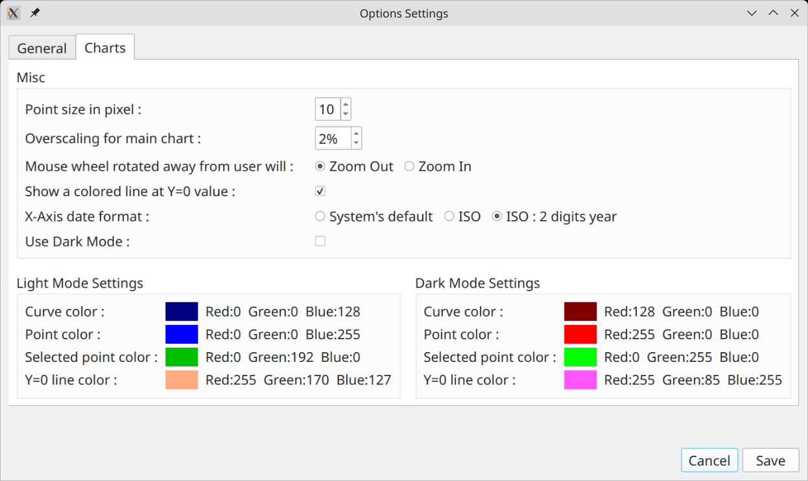

Point Size in Pixels
This parameter set the diameter of the disc superimposed on data points.
For example, here is the difference between 5 and 25 pixel wide point size : 10 point size is probably the most preferred option.

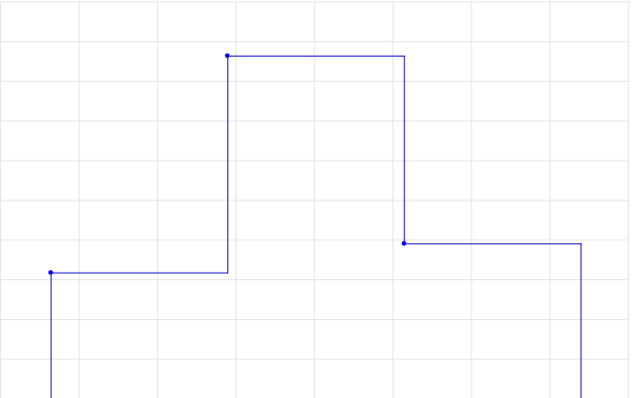
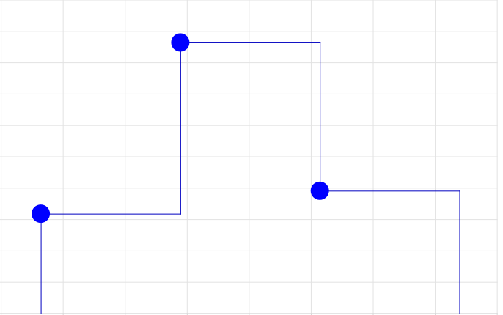
Overscaling for Main Chart
This applies only for the Cash Balance curve displayed in the Main Window, and the one displayed in the View Occurrence Dialog. It sets the level of "overscaling" to be applied on the charts X and Y axis. 0% means no overscaling,

By default, there is no overscaling applied. That means that the X and Y axis minimum and maximum match exactly the min/max values of the data points shown. This may lead to a problem clicking on such points, because the representation disk is clipped :

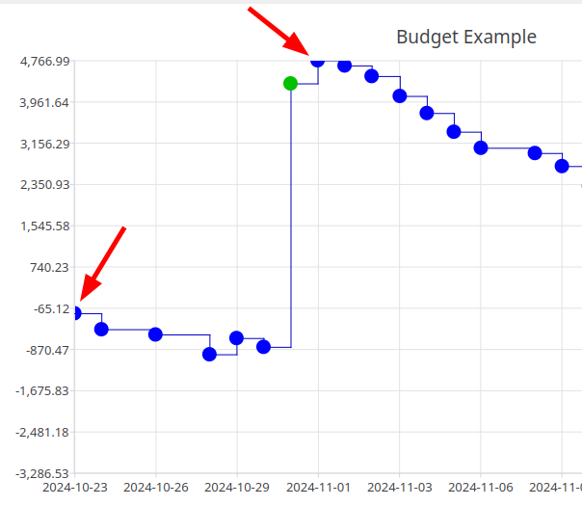
To alleviate this problem, GBP can "overscale" the X and Y axis, so that the min/max points are fully contained in the chart. For example, a 5% overscaling would produce the following result with the previous data shown :
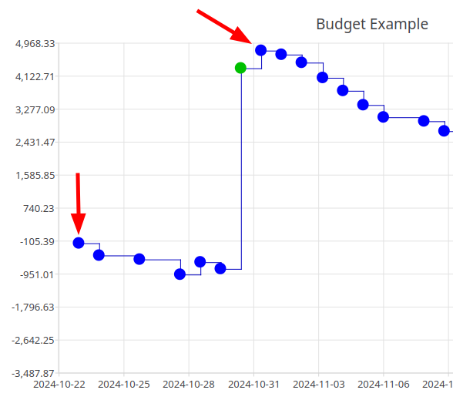
The inconvenient of overscaling is that, when one specifies a range with the upper toolbar buttons, the displayed chart is actually wider. For example, using the "Custom" range button to set an interval of [1 jan 2025 – 31 dec 2025], which is exactly 1 year, we get the following result for a 5% overscaling :

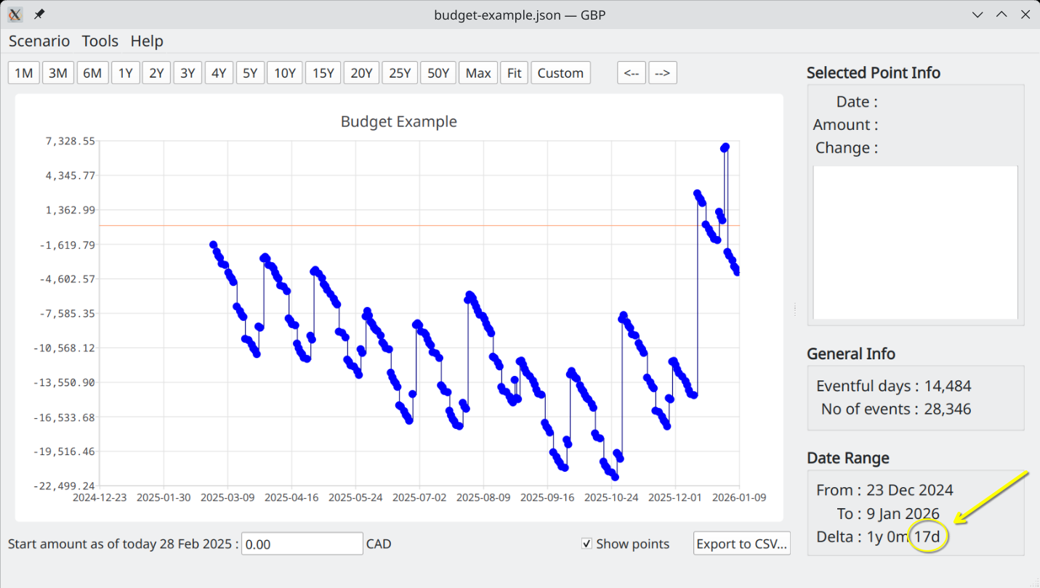
Note the "17 more days" over the 1 year requested. 17 days is roughly 5% of 1 year.

Show a Colored Line at Y=0
If checked, a colored line is superimposed on the Cash Balance curve at Y=0. This is helpful to see where one get in the "red" or the "green". Color is defined in the section below.

X-Axis Date Format
The dates on the X-Axis can have one of 3 formats.

System’s default :
GBP use the default system configuration (a.k.a the defautl Locale) to determine the date format. For example, on Fedora KDE 41, this is set by this dialog :
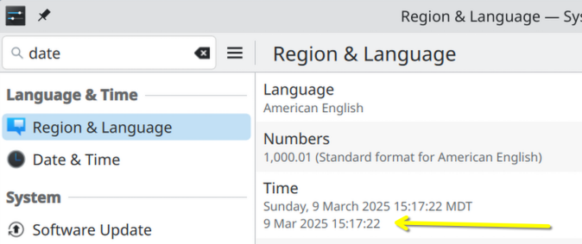
ISO :
Set the date format to ISO 8601, that is YYY-MM-DD

ISO 2-digit year :
Same as ISO, but drop the first 2 digit of the year. This allows for bigger font to be used without screwing the X-Axis rendering.

Using Dark or Light Mode
When not using the KDE Desktop Environment, GBP cannot detect which theming mode is in used. In particular, with GNOME, GBP’s widgets colors may not correspond to the theming colors selected (they always appears "light"). This is due to some incompatibilities between Qt and Gtk.

So to help alleviate the inconvenient this produce, the Options Dialog offers a way to change explicitly how the charts look. When "Use Dark Mode" is checked, "Dark Mode" is used for all the charts (black background with bright foreground text) in GBP. Otherwise, "Light Mode" is used.

The following are screenshots from Linux Mint 22 (GTK-based Desktop Environment) with Dark Theme enabled in Mint :

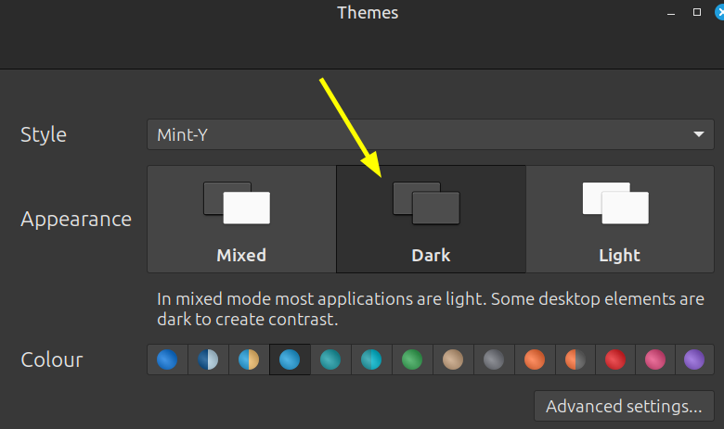

and "Use Dark Mode" selected in GBP.
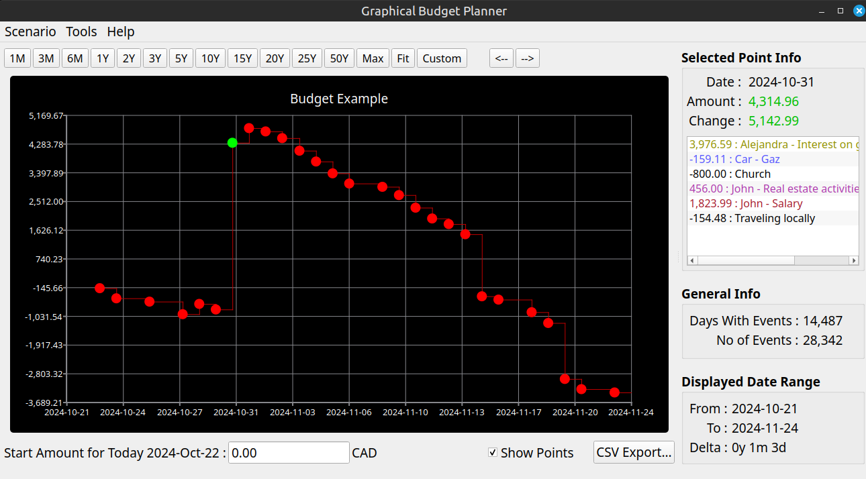

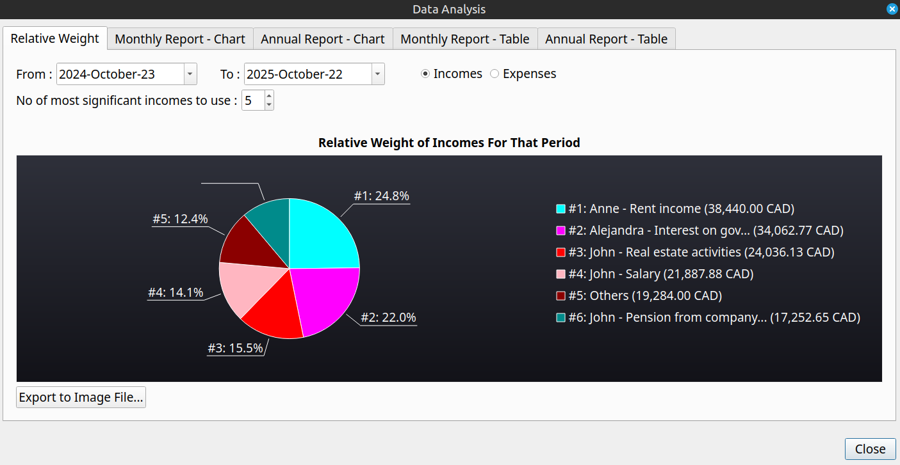
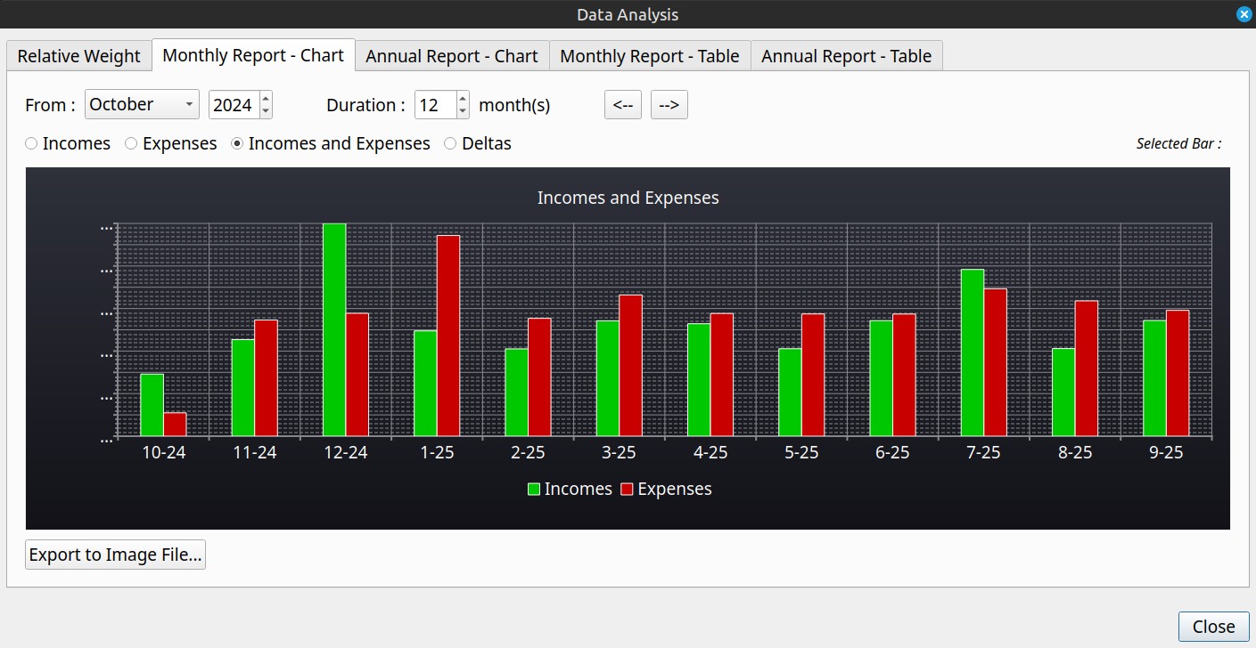
For sake of comparison, here is the same on Fedora 40 KDE with "Breeze Dark Theme" enabled. Clearly, GBP is themed 100% correctly in a KDE environment, which is not surprising knowing that GBP is a Qt 6.8 application.

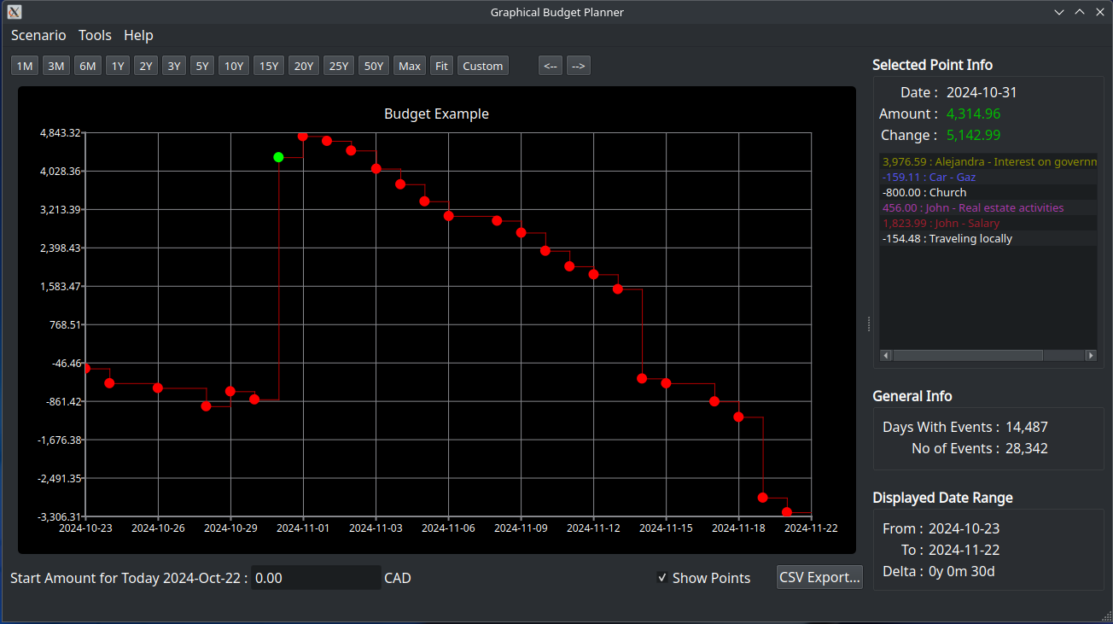
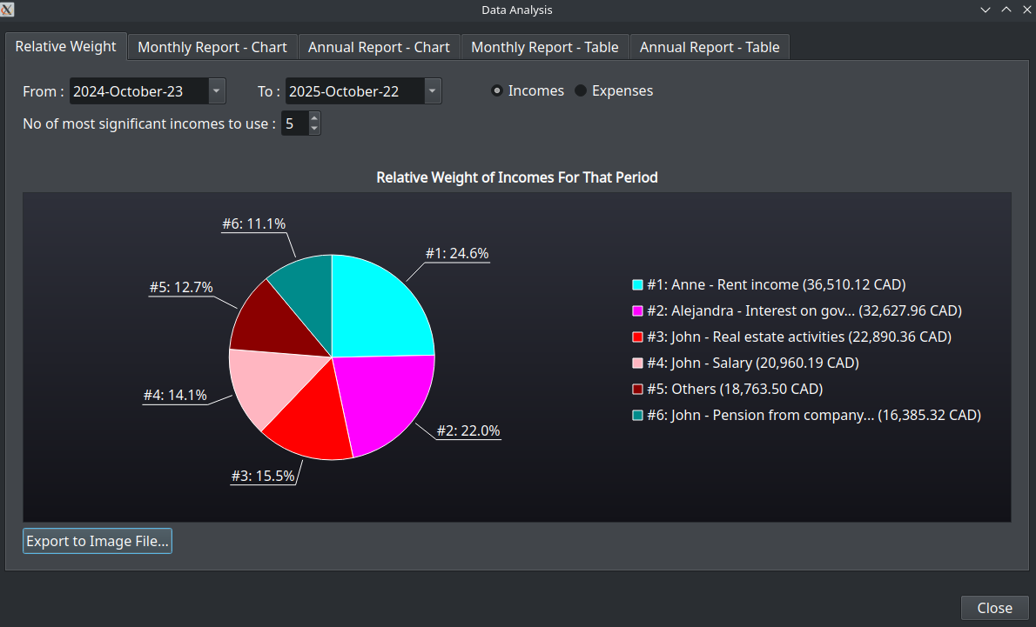
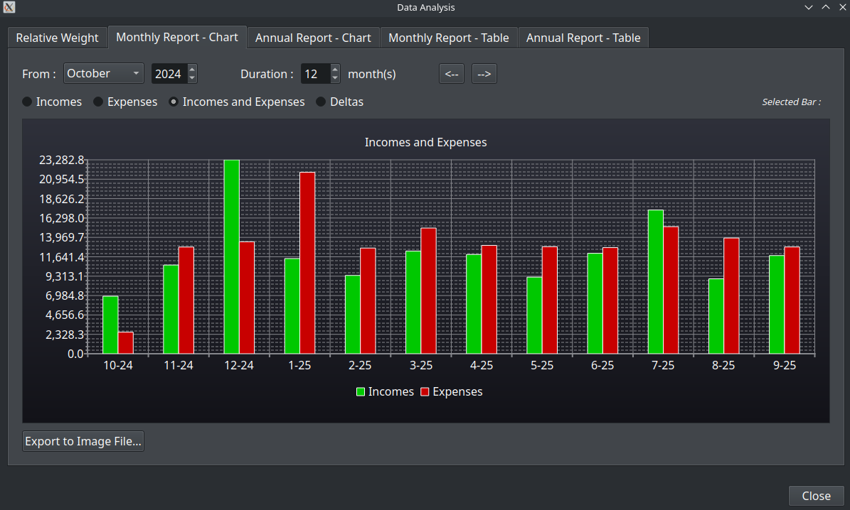
On Mint 22, when "Use Dark Mode" is unchecked in GBP, Light Mode theming is used for the charts. That means white background on dark colored text.

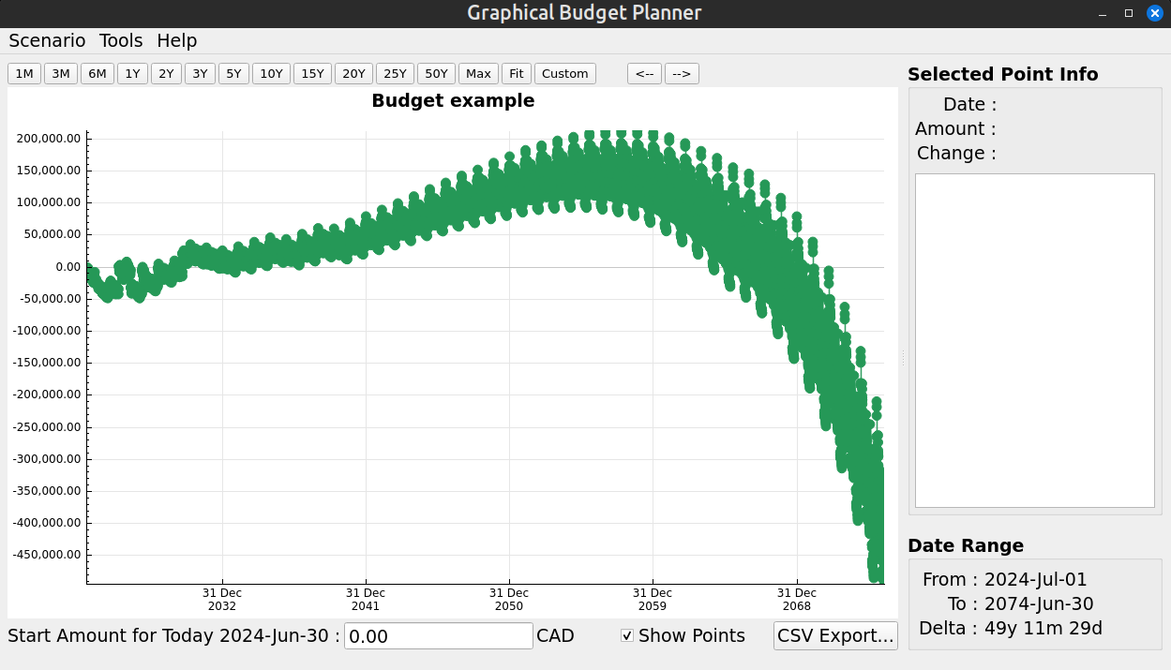
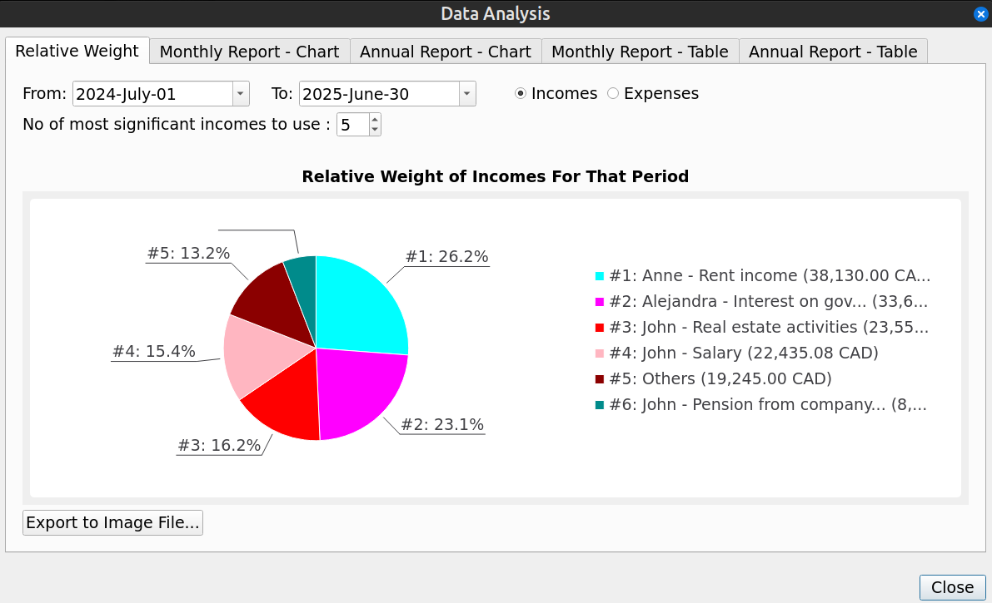
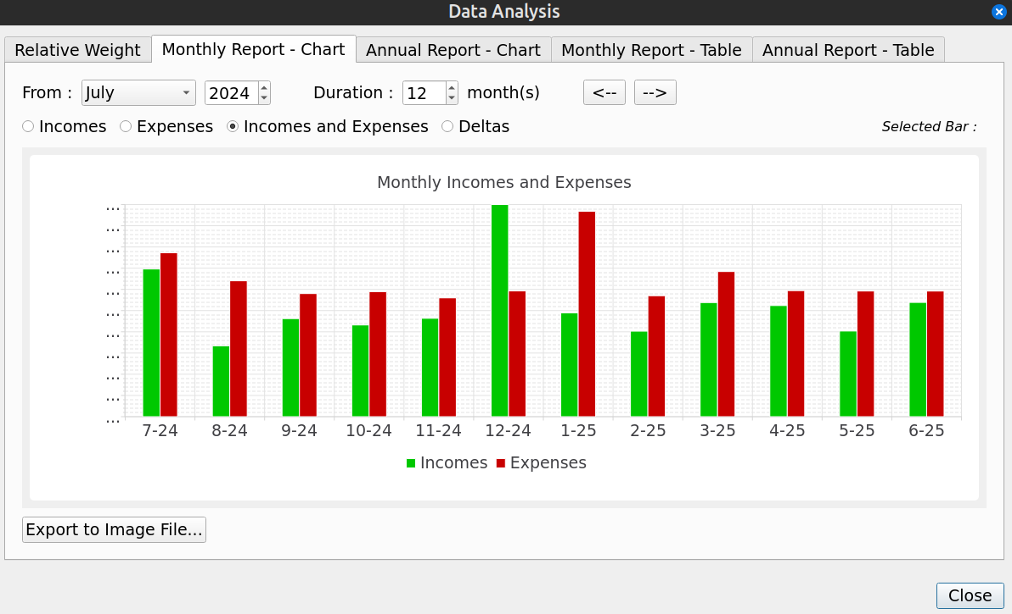

Dark/Light Mode Color Settings
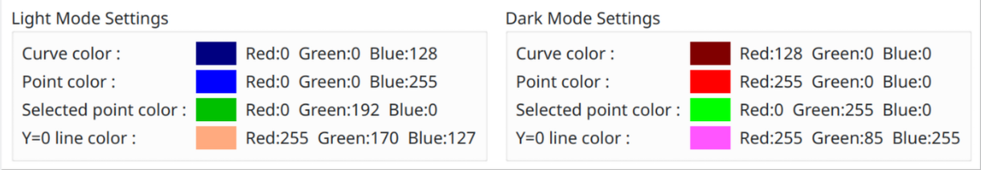
The left panel set the colors of misc items while in Light mode, the right side is for the Dark mode. Color can be set by clicking in the colored square.

- Curve Color : this set the color of the Cash Balance curve itself.
- Point Color : this set the color of the data points in the Cash Balance curve
- Selected Point Color : this set the color of the selected data point in the Cash Balance curve
- Y=0 Line Color : this set the color of the Y=0 line superimposed on the Cash Balance chart in the main window.

Analysis Window
This window provides more in depth statistical analysis of the resulting financial events stream displayed by the Cash Balance curve in the Main Window.

Relative Weight Tab
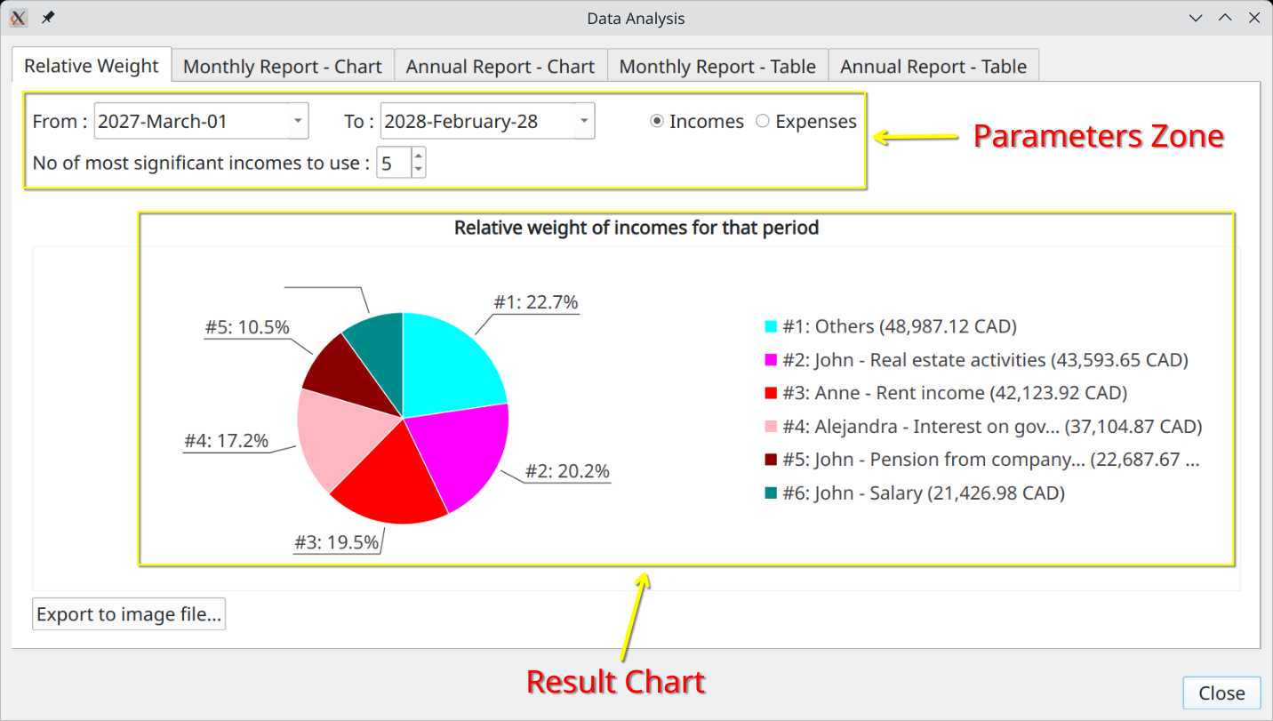
A very important analysis module that provides quite useful information on the current scenario. Its goal is to show on a pie chart the comparative weight of either incomes or expenses, spread over a user-specified time interval.

For example, it will tell you what are the biggest expenses expected during the next 2 years or what is the percentage of the 10 most important incomes compared to all the expected incomes for the next 10 years.

Parameters Zone
This is where you can change parameters that affect the calculation of the Pie Chart below

From
Specify the start of the date interval to consider in the calculation. Financial Events occurring before this date will not be taken into account.

To
Specify the end of the date interval to consider in the calculation. Financial Events occurring after this date will not be taken into account. Must not be smaller than "To" date.

Incomes / Expenses Radio buttons
Specify if we want to consider incomes or expenses (cannot do both at the same time)

No of most significant incomes/expenses
Specify how many slices the pie chart will have. If this number is greater or equal to the total number of incomes (or expenses), then it is the latter that is used. Otherwise, there will be 1 more slice than this number, dedicated to all the "other" incomes (or expenses) taken all together (named "Others" on the chart).

Result Chart
The area where the chart is displayed, along with the legend mapping the pie color to the actual incomes (or expenses). Colors of the slices are pre-configured and cannot be changed by the user.

Exporting to Image File
Pressing this button allows the chart to be saved in an image file. A dialog will be shown required a file name and a destination directory. The image file created will always be a PNG file with lossless compression.

Monthly Report - Chart
This chart is a monthly report, displayed as a Bar Chart.
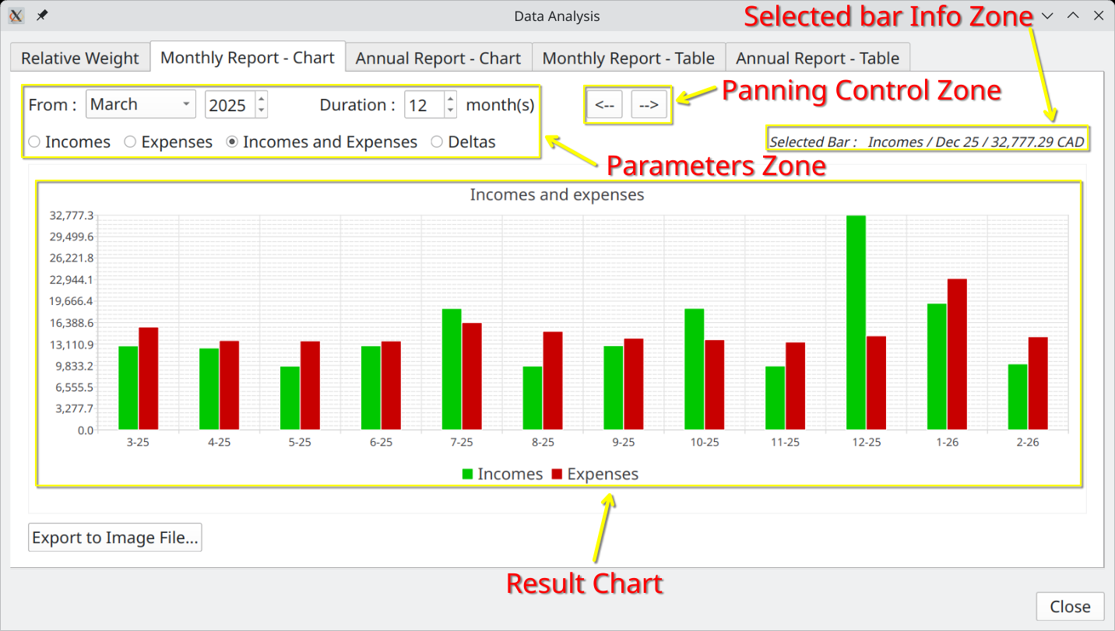

Parameters Zone
This is where you can change parameters that affect the calculation of the Bar Chart below

From
Specify the start of the time interval to consider in the calculation, that is the first month considered. Financial Events occurring before this date will not be taken into account.

Duration
Set how many months to display in the bar chart, including the month specified by "From".

Incomes / Expenses / Deltas
Specify what information will be displayed in the Bar Chart.
  - Incomes : Only Financial Events that are incomes will be used in the calculation of the Bar Chart
  - Expense : Only Financial Events that are expenses will be used in the calculation of the Bar Chart
  - Incomes and Expenses : All Financial Events (incomes and expenses) will be used in the calculation of the Bar Chart
  - Deltas : All Financial Events are used, but the Bar Chart will display the results of Incomes – Expenses.

The Deltas option is particularly useful to watch the evolution of "monthly surplus" over the years : bars in green show surplus, bars in red show deficit

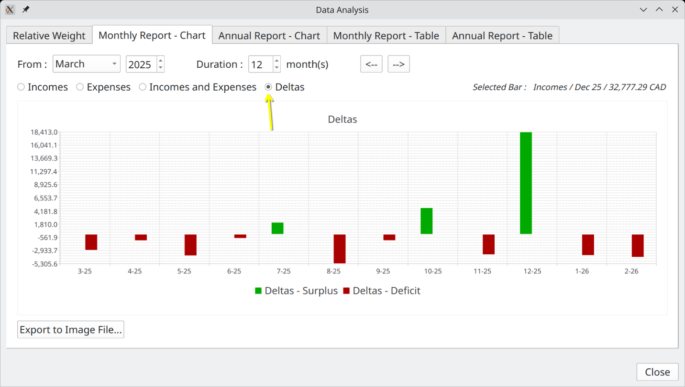

Result Chart
This is where the Bar Chart is displayed. User can click on a specific bar to see more related information in the "Selected Bar Info Zone".

The "Export to Image File" button allows for exporting the displayed Bar Chart as an image file. See section Relative Weight Tab.

Panning Controls Zone
The 2 buttons shift the Bar Chart to the left or right, by an amount of months equal to the "Duration". It is as a matter of facts a way to scroll the Bar Chart.

Annual Report – Chart
Exactly like the "Monthly Report – Chart", except that the data is aggregated by year instead month.

Monthly Report – Table
For all the Financial Events generated for the scenario, produces a table holding, for each month, the following information :
- the month
- Total incomes for the month
- Total expenses for the month
- Delta – The differences between those two. Positive values (monthly surplus) are green, negative (monthly deficit) are red

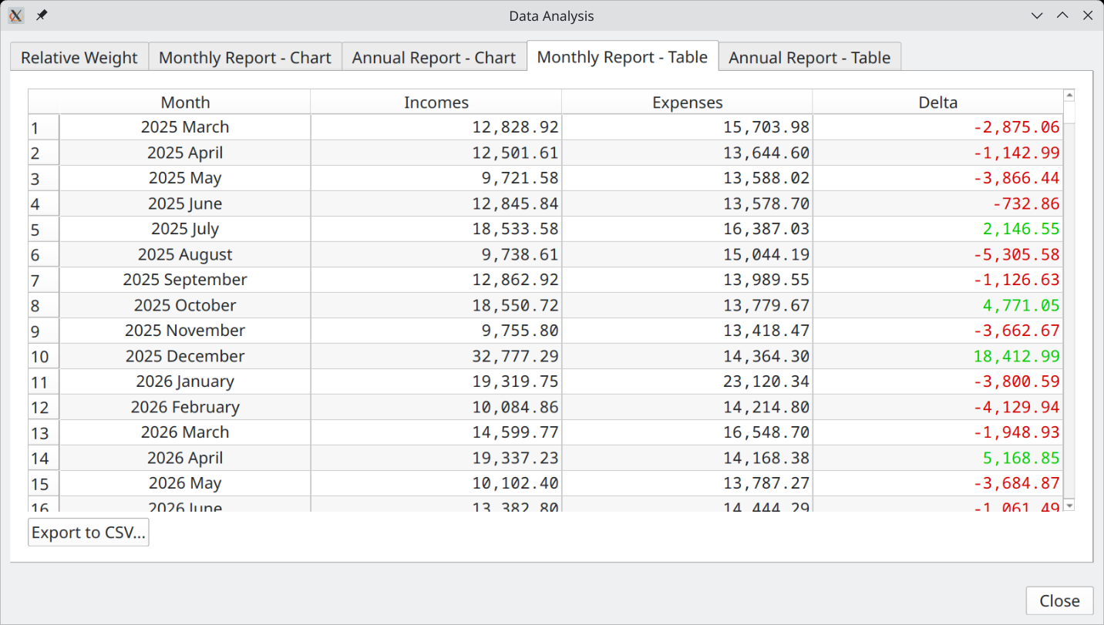

Export To CSV
See CSV Export

Annual Report - Table
Exactly like the "Monthly Report – Table", except that the data is aggregated by year instead month.

Usage

Preparing to create a budget

Collecting Information
A budget in GBP is called a "scenario". The name comes from the fact that you can create as many budgets as you want with the application, each one being a specific "scenario" covering a given set of options or possibilities.

Before creating a new budget, you must remember that GBP will focus only on the future incomes and expenses to come. The past is irrelevant for GBP and essentially discarded.

First, make a list of all sources of incomes and expenses you think will happen from tomorrow to several years in the future (the time frame depends on your needs). Each one will be implemented in GBP as a Cash Stream Definition. For each of them, determine :
- if it is a recurring amount, that is, it repeats itself at identical time intervals of either days, weeks, months, end-of-month or years : if so, it is probably a Cash Stream Definition of type "Periodic". Otherwise, the type is "Irregular"
- for Periodic Cash Stream Definition, what is the first day it occurs and when will it ends ?
- for Periodic Cash Stream Definition, is the amount constant through time or is it changing ? In the latter case, if the change if not governed by one of the 2 rules below, then it is most probably better to use an "Irregular" type
  - constant growth : a simple constant growth percentage, per year or per month
  - variable growth : a complex growth pattern that identifies exactly all the growth transitions that occur in time, using a list of (date, growth value in percentage)

Then try to determine the level of inflation you want applied to the scenario. As a reminder, inflation is defined at the scenario level. A simple case to define the value of inflation is to set it constant through the years (can be 0% or even negative if you want). For a more complex situation (this is more advanced stuff), you can model inflation that varies through the months and years. See the example below

Modeling Inflation that Varies Through the Months and Years
*** Advanced Topic ***

Lets say that we want to model inflation more precisely than the "constant" value option offered. Lets say we want this :
- From 1 Feb 2025 : 5% on an annual basis
- From 1 nov 2025 : 4% on an annual basis
- From 1 Jan 2027 : 2% on an annual basis

For that, we need to define a "variable inflation" pattern for the scenario.

The list of transition dates and values will be entered as follows :

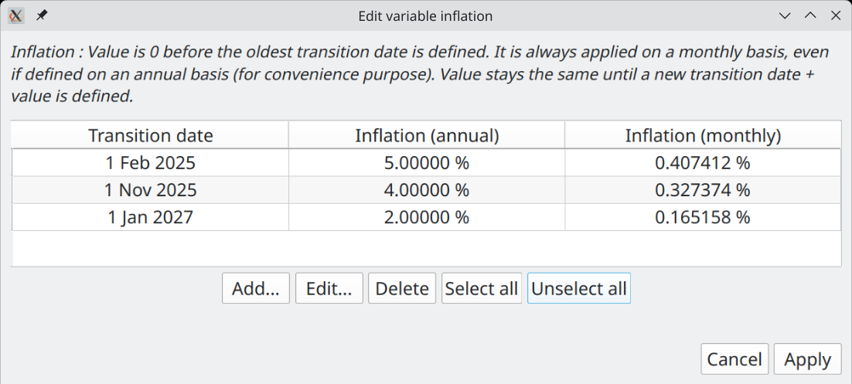
With that definition, the inflation used in the scenario would be as follow :
- From past to Jan 1 2025 : 0% applied on the 1st of every month
- From Feb 1 2025 to Oct 1 2025 : 0.407412% applied on the 1st of every month
- From Nov 1 2025 to Dec 1 2026 : 0.327374% applied on the 1st of every month
- From Jan 1 2027 to infinity : 0.165158% applied on the 1st of every month

Practical Examples of Periodic Cash Stream Definition

Salary Received Every 2 Weeks, No Growth
Period is "week", Period Multiplier is 2. Start Date in the Validity Range must be the first day of occurrence (here on Friday).

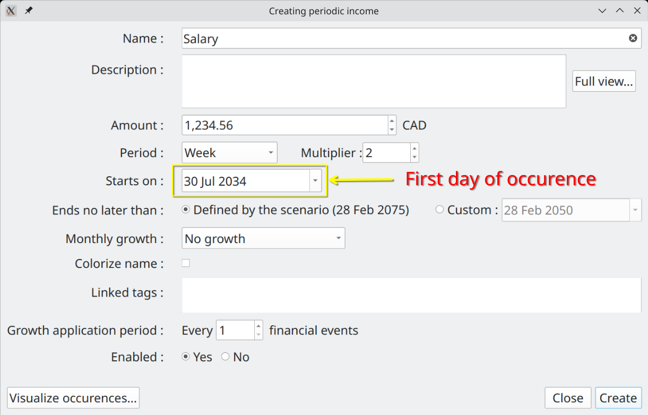

The salary will repeat until it reaches the End Date

2034-07-30 : 1,234.56 CAD (cummul=1,234.56 CAD)
2034-08-13 : 1,234.56 CAD (cummul=2,469.12 CAD)
2034-08-27 : 1,234.56 CAD (cummul=3,703.68 CAD)
...
2039-12-11 : 1,234.56 CAD (cummul=174,072.96 CAD)
2039-12-25 : 1,234.56 CAD (cummul=175,307.52 CAD)

Salary Received Twice a Month (15th , End of Month), No Growth
This one is a little bit tricky, because when we look at it closely, it is a strange "regular" time interval (end of month can be 28,29,30,31). To fix that, we need to have 2 separate incomes : Salary 1 and Salary 2. The first one is on the 15th with a period of 1 Month. The second will cover the end-of-month. Here we specify 30 July, which is 1 day less than the real end of month. GBP will help us by generating the first event on the real end-of-month, which is 31 July.

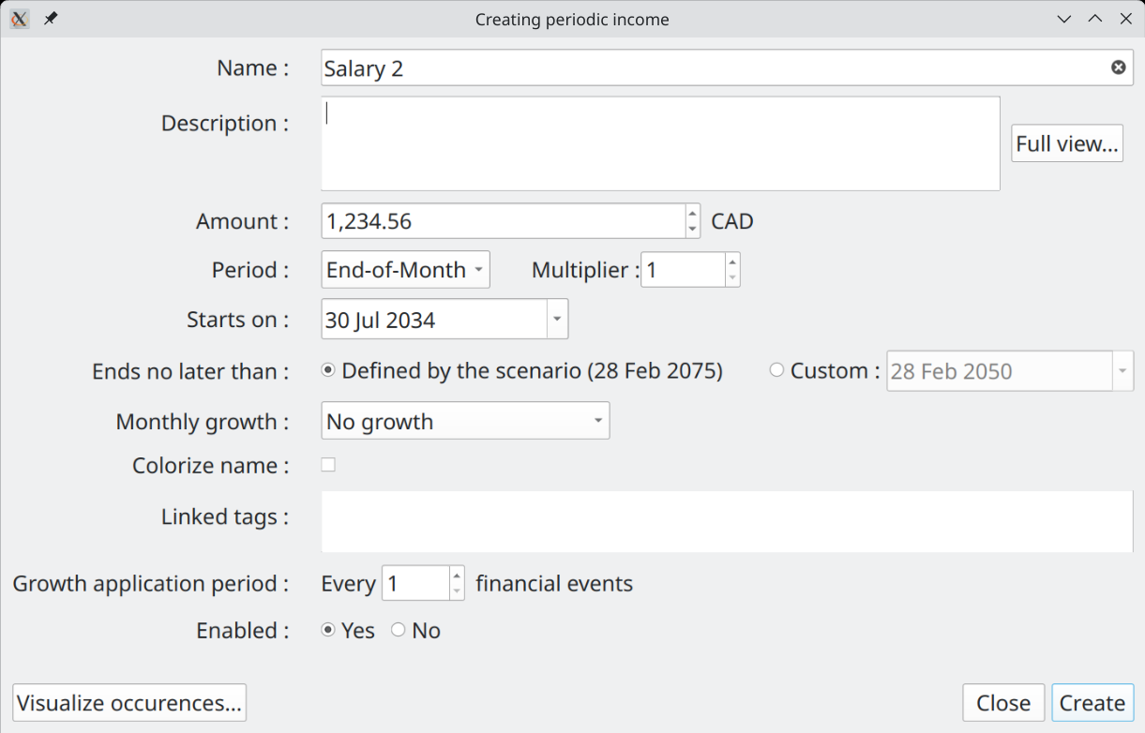

Salary 2 will generate the expected Financial Events : note how the end-of-month date changes

2034-07-31 : 1,234.56 CAD (cummul=1,234.56 CAD)
2034-08-31 : 1,234.56 CAD (cummul=2,469.12 CAD)
2034-09-30 : 1,234.56 CAD (cummul=3,703.68 CAD)
2034-10-31 : 1,234.56 CAD (cummul=4,938.24 CAD)
...
2039-10-31 : 1,234.56 CAD (cummul=79,011.84 CAD)
2039-11-30 : 1,234.56 CAD (cummul=80,246.40 CAD)
2039-12-31 : 1,234.56 CAD (cummul=81,480.96 CAD)

An Annual Rent with Fixed Monthly Payment
Lets say we have a rent with a 1000$ monthly payment, renewed every 12 month with a rent increase of 5 %. Monthly payment are constant within a 12 month contract. This can be modeled in GBP the following way :
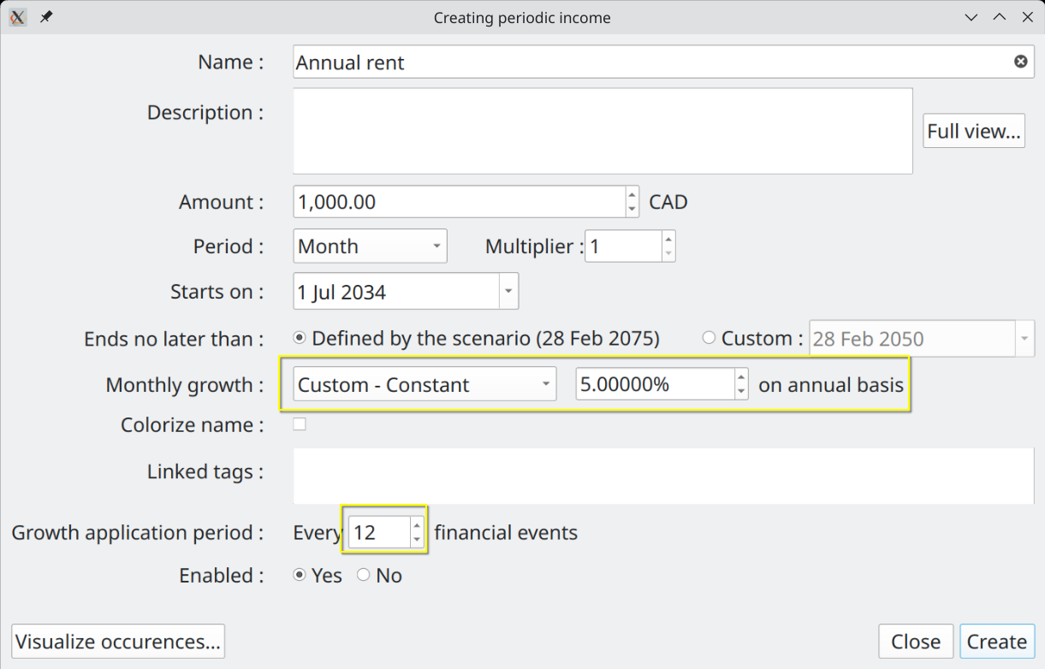
The Period is "1 monthly", since we pay the rent every month. The amount is 1000. Growth is set to "Constant – 5% annually). The trick here is to set "Growth Application Period" to 12, because we want the rent raise to be applied only once a year, at renewal. The generated Financial Events will be, as expected :

2034-07-01 : 1,000.00 CAD (cummul=1,000.00 CAD)
2034-08-01 : 1,000.00 CAD (cummul=2,000.00 CAD)
2034-09-01 : 1,000.00 CAD (cummul=3,000.00 CAD)
...
2035-06-01 : 1,000.00 CAD (cummul=12,000.00 CAD)
2035-07-01 : 1,050.00 CAD (cummul=13,050.00 CAD)
2035-08-01 : 1,050.00 CAD (cummul=14,100.00 CAD)
...

Weekly Grocery Bill that Follows Scenario’s Inflation
This is a weekly expense that should follow inflation, which we set at 5% in the scenario. So Period is "1 week" and growth must be set to "Follow scenario’s inflation". Lets assume a 300$ weekly grocery expense. In GBP, we then have this Periodic Cash Stream Definition :

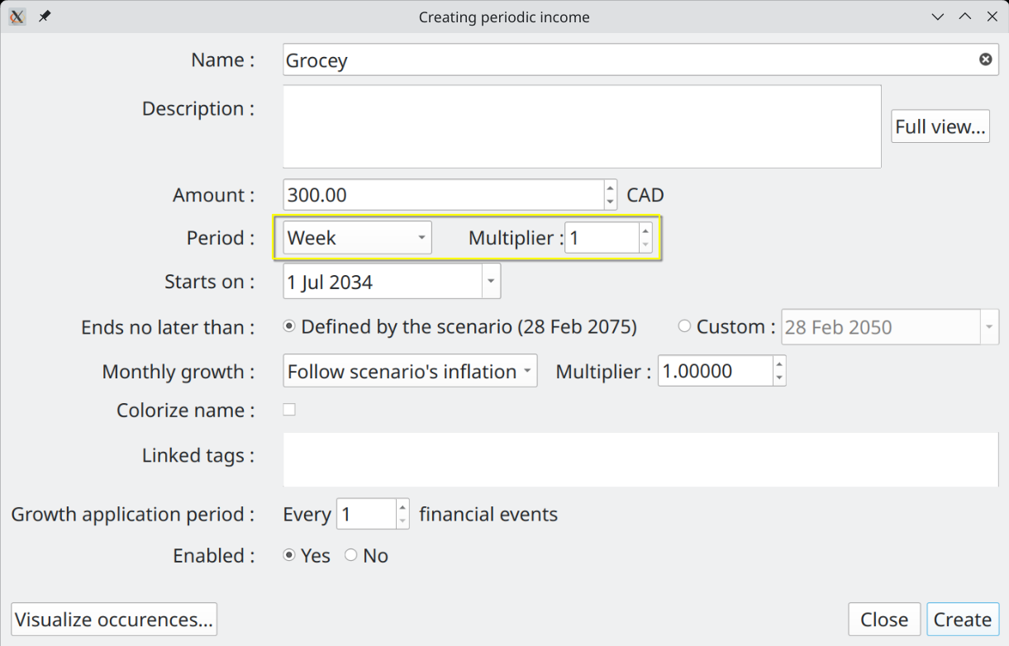

Since inflation (and any defined growth for any Cash Stream Definition) is always converted internally to monthly value and applied on the 1st of each month, we should have the weekly grocery expense stay the same for a whole month. Monthly growth will be 0.4074% (equivalent of 5% annual). Also, remember that the first occurrence never has growth applied. We then get, as expected :

2034-07-01 : 300.00 CAD (cummul=300.00 CAD) <= no growth applied for first occurrence
2034-07-08 : 300.00 CAD (cummul=600.00 CAD)
2034-07-15 : 300.00 CAD (cummul=900.00 CAD)
2034-07-22 : 300.00 CAD (cummul=1,200.00 CAD)
2034-07-29 : 300.00 CAD (cummul=1,500.00 CAD)
2034-08-05 : 301.22 CAD (cummul=1,801.22 CAD) <= Monthly inflation applied
2034-08-12 : 301.22 CAD (cummul=2,102.44 CAD)
2034-08-19 : 301.22 CAD (cummul=2,403.66 CAD)
2034-08-26 : 301.22 CAD (cummul=2,704.88 CAD)
2034-09-02 : 302.45 CAD (cummul=3,007.33 CAD)
2034-09-09 : 302.45 CAD (cummul=3,309.78 CAD)

Monthly Loan Payment at Each End-Of-Month
Lets say we have a loan payment of 100$ that is due at every end of month, with the first occurrence being on 30 nov 2024 and end on 31 oct 2039. In GBP, that translates to :

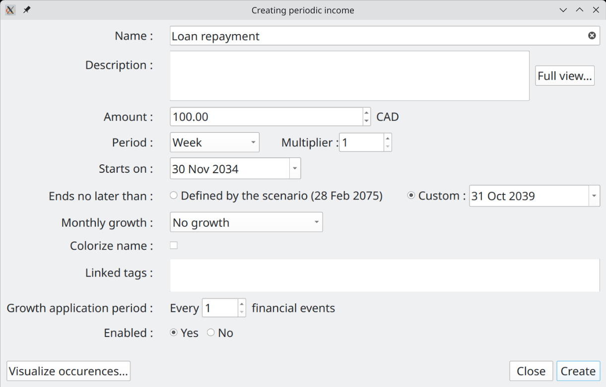
The use of "End-of-Month" for the Period make sure that, as we go forward in time, one always get the real end of month, and not just "date + 1 month" as it would be if we would use Period = "Month". The resulting Financial events are, as expected :

2034-11-30 : 100.00 CAD (cummul=100.00 CAD)
2034-12-31 : 100.00 CAD (cummul=200.00 CAD)
2035-01-31 : 100.00 CAD (cummul=300.00 CAD)
2035-02-28 : 100.00 CAD (cummul=400.00 CAD)
2035-03-31 : 100.00 CAD (cummul=500.00 CAD)
...

Monthly Car Maintenance That Increases By a Variable Amount
Lets say we have a 50$ monthly car maintenance fee. We want this amount to increase by a different growth rate each year, because the car is getting older. Let say that :
- Year 1 : 5% increase (annual basis)
- Year 2 : 10% increase (annual basis)
- Year 3 : 15% increase (annual basis)
- Year 4 and following : 20% increase (annual basis)

To model that in GBP, we have to use a variable growth rate applied to a Period Stream Definition. Like this :

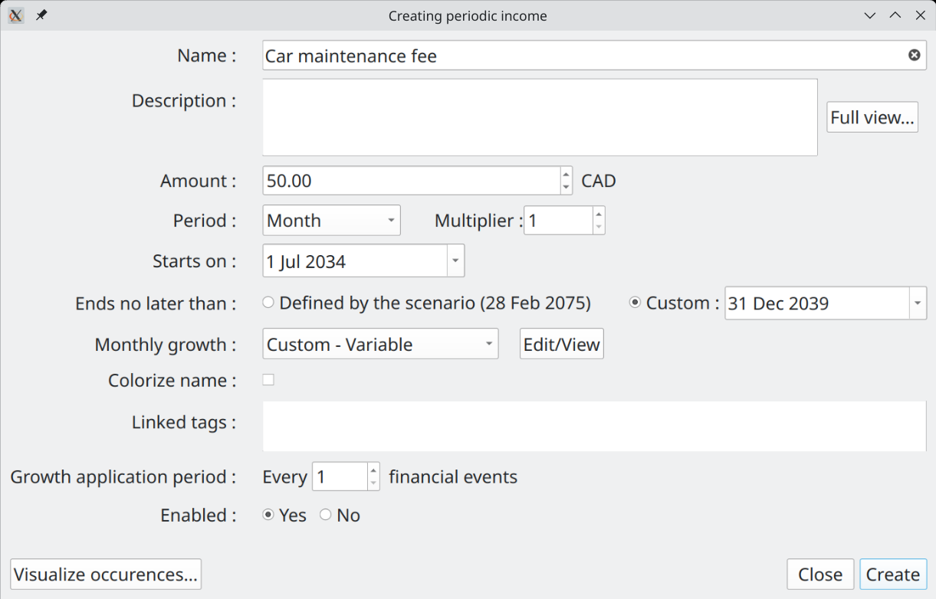
with the definition of the variable growth like the following :

We get the following Financial events, which are as expected :

2034-07-01 : 50.00 CAD (cummul=50.00 CAD) <= growth never applied on the first occurence
2034-08-01 : 50.20 CAD (cummul=100.20 CAD) <= growth of 0.4074%
2034-09-01 : 50.41 CAD (cummul=150.61 CAD) <= growth of 0.4074%
...
2035-06-01 : 52.29 CAD (cummul=613.61 CAD) <= growth of 0.4074%
2035-07-01 : 52.70 CAD (cummul=666.31 CAD) <= new growth of 0.7974%
2035-08-01 : 53.12 CAD (cummul=719.43 CAD) <= growth of 0.7974%

2036-06-01 : 57.52 CAD (cummul=1,274.55 CAD) <= growth of 0.7974%
2036-07-01 : 58.19 CAD (cummul=1,332.74 CAD) <= new growth of 1.1715%
…
2037-06-01 : 66.14 CAD (cummul=2,019.61 CAD) <= growth of 1.1715%
2037-07-01 : 67.16 CAD (cummul=2,086.77 CAD) <= new growth of 1.5309%
…
2038-06-01 : 79.37 CAD (cummul=2,896.93 CAD) <= growth of 1.5309%
2038-07-01 : 80.59 CAD (cummul=2,977.52 CAD) <= STILL growth of 1.5309%

Practical Examples of Irregular Incomes/Expenses

One-time Tax Return
A one-time event is easily modeled in GBP with an Irregular Cash Stream Definition. If for example one plans to receive a 1000$ tax return on May 15 2035, this would look like this :

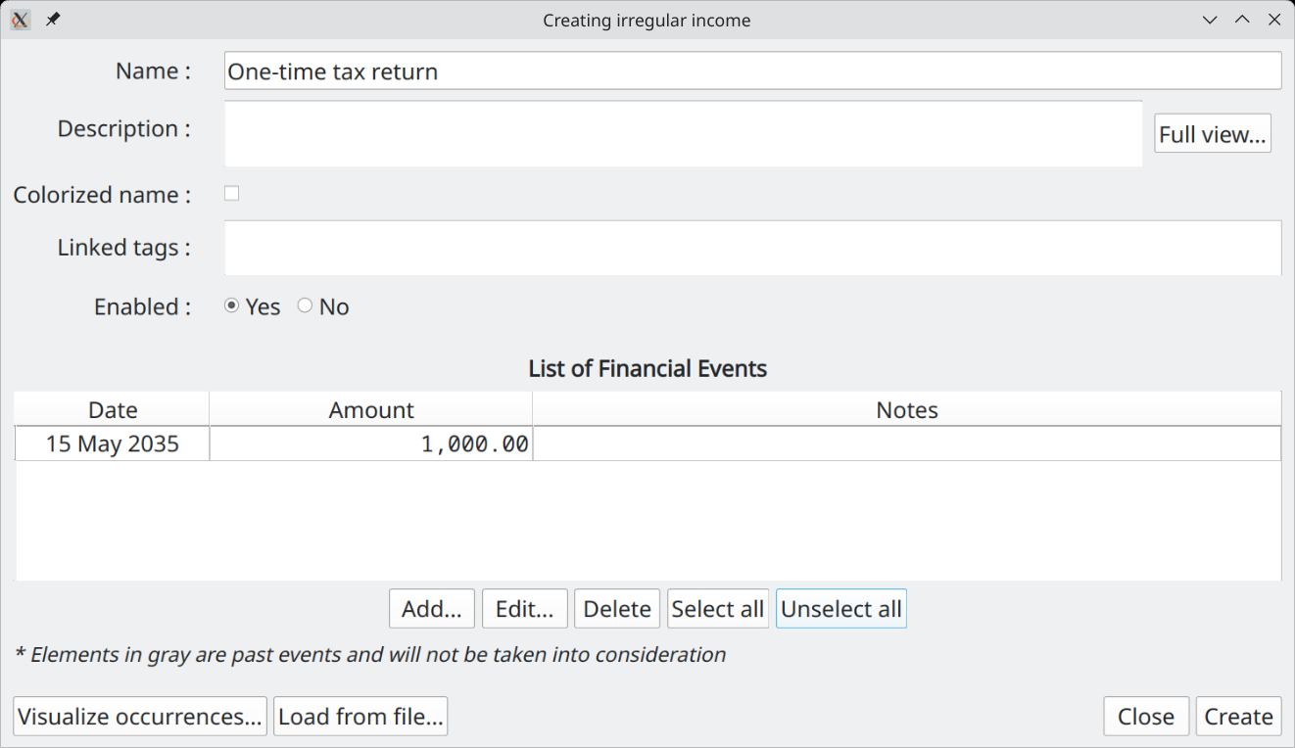
The list of Financial Events hold the expected Financial Events. Use "Add" button to create a new one, "Edit" to modify an existing one, "Delete" to remove all items selected.

Irregular Incomes from Selling Goods
When a set of incomes occurred at irregular intervals, the best approach is to use Irregular Stream Definition. For example, if you expect the following incomes from selling some furnitures before moving to a new place :
- 25 nov 2036 : 2000$
- 30 jan 2037 : 1500$
- 4 jun 2037 : 1200$

This would translates in GBP with the following Irregular Cash Stream Definition :

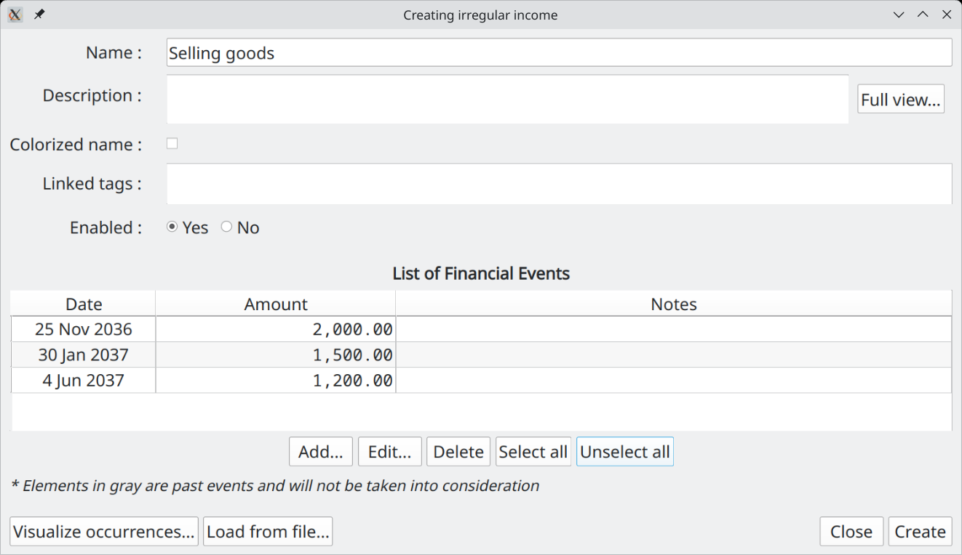

Periodic Expenses but Irregular Amounts
Even if a set of Financial Events occur at regular periodic intervals, it does not means this should be modeled as Periodic Cash Stream Definition. In the case where amounts are not constant or cannot be simply determined by Growth pattern (constant or variable), then Irregular Stream Definition is the way to go.

Lets say we get dividends from a investment portfolio every 3 months. The amount varies enormously and are given by :
- 31 jan 2036 : 5000$
- 30 avr 2036 : 10000$
- 31 july 2036 : 25000$

In GBP, we would have the following Irregular Cash Stream Definition :

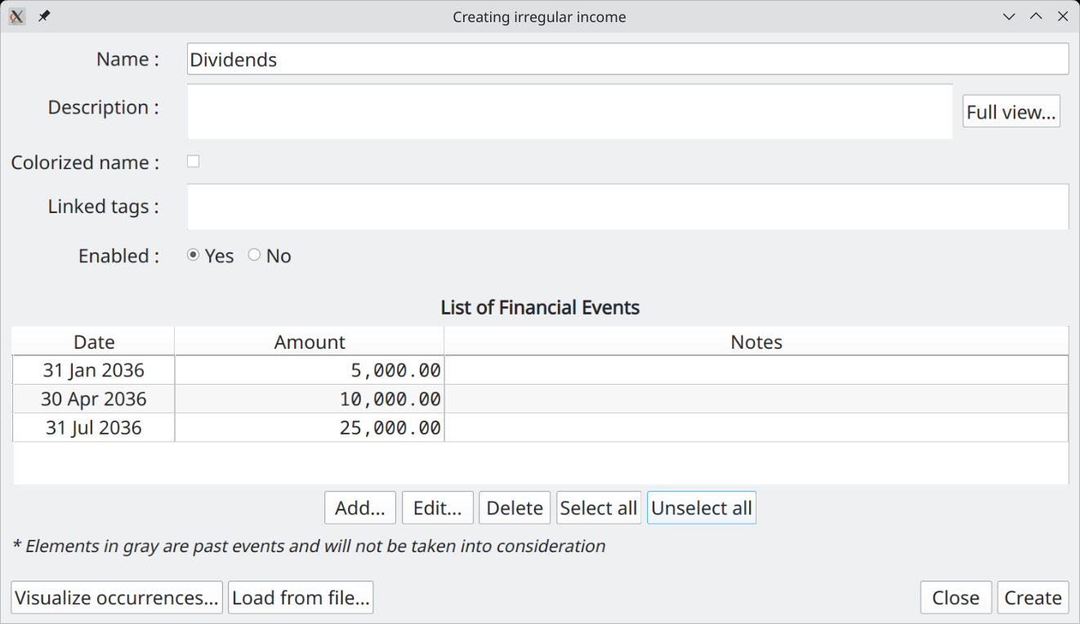

Importing a Complex Set of Incomes
In the case where a set of incomes are determined by a complex model external to GBP, it is possible to import the result in a GBP Irregular Stream Definition with the help of a CSV file.

To do so, create a new Irregular Stream Definition and press the "Load from file" button at the bottom left :

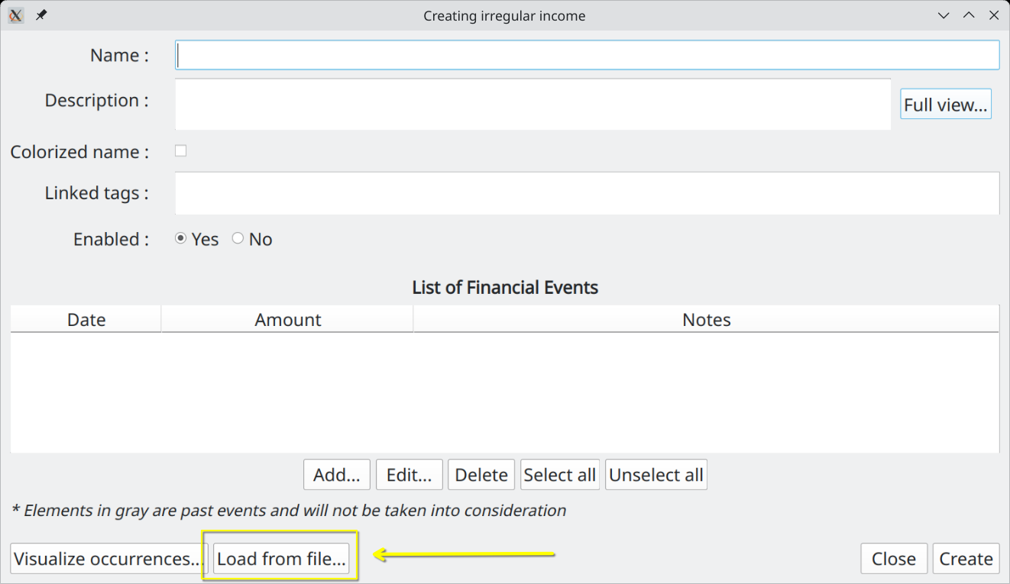

The File import Dialog is shown : proceed by selecting a CSV file using the "Browse" button and press "Import" :

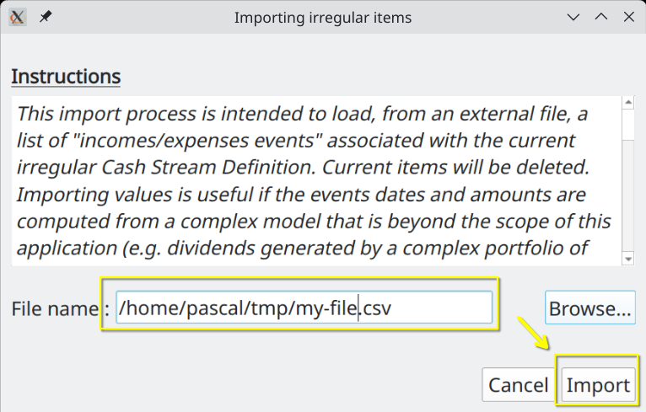

The content of the CSV file will be brought into the irregular income, replacing the current content :
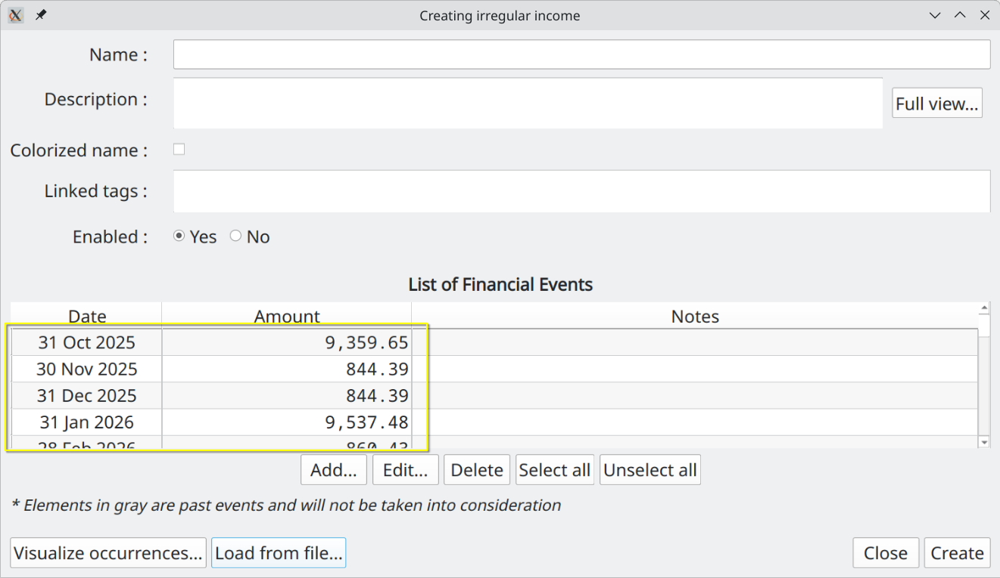

Creating the Budget in GBP
Once you gather all this information, you can create a new scenario by using the "Scenario→New…" menu. The following Dialog will be shown :

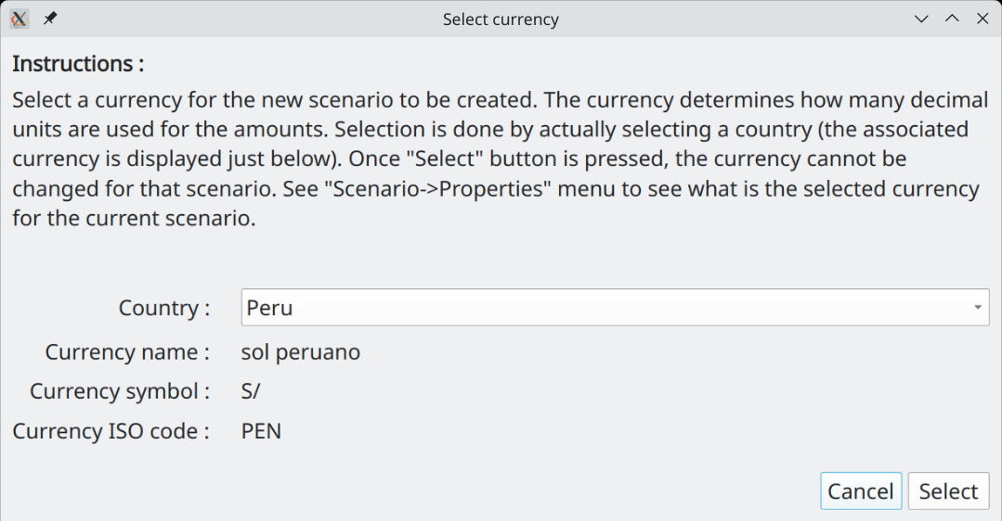
Select the currency to be used in the scenario by selection a country. After pressing "Select", you will have access to the "Edit Scenario" Dialog : enter the collected data and then press "Apply changes" button at the bottom right.

The last step would be to save the scenario in a disk file, using the "Scenario→Save As…" menu.

Using a Budget Scenario Over Time

Typical Workflow
Once a budget is created, user will launch the program from time to time in order to either look at the budget, to modify the scenario’s data or to make some analysis. The following is a brief description of the typical way to use GBP, as intended by the author.

The standard workflow relies on the default behavior of GBP to read the date of "today" from the system’s date at launch time. This can be changed in the Options Window, but in that case it leads to the "alternate workflow" described in the following section.

Set "Start Amount as of Today" Value
First, right after launching GBP and a scenario is loaded, the user should update as soon as possible the "Start Amount as of today" value. The basic assumption behind this approach is that it is easy to collect the net cash balance of the user (e.g. by looking at the balance of all "checking" bank accounts) or net value. This is what is entered in the "Start Amount as of Today" field, as it represent the current cash balance as of "today" (or net value) and constitutes the initial condition on top of which the future incomes/expenses will be added. Think of it as a "baseline".

Inspect the Cash Balance Curve and Analysis Module
Once this is done, user will typically do the following :

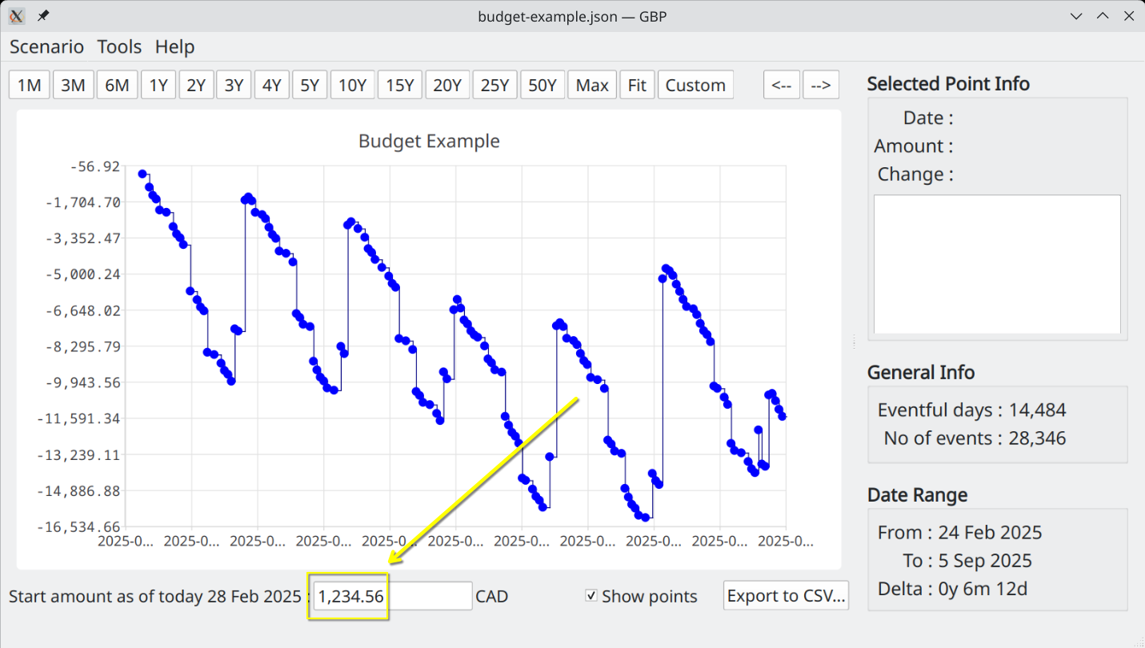
- Spend a lot of time changing the range of the displayed Cash Balance curve (zooming, panning, predefined range buttons at the top) and looking at how the cash balance evolves over time. This gives a good idea of how well the user is doing.
- Selecting miscellaneous points in order to know what Financial Events occurred in a specific day and see their effects.
- Looking at the Analysis module to inspect the evolution of monthly/yearly cash balance or to evaluate the relative weight of incomes/expenses over a custom period of time. The latter allows for quick identification of the most impactful incomes or expenses.

These activities will allow the user to better understand his current financial situation and help making appropriate decisions, which is the goal of GBP. For example :
- If the cash Balance curve gets dangerously close to 0 during a certain period of time, user may decide to delay or to reduce some expenses, like vacations, buying a new car, etc, or rather increase its incomes.
- A monthly cash balance (as reported in Analysis module) that is decreasing over time may lead to the conclusion that some decisions are required in order to be in better shape financially speaking

Play with the Scenario Data and Look at the Results
- By changing the amounts of some Cash Stream Definitions and see the effect on the curve, user can see if he can afford certain expenses (e.g. "Should I reduce the budget allocated to eating out and by how much ?")
- Many simulations can be conducted by playing with the Cash Stream Definitions of a scenario, including enabling/disabling them, in order to see the financial impact of major life changing decisions (e.g. retirement, changing job, starting a business, moving to a different country, doing a PHD or not, go back to school, downsizing the housing expectation)

Improve Readability Using Colorization of Name
In order to distinguish groups of incomes/expenses from one another, user will typically use the "Colorize Name" feature of a Cash Stream Definition. For example, he may use blue color to identify expenses related to car :

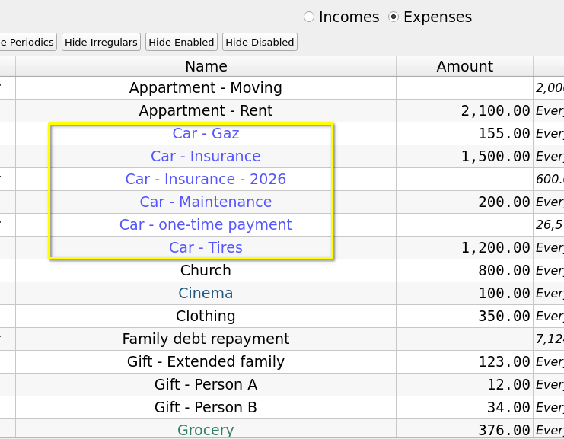
Not only is it easier to identify them in the list of Cash Stream Definitions in the "Edit Scenario" window, but identification is also easier in the "Selected Point Info" of the Main Window :

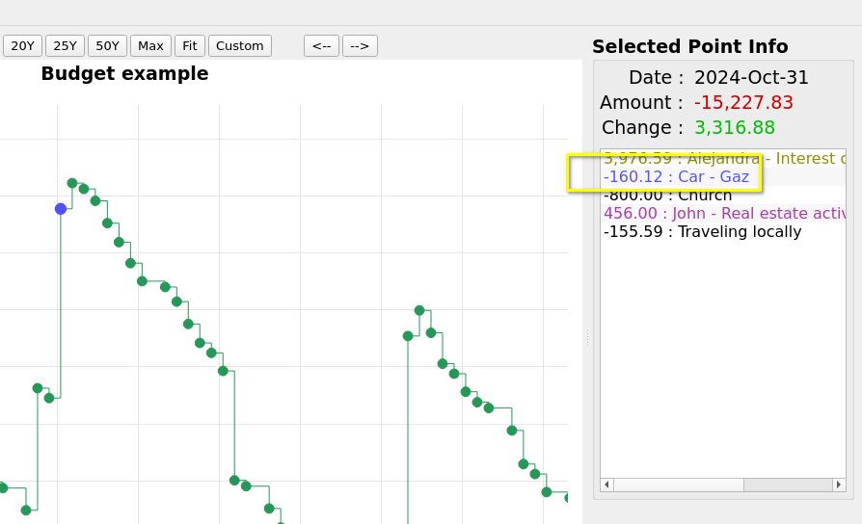

Alternate Workflow

What Is the Alternate Workflow ?
It is essentially the same as the "typical" one, with one very important difference : the date of "today" is not read from system’s date at startup (which is the default behavior), but is rather set to a custom value obtained from GBP configuration settings.

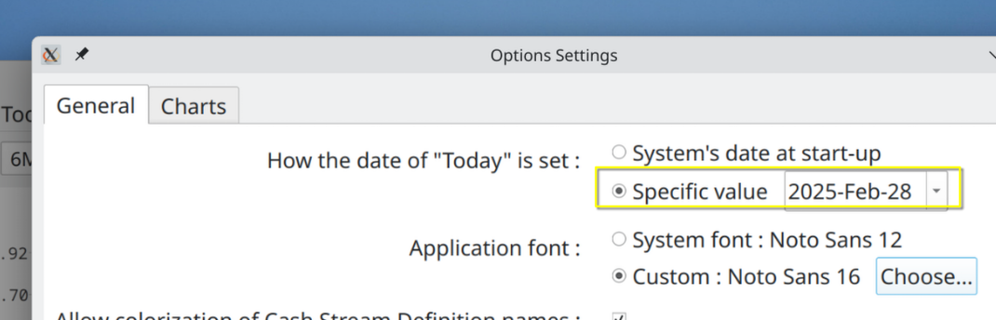
This means that the view provided by GBP is "frozen in time", since the date of "today" does not change each time the program is launched. The date of "today" can be seen at the bottom of the Main Window :

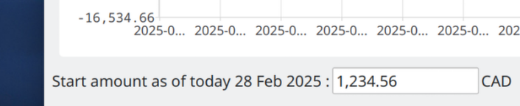

When Can this Alternate Workflow Be Useful ?
There could be some situations where :
- For an income/expense, you may have configured it to occur at a specific day in the month for example, but in reality you don’t know for sure when it occurs
- For an income/expenses, the day of occurrence may change from time to time.
- The current cash balance can be difficult to collect

For example :
- Case 1 - Periodic monthly Health Care expense : you may set it for the 15 of every month, for convenience purpose, but in reality it may happen anytime in the month, more than one time. You could also decide to make it a daily expense, which kind of average it out and makes the use of the alternate workflow not required. But the inconvenient is that you will get a lot of Financial Events daily that are "less real".
- Case 2 - Periodic investment incomes due for end-of-month : you may get them sometimes earlier in the month. It could be dividend payments that you scheduled every end-of-month for sake of simplicity, but in reality they occur at different moments in a month from time to time. For example :
    - mars 2035
      - on the 15th : monthly dividend from stock A
      - on the 28th : trimestrial dividend from stock B
    - April 2035
      - on the 15th : monthly dividend from stock A
    - June 2035
      - on the 15th : monthly dividend from stock A
    - July 2035
      - on the 15th : monthly dividend from stock A
      - on the 27th : trimestrial dividend from stock B
All is fine if you "retrieve" the dividends from your investment accounts at the end of the month, since they will have have been collected and be part of your end-of-month Cash Balance amount. But if you get some of them on, lets say, the 15th and transfer the amount on the 16th, you will have an inaccuracy if you log in GBP the [16 – 31] period, as your cash balance will already have been increased by the dividends collected and transferred, but your Financial Event Stream definition states that you still have to receive it by the end of the month.
- Case 3 - you may have difficulty accessing the accounts or you have too many sources that contribute to determine your "current cash balance" amount.

To alleviate these situation, you may decide to use the alternate workflow and update the budget only at the end of the month for example, where all the intra-month incomes/expenses will have occurred. Meanwhile, to work with GBP before the coming end of the month, you
- set the date of today as the "last end-of-month"
- set the same "current cash balance" you had at the end of the last month.

Future Values vs Present Values
This is an advance topic.

By default, all the Financial Event amounts produced by GBP are "future values", meaning the actual "nominal" values, as produced by the Cash Stream Definitions. A periodic income of 1000$ a month will still produce 1000$ for every month until the end of the validation interval.

The problem is that these amounts occurring so far in the future are in fact worth less than today’s equivalent nominal amounts, due to several economic factors, such as :

- Inflation: The value of money depreciates over time due to inflation. As prices rise, the purchasing power of a dollar decreases, making future values worth less.
- Opportunity Cost: Money received in the future has less value because it cannot be invested or used immediately. This means that money received today can produce return on investment (interest, dividend, capital gain, etc) or be used for immediate needs, whereas money received later has less potential for growth or utilization.

Inflation is already modeled quite well in GBP. For "opportunity cost", it can be approximated using the conversion to Present Value. The conversion is enabled in the Options Dialog (item "Use Present Value"), where a "annual discount rate" in percentage must be provided by the user for the calculation to proceed. The conversion not only affect the Cash Balance curve displayed in the Main Window, but also all the data presented in the Analysis Window. Note that the conversion is on a monthly basis, meaning that all the amounts in a given month use the same conversion factor from future to present values. This simplification is perfectly adequate considering that we are looking at data in the far future and the annual discount rate is by itself an approximation.

The conversion to "Present Values" is useful when one looks at the general trend of the Cash Balance curve over a long period of time (many years). This can help to prevent misinterpretation of a climbing curve by thinking one accumulates a surplus over the years, as in reality it could be the inverse. The inconvenient of using this option is that all the financial event amounts (specially the short term ones because they are so close to the present) lose their intuitive interpretation : a Salary of 1000$ in 24 months will be actually a different amount (like e.g. 800$, depending on the discount rate used).

Take for example this 50-year cash balance curve : a simple monthly salary of 1000$ following a 4% inflation rate.

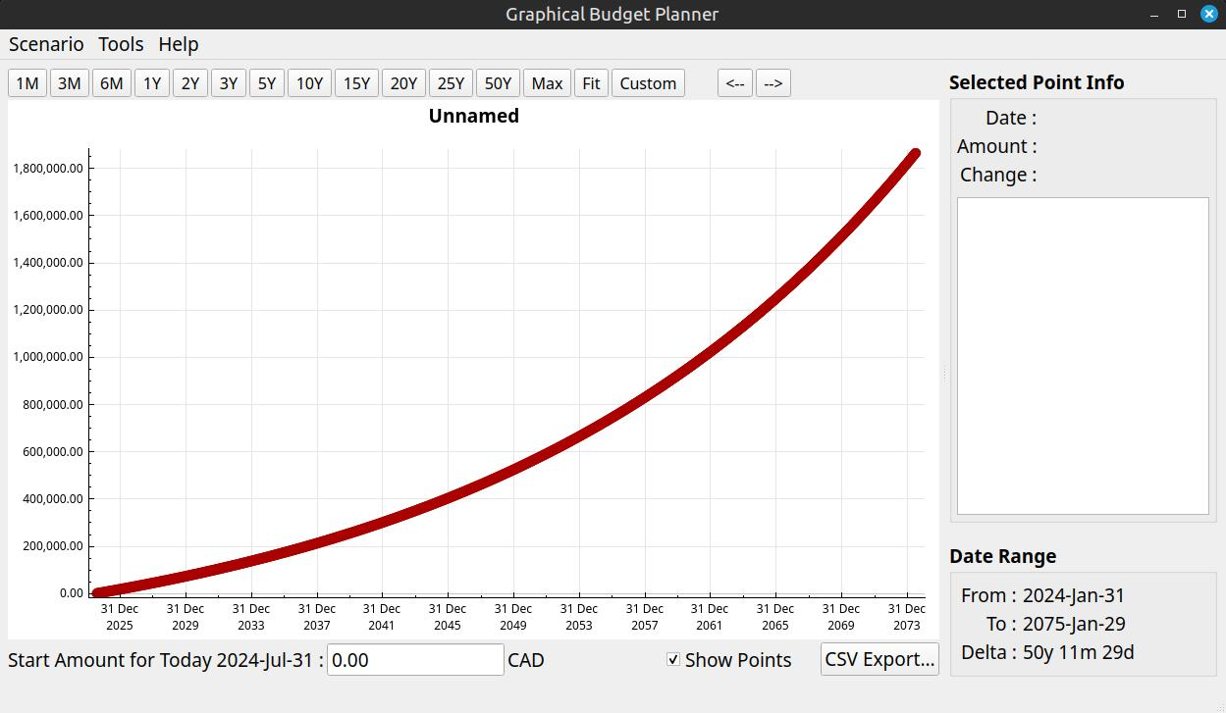

All seems fine, as the curve is "ascending"... However, by converting to Present Values using a discount rate of 8% (the "opportunity cost"), we obtain this :

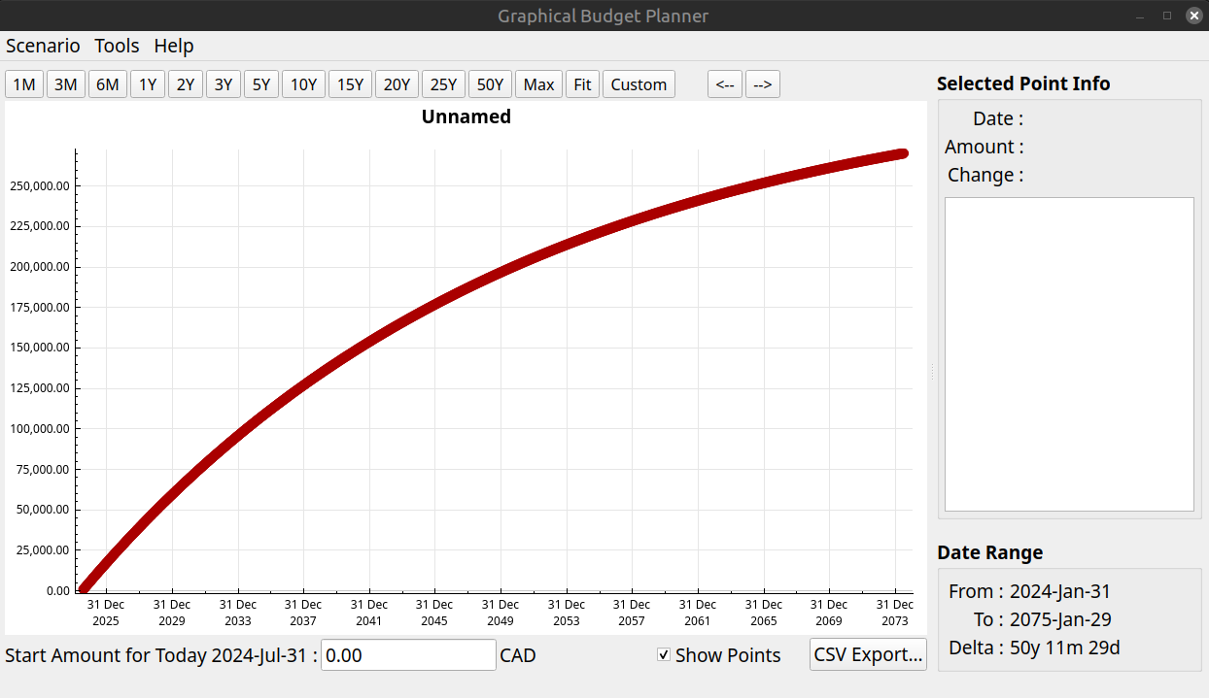
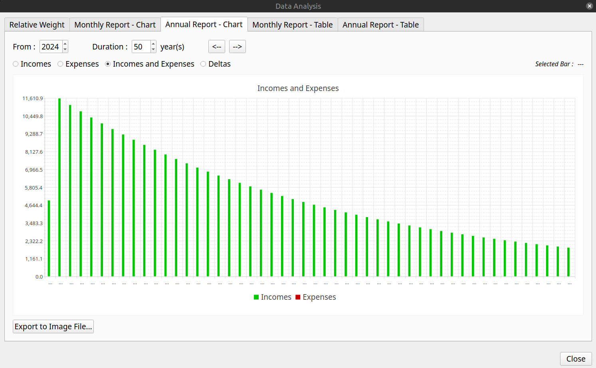
We can see that the surplus is actually diminishing every year in terms of Present Values, which may represent a problem for a personal budget. This is a conclusion that would not be possible to make as easily if only future values would be used.

Command Line Parameters
It is possible to alter some behaviors of GBP by passing some parameters on the command line when starting the application.

Force the Use of System Font
In Options, if ever the user selects a font that make the text unreadable to him, GBP can be started again in a terminal window with the argument "-usesystemfont". This will reset the font to system font.

Override System Locale
By default, GBP uses the System Locale (language and regional settings). This for example influences how numbers are entered and displayed (decimal separator character, thousands separator character, etc). It is possible to alter this behavior by passing an argument on the command line that forces GBP to use a specific locale. The format of the argument is :

-locale=<L>-<T>

where :
- <L> is a 2 or 3 char string representing ISO 639, e.g. "en", "fr", "ar"
- <T> is a 2 or 3 char string representing ISO 3166 code, e.g. "CA", "US", "SA"

If ever the argument is ill formatted, GBP will revert to default System Locale. The selected final Locale is displayed in the "About box".
Note finally that the UI language itself wont change to something other than French or English if the Locale is overridden by this method. At the moment, only French and English are available for the UI language. If the Locale has the "French" language specified ("fr") (e.g. fr-BE), then the UI will be in French, otherwise it defaults to English.

Logs

Format and Location
GBP has an internal logging mechanism intended to help debugging, if the need arises.

There are 3 log levels :
- None
- Minimal (default) : contains no data that can be considered as "private", that is no file content, no directory or file name, no income or expense names and/or amounts.
- Debug : for full debug process and may contain private data

To change the log level, you must pass the following argument to GBP :

-loglevel=<L>

where L is :
- 0 = None
- 1 = Minimal (default)
- 2 = Debug

Log files location is indicated on the terminal when GBP starts. On Linux, it should be:

~/.local/share/graphical-budget-planner/logs

Log file name is created when GBP starts and follows the pattern :

YYYY-MM-DD__hh_mm_ss.txt

where :
- YYYY is the year of creation
- MM is the month (01 to 12) of creation
- DD is the day in the month of creation
- hh is the hour of creation
- mm is the minute of creation
- ss is the second of creation

When GBP starts, it launches automatically a log cleaning process : any log file that has been created more than 100 days ago is erased (i.e. trashed).

All logs are in English only.

Example
This is for the default "minimal" log level :

[2024-07-12 09:36:54] - INFO - Application started
[2024-07-12 09:36:54] - INFO - Deleting old log file /home/pascal/.local/share/graphical-budget-planner/logs/2024-04-01__11_36_26.txt : success=1
[2024-07-12 09:36:54] - INFO - Deleting old log file /home/pascal/.local/share/graphical-budget-planner/logs/2024-04-01__11_27_53.txt : success=1
[2024-07-12 09:36:54] - INFO - Deleting old log file /home/pascal/.local/share/graphical-budget-planner/logs/2024-04-02__09_17_46.txt : success=1
[2024-07-12 09:36:54] - INFO - Deleting old log file /home/pascal/.local/share/graphical-budget-planner/logs/2024-03-31__21_17_20.txt : success=1
[2024-07-12 09:36:54] - INFO - Deleting old log file /home/pascal/.local/share/graphical-budget-planner/logs/2024-04-02__09_04_13.txt : success=1
[2024-07-12 09:36:54] - INFO - Deleting old log file /home/pascal/.local/share/graphical-budget-planner/logs/2024-03-31__21_22_57.txt : success=1
[2024-07-12 09:36:54] - INFO - Deleting old log file /home/pascal/.local/share/graphical-budget-planner/logs/2024-04-01__09_56_24.txt : success=1
[2024-07-12 09:36:54] - INFO - Deleting old log file /home/pascal/.local/share/graphical-budget-planner/logs/2024-03-31__21_19_21.txt : success=1
[2024-07-12 09:36:54] - INFO - Deleting old log file /home/pascal/.local/share/graphical-budget-planner/logs/2024-04-01__11_46_03.txt : success=1
[2024-07-12 09:36:54] - INFO - Deleting old log file /home/pascal/.local/share/graphical-budget-planner/logs/2024-04-02__10_29_01.txt : success=1
[2024-07-12 09:36:54] - INFO - Deleting old log file /home/pascal/.local/share/graphical-budget-planner/logs/2024-04-02__09_09_57.txt : success=1
[2024-07-12 09:36:54] - INFO - Deleting old log file /home/pascal/.local/share/graphical-budget-planner/logs/2024-04-02__09_37_49.txt : success=1
[2024-07-12 09:36:54] - INFO - Attempting to load settings from /home/pascal/.config/graphical-budget-planner.ini
[2024-07-12 09:36:54] - INFO - Settings loaded successfully
[2024-07-12 09:36:54] - INFO - scenario_max_years = 50
[2024-07-12 09:36:54] - INFO - chart_dark_mode = 1
[2024-07-12 09:36:54] - INFO - chart_dark_mode_curve_color = #c00000
[2024-07-12 09:36:54] - INFO - chart_light_mode_curve_color = #259857
[2024-07-12 09:36:54] - INFO - export_text_amount_localized = 0
[2024-07-12 09:36:54] - INFO - main_chart_scaling_percentage = 0
[2024-07-12 09:36:54] - INFO - use_default_system_font = 0
[2024-07-12 09:36:54] - INFO - custom_application_font = Ubuntu,14,-1,5,400,0,0,0,0,0,0,0,0,0,0,1,Regular
[2024-07-12 09:36:54] - INFO - today_use_system_date = 1
[2024-07-12 09:36:54] - INFO - today_custom_date =
[2024-07-12 09:36:54] - INFO - allow_decoration_color = 1
[2024-07-12 09:36:54] - INFO - Default system font as reported by Qt : Sans Serif,9,-1,5,400,0,0,0,0,0,0,0,0,0,0,1
[2024-07-12 09:36:54] - INFO - Custom font to be used as the application font... Attempting font change
[2024-07-12 09:36:54] - INFO - Custom font to be used is : Ubuntu,14,-1,5,400,0,0,0,0,0,0,0,0,0,0,1,Regular
[2024-07-12 09:36:54] - INFO - Success of the custom font installation
[2024-07-12 09:36:54] - INFO - System Locale is : en_CA
[2024-07-12 09:36:54] - INFO - Decimal point : .
[2024-07-12 09:36:54] - INFO - Group separator : ,
[2024-07-12 09:36:54] - INFO - Language : English
[2024-07-12 09:36:54] - INFO - Territory : Canada
[2024-07-12 09:36:54] - INFO - Attempting to load translation file gbp_en_CA.qm from directory /tmp/.mount_graphiKjU7TN...
[2024-07-12 09:36:54] - INFO - Translation file found and loaded
[2024-07-12 09:36:54] - INFO - Edit Scenario - infoActiveTable - Font size set from 14 to 12
[2024-07-12 09:36:54] - INFO - Edit Scenario - infoInactiveTable - Font size set from 14 to 12
[2024-07-12 09:36:54] - INFO - Edit Scenario - Description - Font size set from 14 to 12
[2024-07-12 09:36:54] - INFO - Edit Scenario - Filter Buttons - Font size set from 14 to 10
[2024-07-12 09:36:54] - INFO - Edit Periodic Dialog - Description - Font size set from 14 to 12
[2024-07-12 09:36:54] - INFO - Edit Irregular Dialog - Description - Font size set from 14 to 12
[2024-07-12 09:36:54] - INFO - Edit Irregular Dialog - Warning Label - Font size set from 14 to 12
[2024-07-12 09:36:54] - INFO - Analysis Dialog - Monthly Chart - X axis - Font size set from 14 to 10
[2024-07-12 09:36:54] - INFO - Analysis Dialog - Monthly Chart - X axis font size set from 14 to 10
[2024-07-12 09:36:54] - INFO - Analysis Dialog - Monthly and Yearly Chart - Selected Bar Info font size set from 14 to 12
[2024-07-12 09:36:54] - INFO - Analysis Dialog - Yearly Chart - X axis - Font size set from 14 to 10
[2024-07-12 09:36:54] - INFO - Analysis Dialog - Yearly Chart - X axis - Font size set from 14 to 10
[2024-07-12 09:36:54] - INFO - Main Window - FE List - Font size from 14 to 12
[2024-07-12 09:36:54] - INFO - Main Window - Toolbar - Font size from 14 to 12
[2024-07-12 09:37:49] - INFO - Scenario loaded successfully

Glossary
GBP
Acronym for this application, that is graphical-budget-planner.

Financial Event (FE)
The occurrence of a single amount of money at a specific date in time, adding to your global cash balance. The amount is >= 0 for an income, <=0 for an expense. For example, an income of 100.00 on 2029-12-31 or an expense of -234.56 on 2045-01-31

Cash Stream Definitions (CSD)
The set of data that defines an income or an expense, in a conceptual (i.e. declarative) form. For example, a monthly salary of 1234 Euro. From this definition, a series of Financial Events (a financial "stream") can be generated (from the previous example, a series of monthly 1234 Euro).

Financial Stream Generation
From a CSD, the application automatically "generates" all the financial events when the scenario is loaded. For example, a CSD could define a periodic salary of 2000 USD starting on 2032-01-15 , with no growth, to be repeated every week. The financial events that will be generated by the application would be :
- 2031-01-15 : 2000
- 2031-01-22 : 2000
- 2031-01-29 : 2000
- etc

Periodic Cash Stream Definition (PCSD)
A type of CSD that defines a Periodic Cash Stream Definition, that is an amount that repeat regularly over time. Growth can also be defined to the amount, so that it can actually change with time.

Irregular Cash Stream Definition (ICSD)
A type of CSD that defines a set of financial events occurring in time. Amounts cannot have growth associated with.

Scenario
A file that contains a set of CSD (between 0 and 500), along with some information associated to the context, like a scenario name, inflation rate, etc.

